Management Control System

Software Training Materials

**Table of Contents**

1. INTRODUCTION OF MANAGEMENT CONTROL SYSTEM 7

How to Log in the MCS 8

2. ADMINISTRATION WING 8

3.ESTATE MANAGEMENT (SUB MODULE) 10

4.ESTATE MENU OVERVIEW 11

4.1: Add Lease Menu Overview 12

4.1.1: (Add Lease) Add Lease Information Input field 12

4.2: Lease Payment Menu Overview 13

4..2.1: (Lease Payment) Add Lease payment input field 13

4..2.2: (Lease Payment) View of Lease Payment List 14

4..2.3: (Lease Payment) Update input field 14

4..2.4: (Lease Payment) Delete 15

4..2.5: (Lease Payment) Search 16

4.3: Single Report Menu Overview 16

4..3.2: (Single Report) View of Lands report 17

4..3.2.1: (Single Report) view of lands report(Details) 17

4..3.2.2: (Single Report) view of lands report (Update) 18

4..3.2.3: (Single Report) view of lands report (Delete) 19

4..3.3: (Single Report) View of ponds report 20

4..3.3.1: (Single Report) View of ponds report(Details) 20

4..3.3.2: (Single Report) View of ponds report(Update) 21

4..3.3.3: (Single Report) View of ponds report(Delete) 22

4.3.4: (Single Report) View of others report 22

4.3.4.1: (Single Report) View of others report(Details) 23

4.3.4.2: (Single Report) View of others report(Update) 23

4.3.4.3: (Single Report) View of others report(Delete) 24

4.3.5: (Single Report) View of all report 25

4.3.5.1: (Single Report) View of all report(Delete) 25

4.4: All Report Menu Overview (Same as Single report……Incomplete) 26

4.5: Settings Menu Overview 27

4.5.1.1: Add Pond (Settings) add new pond input field 27

4.5.1.2: Add Pond (Settings) view details of add new pond 28

4.5.1.3: Add Pond (Settings) Update 29

4.5.1.4: Add Pond (Settings) Delete 29

4.5.1.5: Add Pond (Settings) Search 30

4.5.2.1: Add Agriculture land (Settings) add new agriculture land input field 31

4.5.2.2: Add Agriculture land (Settings) view details of agriculture land 31

4.5.2.3: Add Agriculture land (Settings) Update 32

4.5.2.4: Add Agriculture land (Settings) Delete 33

4.5.2.5: Add Agriculture land (Settings) Search 33

4.5.3.1: Add Non-Agriculture land (Settings) Add nonagriculture land input field 34

4.5.3.2: Add Non Agriculture land (Settings) View details of non agriculture land 35

4.5.3.3: Add Non Agriculture land (Settings) Update 35

4.5.3.4: Add Non Agriculture land (Settings) Delete 36

4.5.3.5:Add Non Agriculture land (Settings) Search 37

4.5.4.1: Add Others/Tariff (Settings) Add new others/tariff input field 37

4.5.4.2: Add Others/Tariff (Settings) view details others/tariff 38

4.5.4.3: Add Others/Tariff (Settings) update 39

4.5.4.4: Add Others/Tariff (Settings) Delete 39

4.5.4.5: Add Others/Tariff (Settings) Search 40

4.5.5.1: Add Person (Settings) Add person input field 41

4.5.5.2: Add Person (Settings) view of add person details 41

4.5.5.3: Add Person (Settings) view document 42

4.5.5.4: Add Person (Settings) Download document 42

4.5.5.5: Add Person (Settings) Update 43

4.5.5.6: Add Person (Settings) Delete 44

4.5.5.7: Add Person (Settings) Search 44

4.5.6.1: Add Institute (Settings) add new institute input field 45

4.5.6.2: Add Institute (Settings) Add institute view details 46

4.5.6.3: Add Institute (Settings) download document 46

4.5.6.4: Add Institute (Settings) view document 47

4.5.6.5: Add Institute (Settings) Update 48

4.5.6.6: Add Institute (Settings) Delete 48

4.5.7.1: Add Govt/Others (Settings) add new govt/others input field 49

4.5.7.2: Add Govt/Others (Settings) add govt/others view details 50

4.5.7.3: Add Govt/Others (Settings) download document 50

4.5.7.4: Add Govt/Others (Settings) view document 51

4.5.7.5: Add Govt/Others (Settings) Update 52

4.5.7.6: Add Govt/Others (Settings) Delete 52

4.5.8.1: Update Vat/Tax (Settings) View details 53

4.5.8.2: Update Vat/Tax (Settings) Update 54

5.TRANSPORT (SUB MODULE) 54

6.TRANSPORT MENUS OVERVIEW 55

6.1: New Requisition Menu Overview 56

6.1.1: (New Requisition) Add new requisition input field 57

6.2: Requisition List Menu Overview 58

58

6.2.1: ( Requisition List)View of Requisition List 58

6.2.2: ( Requisition List) Update 59

6.2.3: ( Requisition List) Download Requisition list 59

6.3: Manage Drivers List Menu Overview 60

6.3.1: ( Manage Drivers) Add new (Outsource driver record form) 60

6.3.2: ( Manage Drivers)view of details 61

6.3.3: ( Manage Drivers) Download the report 62

6.3.4: ( Manage Drivers)Search 63

6.4: Vehicle Menu Overview 64

6.4.1.1: Vehicle Record (Vehicle )Add vehicle 64

6.4.1.2: Vehicle Record (Vehicle )View of Details 65

6.4.1.3: Vehicle Record (Vehicle )Vehicle Update 66

6.4.1.4: Vehicle Record (Vehicle )Driver Update 66

6.4.1.5: Vehicle Record (Vehicle )Download Report 67

6.4.1.6: Vehicle Record (Vehicle )Search 68

6.4.2.1: Types (Vehicle )Add New 69

6.4.2.2: Types (Vehicle )View of details 69

6.4.2.3: Types (Vehicle )Download Report 70

6.4.2.4: Types (Vehicle )Update 71

6.4.3.1: Models (Vehicle )Add New 72

6.4.3.2: Models (Vehicle )View of models details list 72

6.4.3.3: Models (Vehicle )Update 73

6.4.3.4: Models (Vehicle )Download Report 74

6.4.4.1: Manufacturers (Vehicle )Add New 75

6.4.4.2: Manufacturers (Vehicle )View of manufacturers details list 75

6.4.4.3: Manufacturers (Vehicle )Download Report 76

6.4.5.1: Pools (Vehicle )Vehicle pool record form 77

6.4.5.2: Pools (Vehicle )View of details vehicle pool list 78

6.4.5.3: Pools (Vehicle )Update 78

6.4.5.4: Pools (Vehicle )Download Report 79

6.5: Requisition Menu Overview 80

6.5.1.1: Requisition Record (Requisition)View of requisition list 81

6.5.1.2: Requisition Record (Requisition)Report download 81

6.5.1.3: Requisition Record (Requisition)Search 82

6.5.2.1: Controll Officer (Requisition)View of pending requestion for controller officer. 83

6.5.2.2: Controll Officer (Requisition)Download report. 84

6.5.3.1: Pending (Requisition)View of pending requisition list. 84

6.5.4.1: Approved(Requisition)Approved requisition list. 85

6.6: Maintenance Menu Overview 86

6.6.1.1: Maintenance Record(Maintenance)Add new vehicle servicing 86

6.6.1.2: Maintenance Record(Maintenance)View of servicing list 87

6.6.1.3: Maintenance Record(Maintenance)Details servicing 88

6.6.1.4: Maintenance Record(Maintenance)Search 88

6.6.1.5: Maintenance Record(Maintenance)Service report download 89

6.6.1.6: Maintenance Record(Maintenance)Details report download 90

6.6.2.1: Product Category(Maintenance)Add new Category 91

6.6.2.2: Product Category(Maintenance)Update 92

6.6.2.2: Product Category(Maintenance)Download Report 92

6.6.3.1: Product List(Maintenance)Add new product 93

6.6.3.2: Product List(Maintenance)Update 94

6.6.3.2: Product Lists(Maintenance)Download Report 95

6.6.4.1: Workshop(Maintenance)Add workshop 96

6.6.4.2: Workshop(Maintenance)Update 96

6.6.4.3: Workshop(Maintenance)Download Report 97

6.6: Fuel Menu Overview 98

6.7.1.1: Fuel Record(Fuel)Add new fuel record form 99

6.7.1.2: Fuel record(Fuel)View of fuel record list 99

6.7.1.3: Fuel Record(Fuel)Update 100

6.7.1.4: Fuel Record(Fuel)Download Report 101

6.7.1.5: Fuel Record(Fuel)Search 102

6.7.2.1: Fuel Type(Fuel)Add new fuel type form 102

6.7.2.2: Fuel Type(Fuel)View of fuel type list 103

6.7.2.3: Fuel Type(Fuel)Update 104

6.7.2.4: Fuel Type(Fuel)Download Report 104

6.8: Manage Rank Menu Overview 105

6.8.1: (Manage Rank)View of requisition hierarchy rank list 106

6.8.2: (Manage Rank)Update 106

6.8.3: (Manage Rank)Report download 107

7.IT (SUB MODULE) 108

8.IT MENUS OVERVIEW 109

8.1: New Requisitions Menu Overview 110

8.1.1:(New Requisitions)Make Request for product requisitions search 110

8.2: All Requisitions Menu Overview 111

8.2.1.1:View(All Requisition)all requisition status 111

8.2.1.2:View(All Requisition)Search 112

8.2.2.1.:Products(All Requisition)view requisition product details 113

8.2.2.2:Products(All Requisition)Search 113

8.3: Maintenance Menu Overview 114

8.3.1:Request(Maintenance)Requisition Products Search 114

8.3.2:View(Maintenance)Maintenance Products information. 115

8.4: Reports Menu Overview 116

8.4.1:(Reports)Requisition/Maintenance Report generator 116

# 1. INTRODUCTION OF MANAGEMENT CONTROL SYSTEM

……….

….

…….

…….

…….

Link for MCS is <http://192.168.3.7:3000/> which is accessible within BBA’s local network . After search will open a login page. Which is like –

### How to Log in the MCS

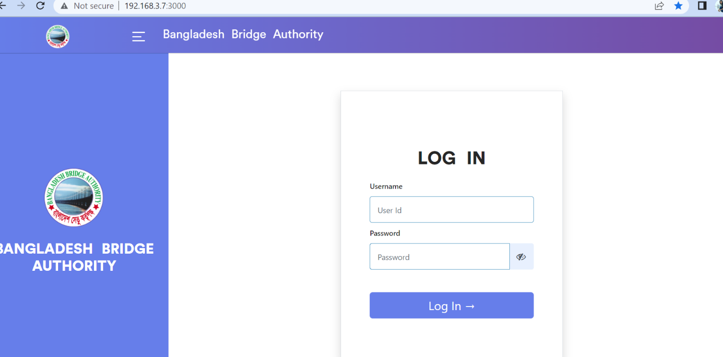

Figure 1: Log in Page

**Steps to Log in MCS**

1. User will input his Username
2. User will input his Password
3. Click Log In Button

If the username & password are correct, users will get access to the system.

# 2. ADMINISTRATION WING

For the Administration module –

**Steps to Enter in Administration**

1. After login will show this dashboard of MCS.

2. Click on the Administration.

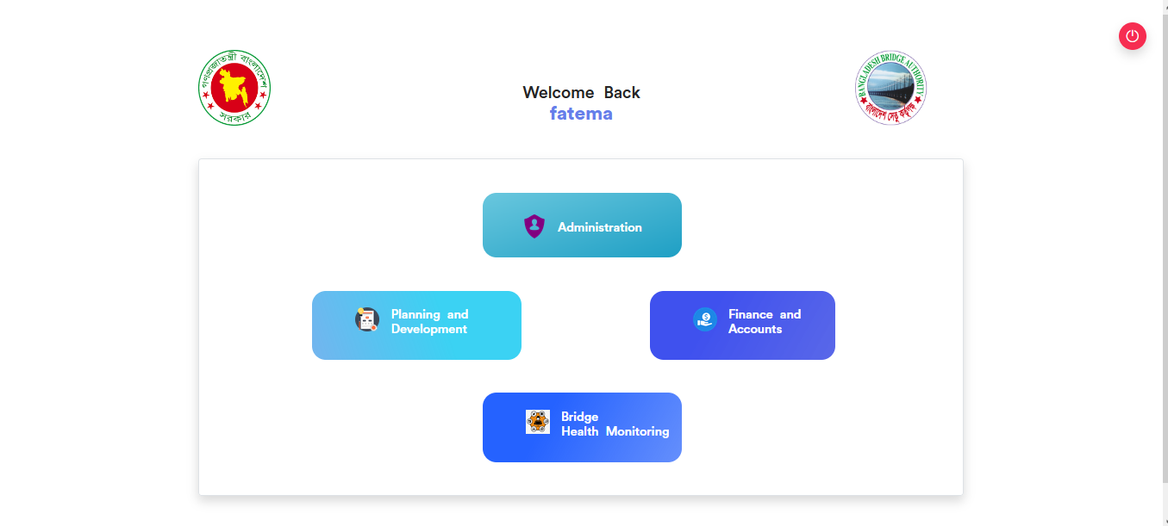

Figure 2.1: Dashboard of MCS

After entering into Administration then there will show another dashboard with another Five (5) Submodules. Such as-

1.Human Resources

2.Estate

3.Transport

4.IT

5.Store

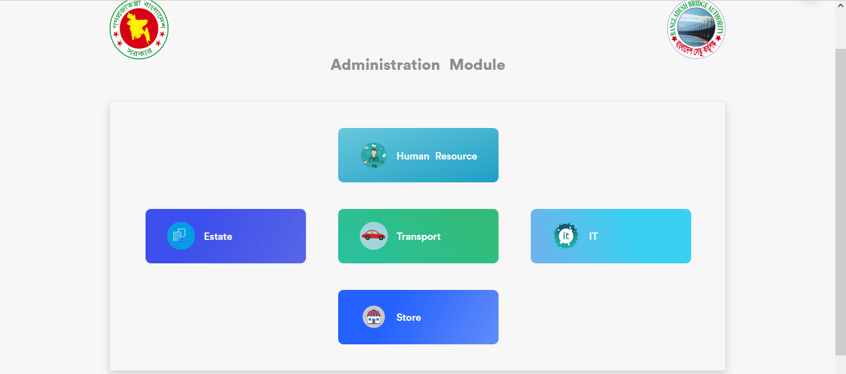

Figure 2.2: Dashboard of Administration Module.

**Overview of Administration Sub Modules**

# 3.ESTATE MANAGEMENT (SUB MODULE)

After clicking into Estate, it will redirect to the (Estate Sub Module) dashboard with some menus.

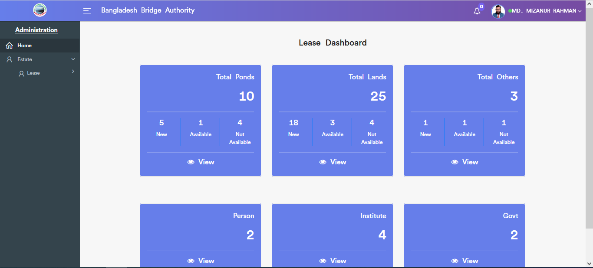

Figure 3: Dashboard of the estate (sub module).

There are six segments on the right side of the Estate Dashboard Such as **Total Ponds, Total Lands ,Total Others, Person, Institute** And **Govt.**

To get the details info about (**Total Ponds, Total Lands ,Total Others, Total person , Institute ,Govt**) just click on the view after that it will redirect to the relevant details info page.

# 4.ESTATE MENU OVERVIEW

**Estate Menus Overview**

## 4.1: Add Lease Menu Overview

**Overview of Add Lease**

### 4.1.1: (Add Lease) Add Lease Information Input field

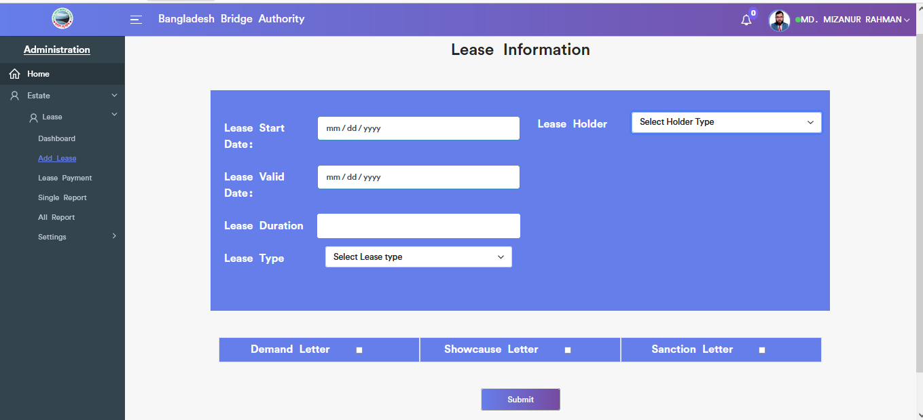

Figure 4.1.1.: add lease information input field

## 4.2: Lease Payment Menu Overview

**Overview of Lease Payment**

### 4..2.1: (Lease Payment) Add Lease payment input field

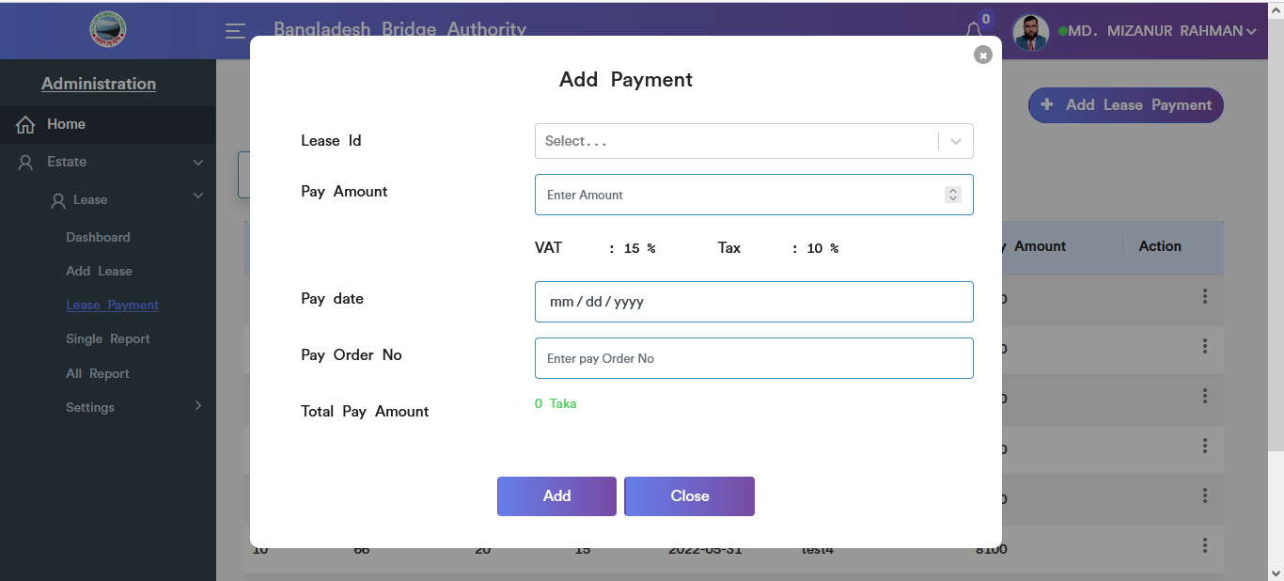

Figure 4.2.1.: add lease payment input field

### 4..2.2: (Lease Payment) View of Lease Payment List

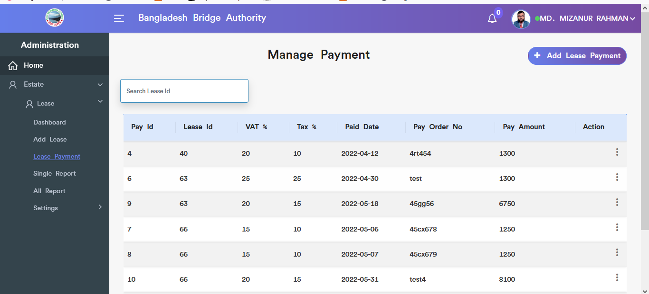

Figure 4.2.2.: view of lease payment list

### 4..2.3: (Lease Payment) Update input field

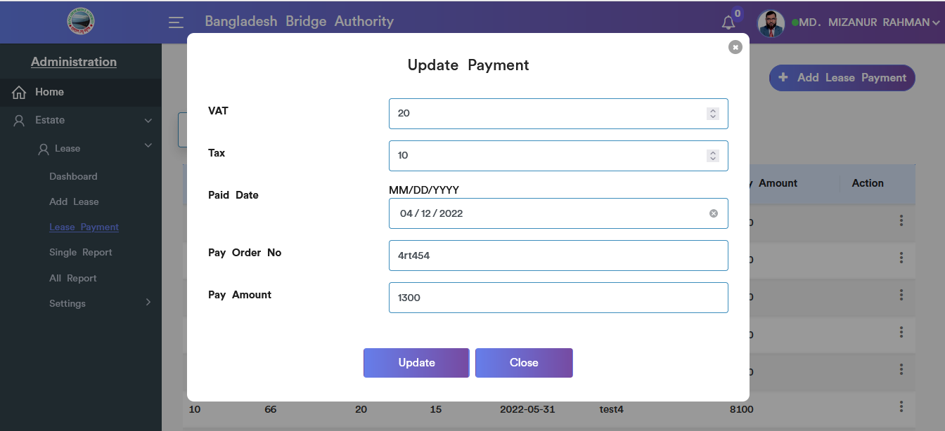

Figure 4.2.3.: Lease payment Update input field

### 4..2.4: (Lease Payment) Delete

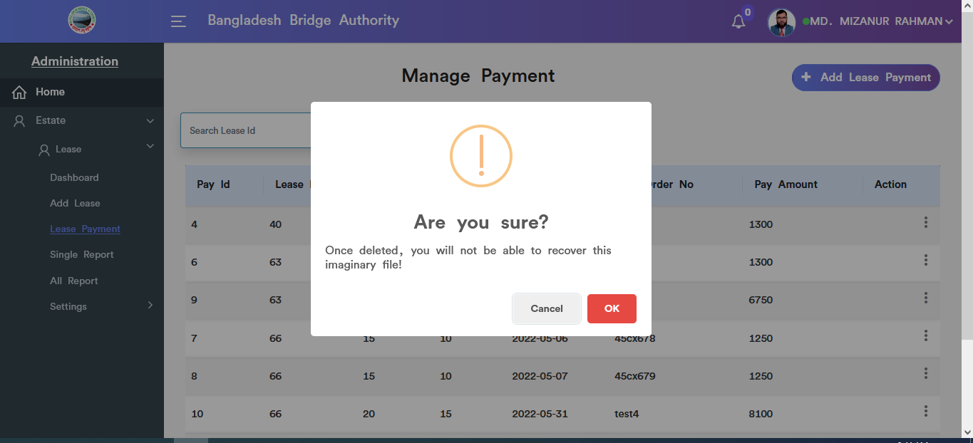

Figure 4.2.4.: Lease payment data delete

### 4..2.5: (Lease Payment) Search

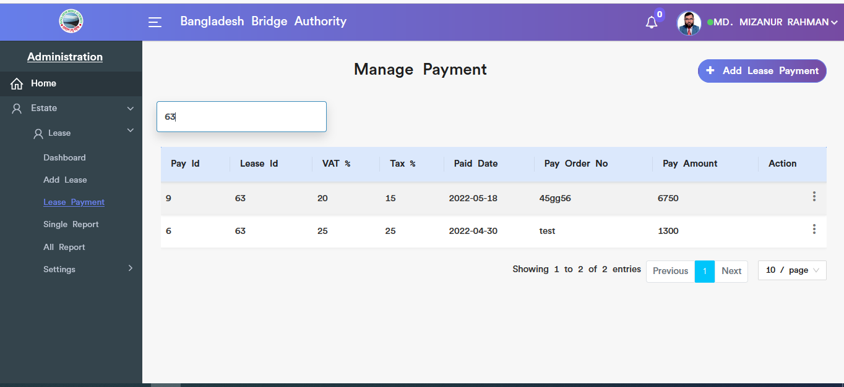

Figure 4.2.5.: Lease payment Search

## 4.3: Single Report Menu Overview

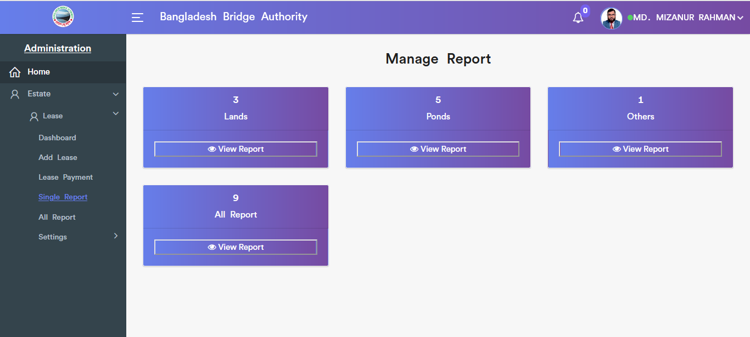

Figure 4.3.: (single report) view of single report (all) options

**Overview of Single Report**

### 4..3.2: (Single Report) View of Lands report

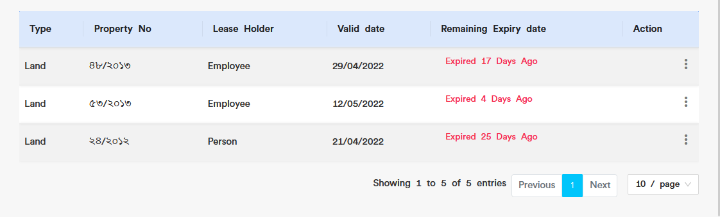

Figure 4.3.2.: (single report) view of lands report

### 4..3.2.1: (Single Report) view of lands report(Details)

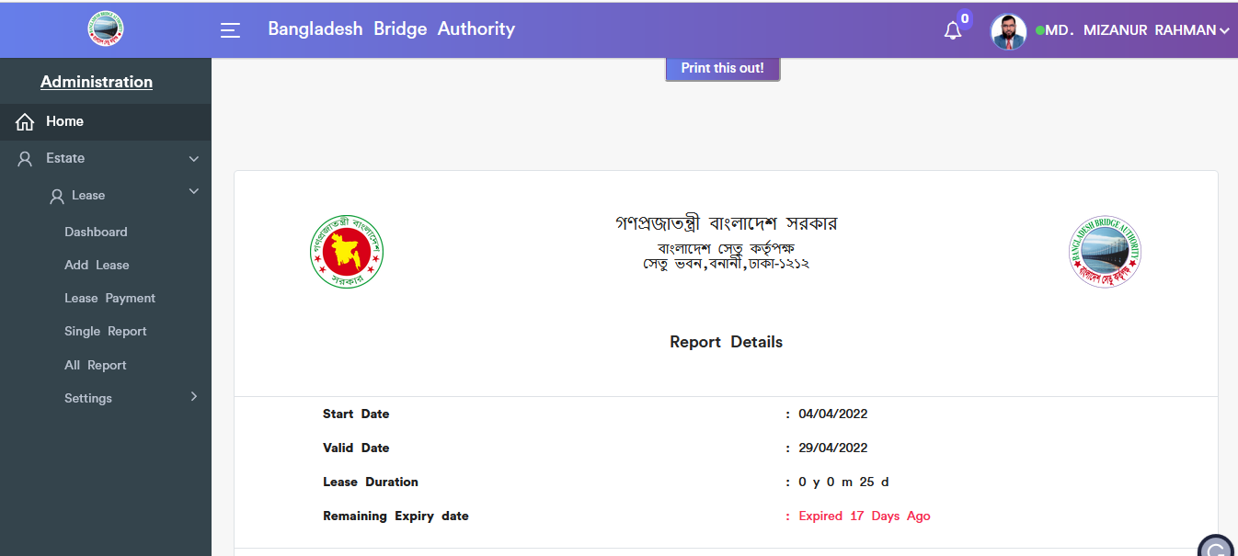

Figure 4.3.2.1.: view of lands report(details)

### 4..3.2.2: (Single Report) view of lands report (Update)



Figure 4.3.2.2.: view of lands report update input field

### 4..3.2.3: (Single Report) view of lands report (Delete)

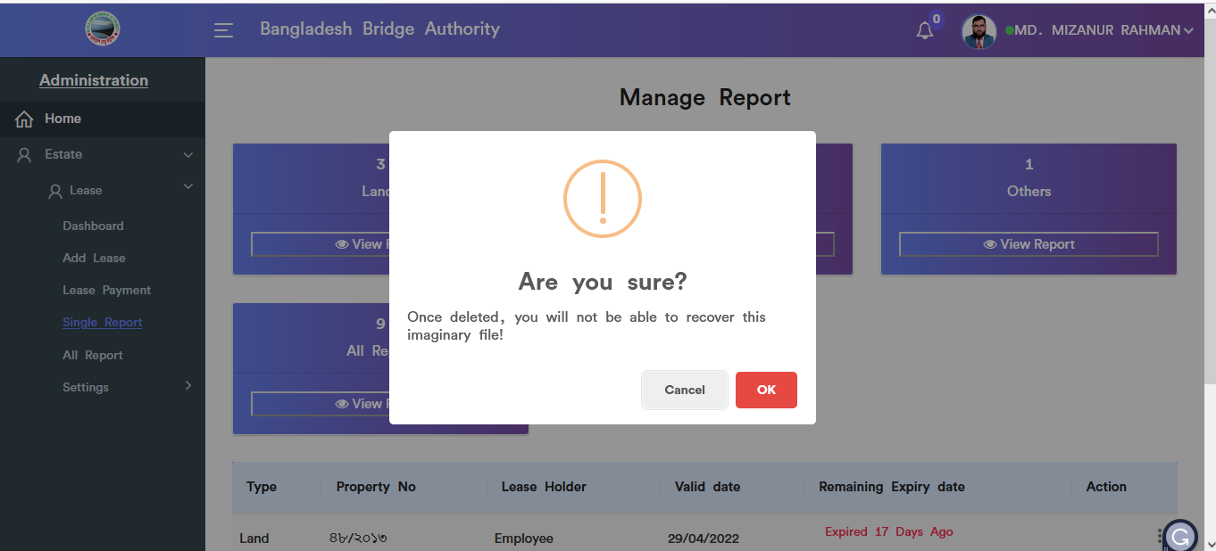

Figure 4.3.2.3.: view of lands report(delete)

### 4..3.3: (Single Report) View of ponds report

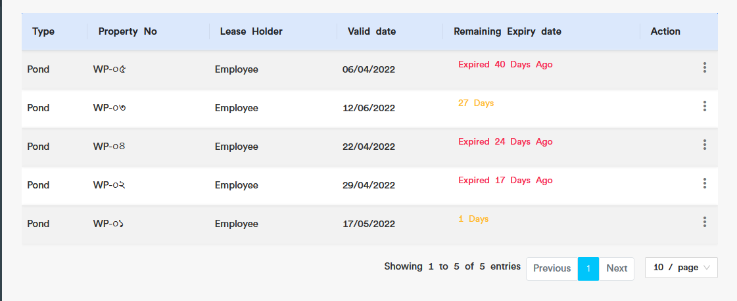

Figure 4.3.3.: view of ponds report

### 4..3.3.1: (Single Report) View of ponds report(Details)

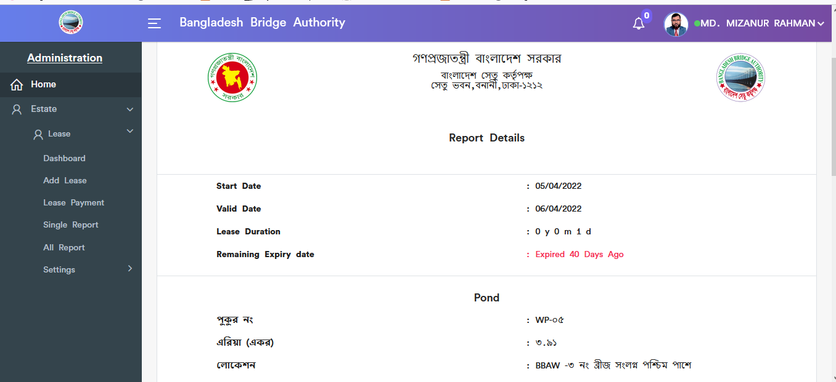

Figure 4.3.3.1: view of ponds report(details)

### 4..3.3.2: (Single Report) View of ponds report(Update)



Figure 4.3.3.2: view of ponds report(Update)

### 4..3.3.3: (Single Report) View of ponds report(Delete)

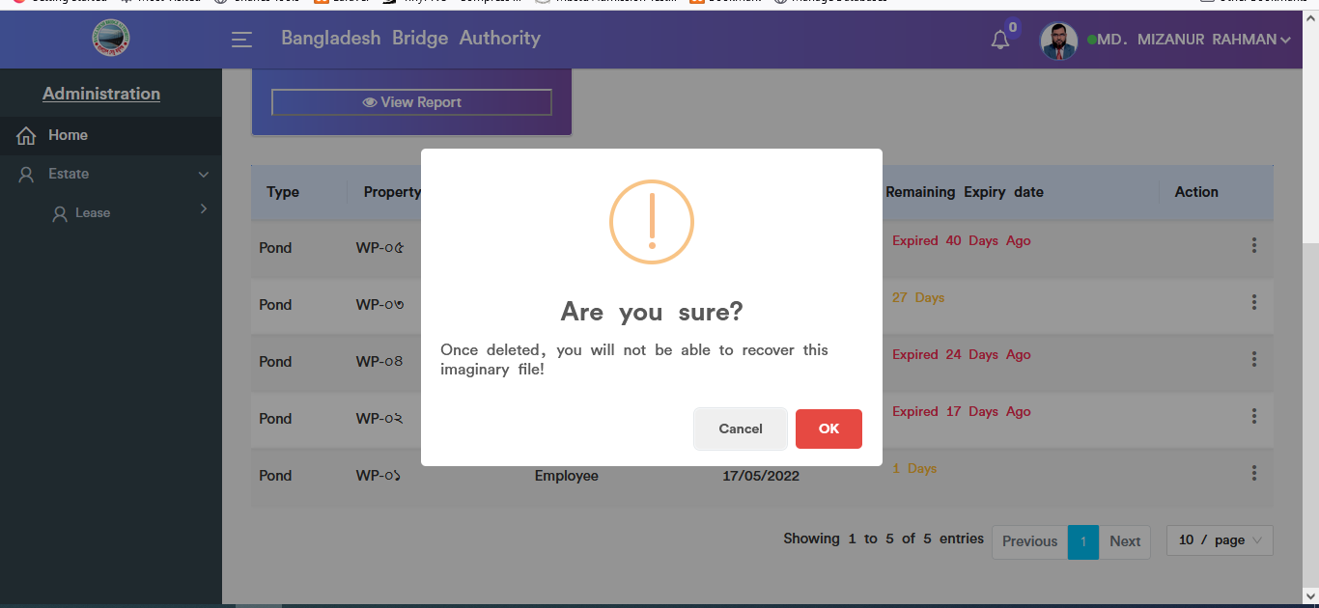

Figure 4.3.3.3: (single report) view of ponds report(delete)

### 4.3.4: (Single Report) View of others report

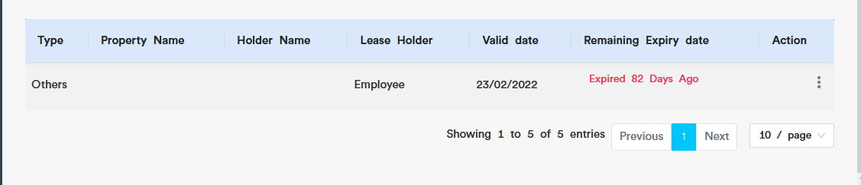

Figure 4.3.4: view of others report

### 4.3.4.1: (Single Report) View of others report(Details)

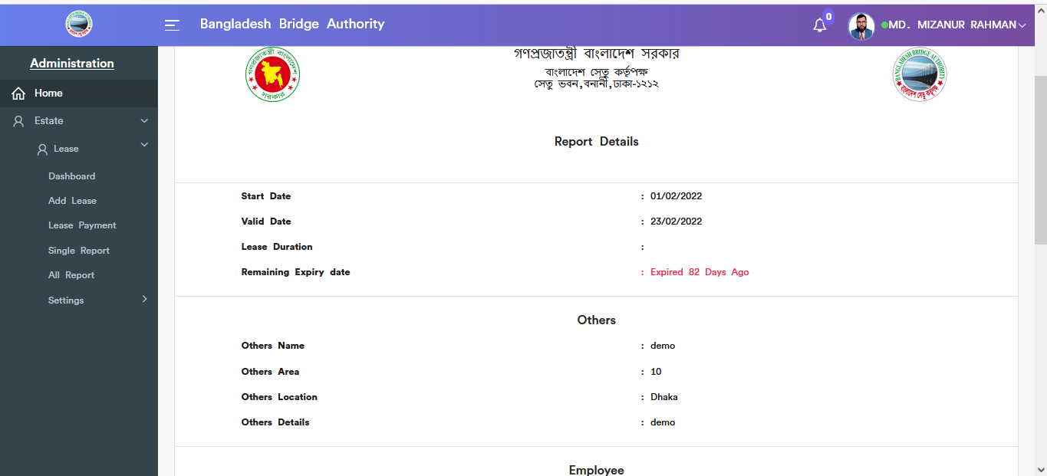

Figure 4.3.4.1: view of others report(details)

### 4.3.4.2: (Single Report) View of others report(Update)



Figure 4.3.4.2: view of others report(update)

### 4.3.4.3: (Single Report) View of others report(Delete)

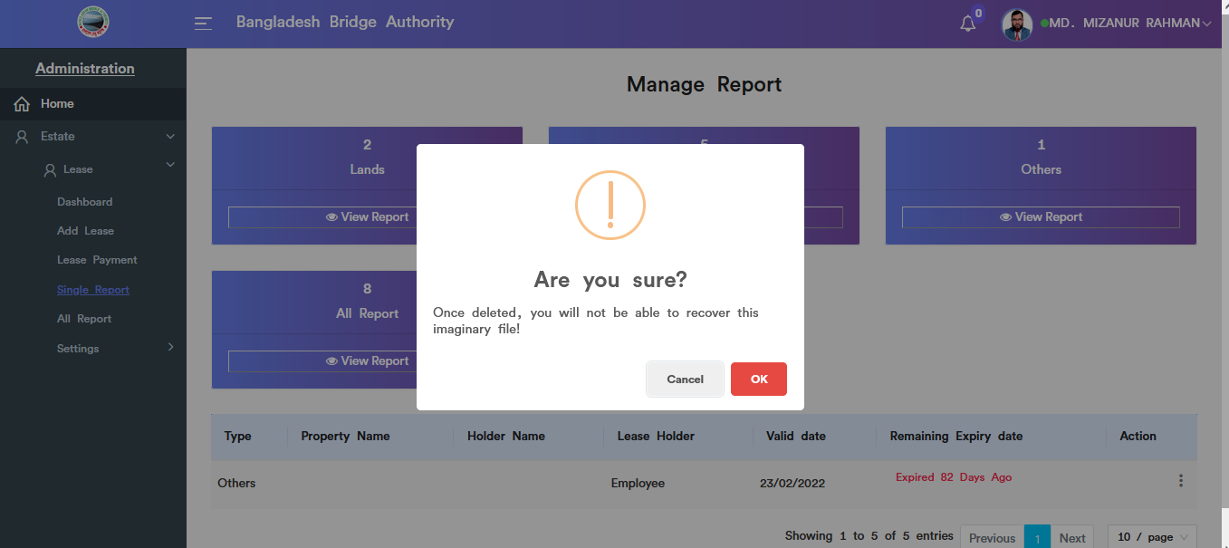

Figure 4.3.4.3: view of others report(delete)

### 4.3.5: (Single Report) View of all report

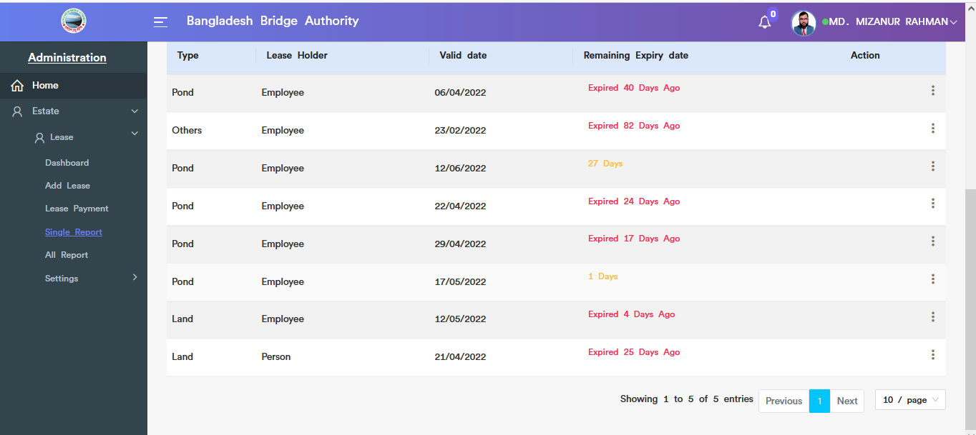

Figure 4.3.5: view of all report

### 4.3.5.1: (Single Report) View of all report(Delete)

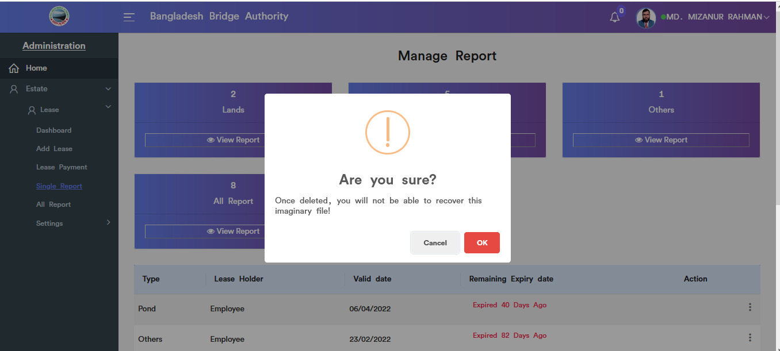

Figure 4.3.5.1: view of all report(delete)

## 4.4: All Report Menu Overview (Same as Single report……Incomplete)

## 4.5: Settings Menu Overview

**Overview of Settings**

### 4.5.1.1: Add Pond (Settings) add new pond input field

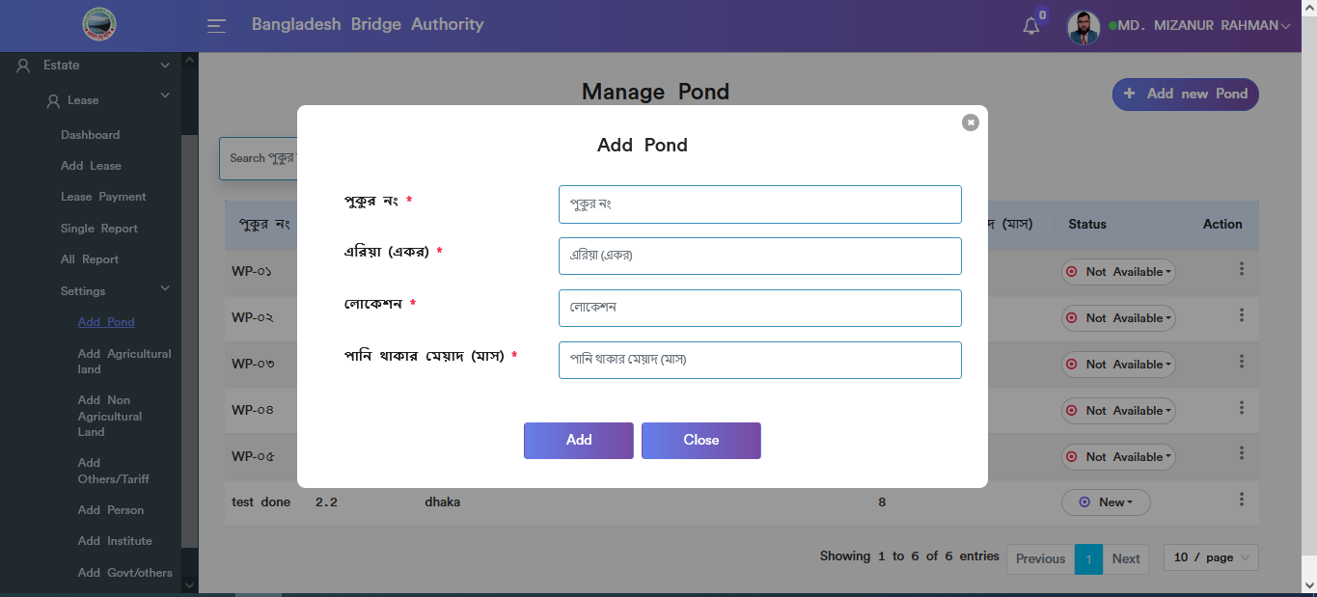

Figure 4.5.1.1: add new pond input field

### 4.5.1.2: Add Pond (Settings) view details of add new pond

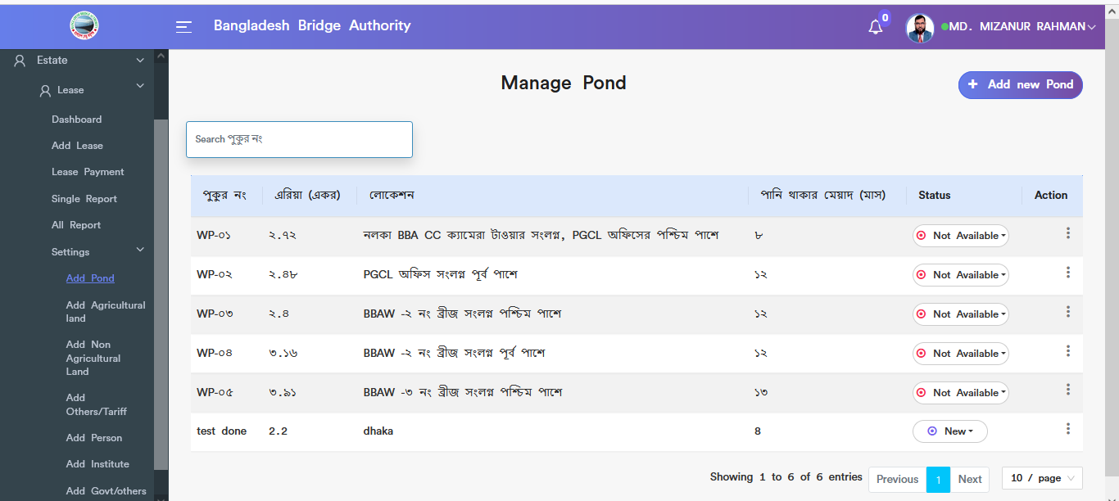

Figure 4.5.1.2: view details of add new pond

### 4.5.1.3: Add Pond (Settings) Update

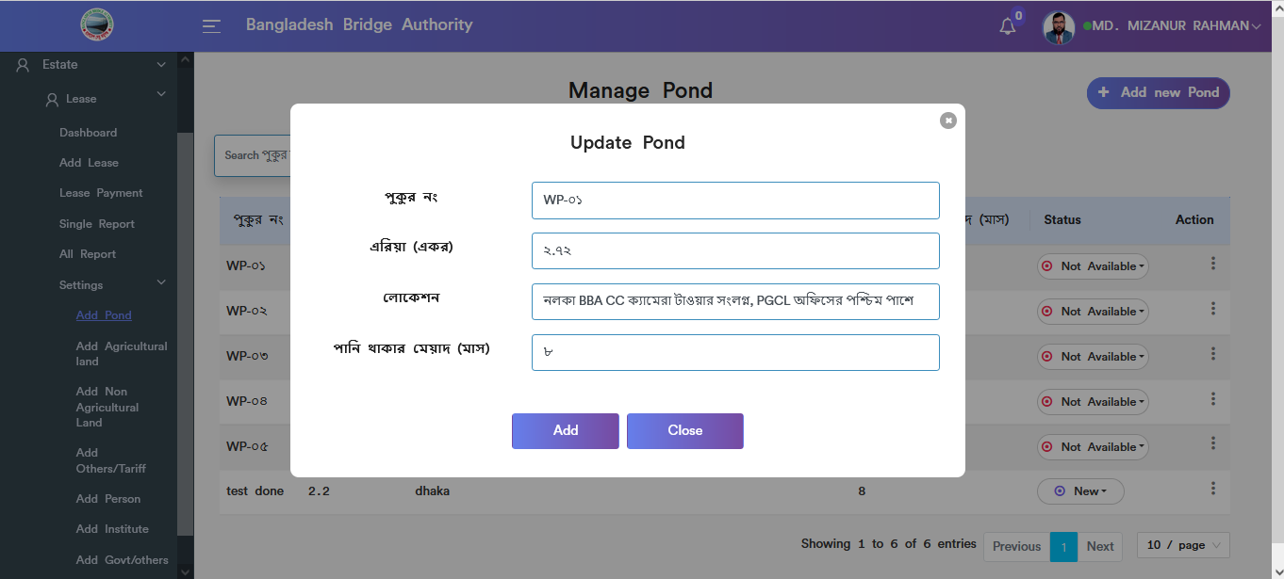

Figure 4.5.1.3: pond update input field

### 4.5.1.4: Add Pond (Settings) Delete

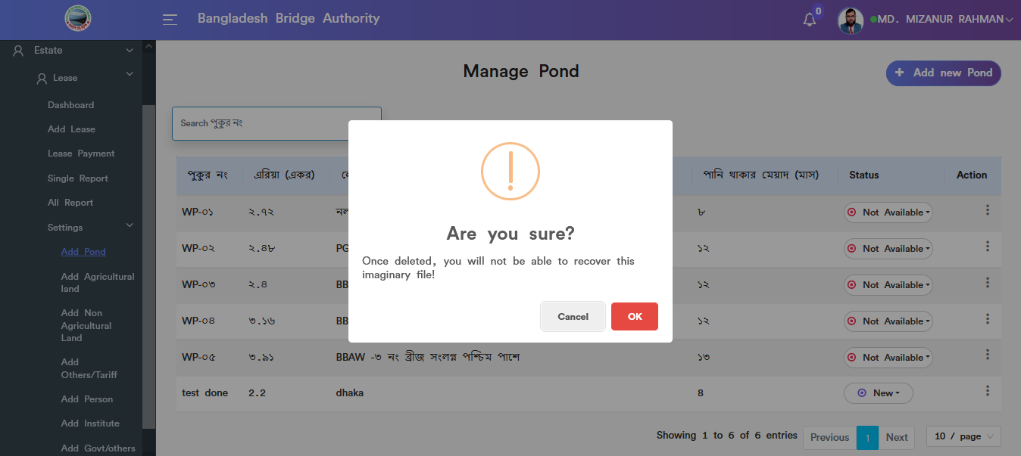

Figure 4.5.1.4: pond data Delete

### 4.5.1.5: Add Pond (Settings) Search

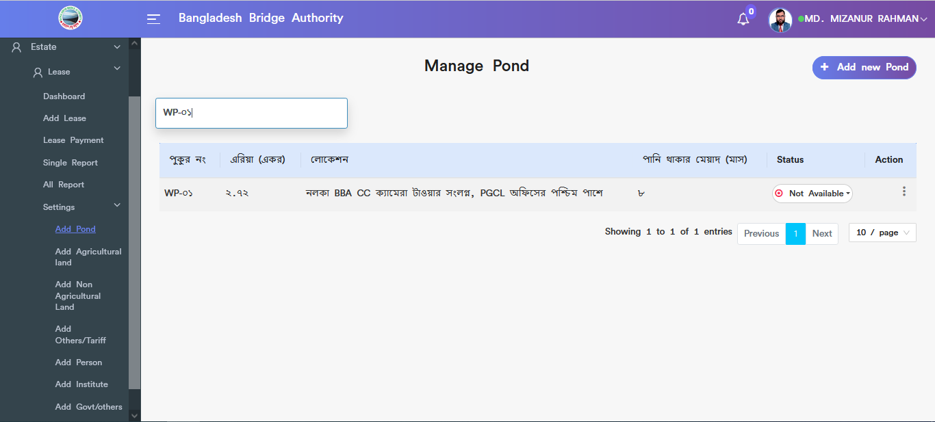

Figure 4.5.1.5: pond data Search

### 4.5.2.1: Add Agriculture land (Settings) add new agriculture land input field

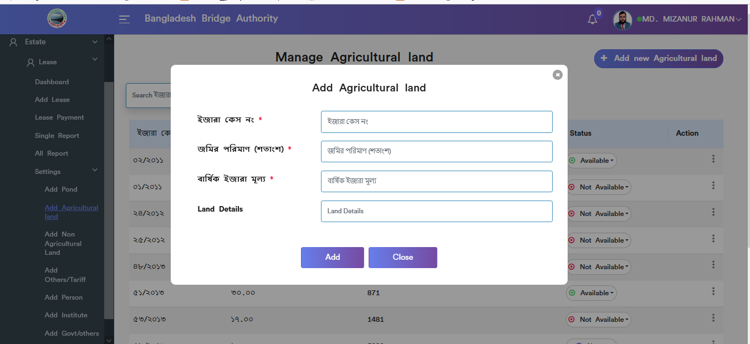

Figure 4.5.2.1: add new agriculture land input field

### 4.5.2.2: Add Agriculture land (Settings) view details of agriculture land

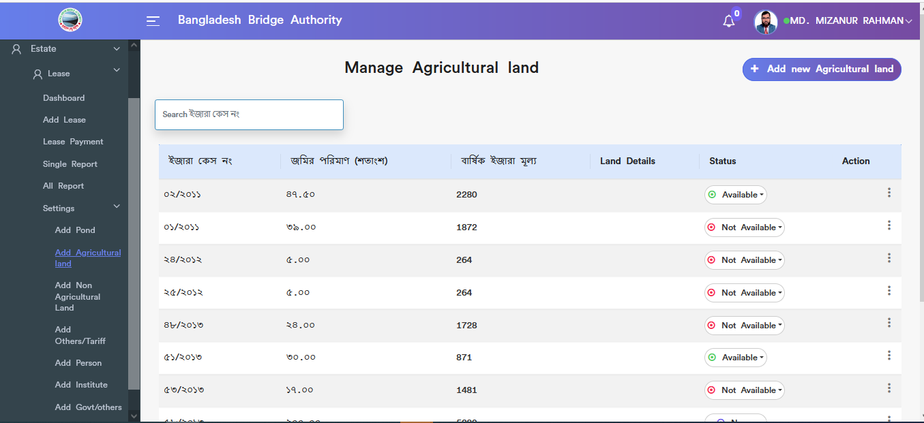

Figure 4.5.2.2: view details of agriculture land

### 4.5.2.3: Add Agriculture land (Settings) Update

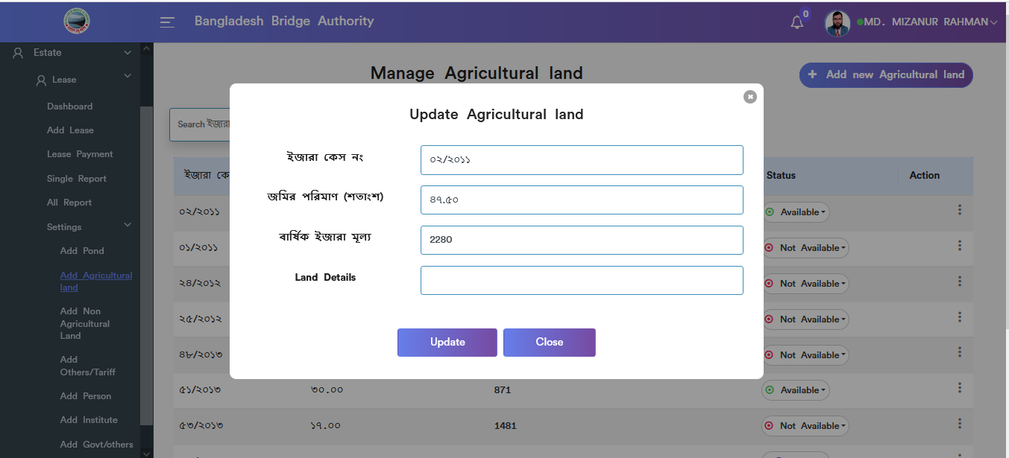

Figure 4.5.2.3: agriculture land update input field

### 4.5.2.4: Add Agriculture land (Settings) Delete

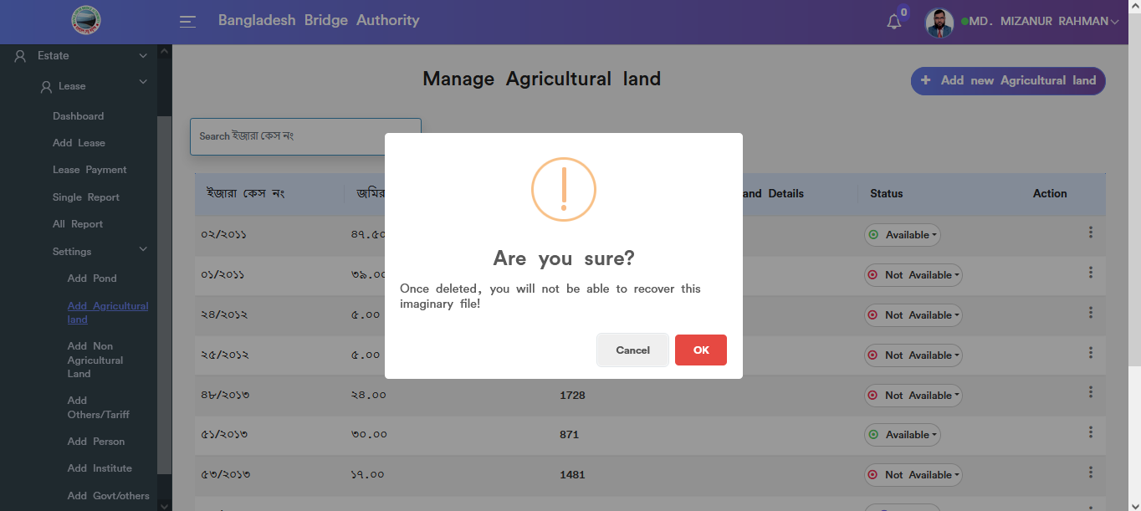

Figure 4.5.2.4: agriculture land data Delete

### 4.5.2.5: Add Agriculture land (Settings) Search

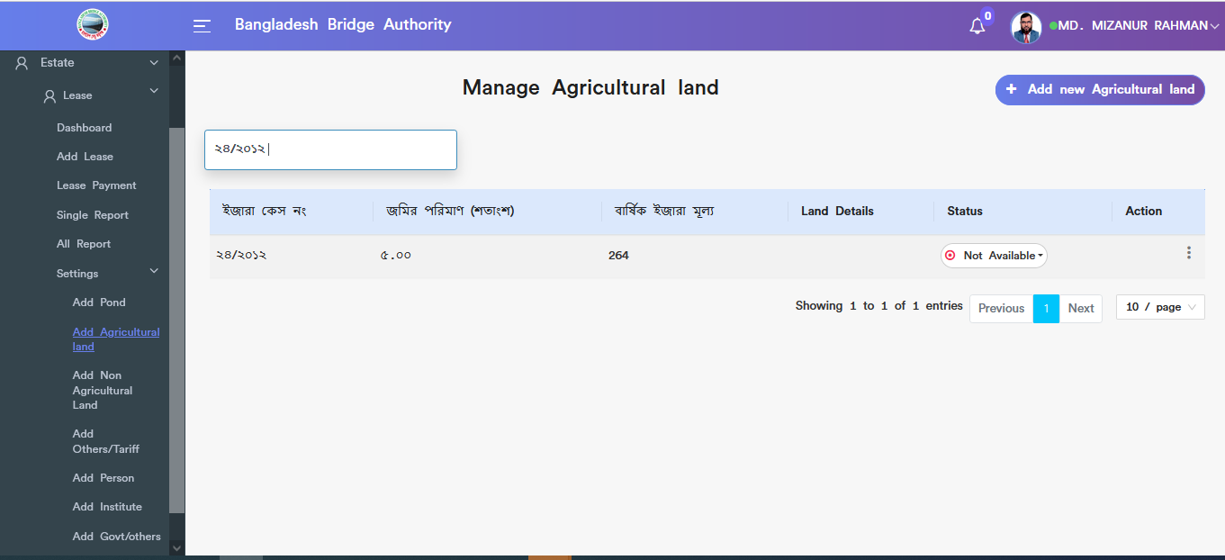

Figure 4.5.2.5: agriculture land data Search

### 4.5.3.1: Add Non-Agriculture land (Settings) Add nonagriculture land input field

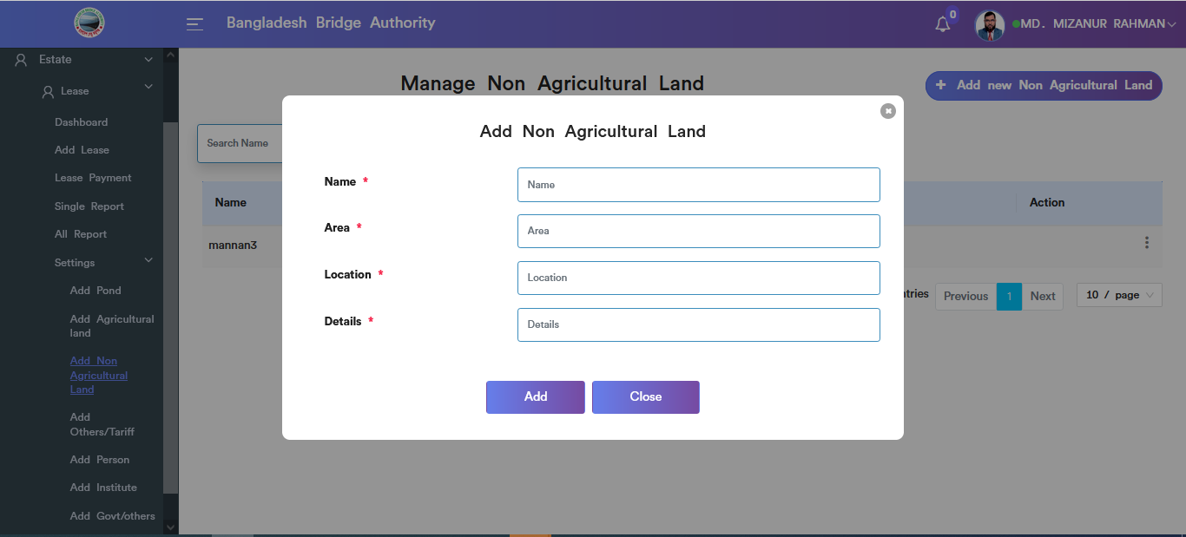

Figure 4.5.3.1: add non agriculture land input field

### 4.5.3.2: Add Non Agriculture land (Settings) View details of non agriculture land

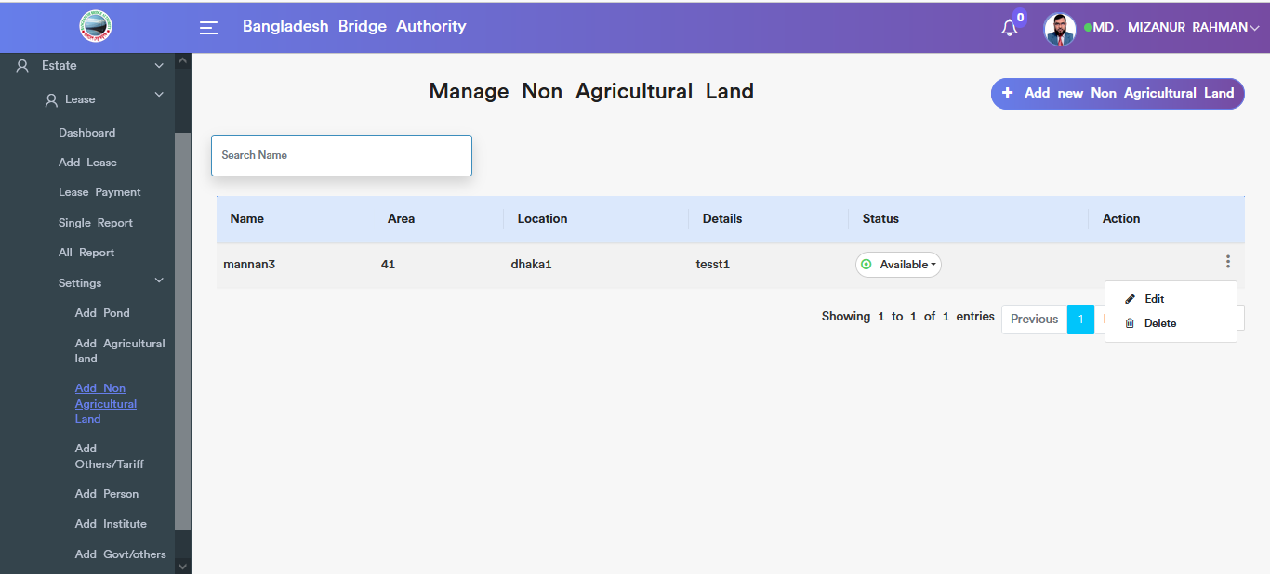

Figure 4.5.3.2: view details of non agriculture land information

### 4.5.3.3: Add Non Agriculture land (Settings) Update

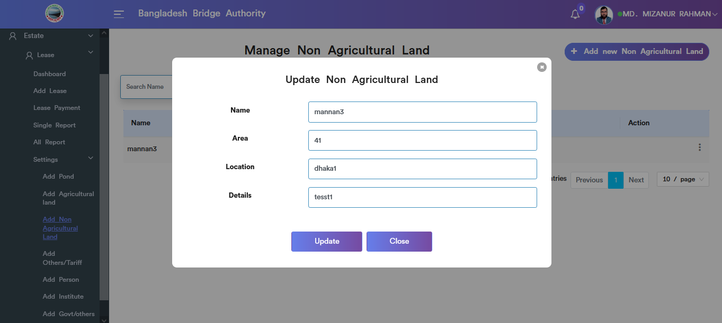

Figure 4.5.3.3: Add non agriculture land Update input field

### 4.5.3.4: Add Non Agriculture land (Settings) Delete

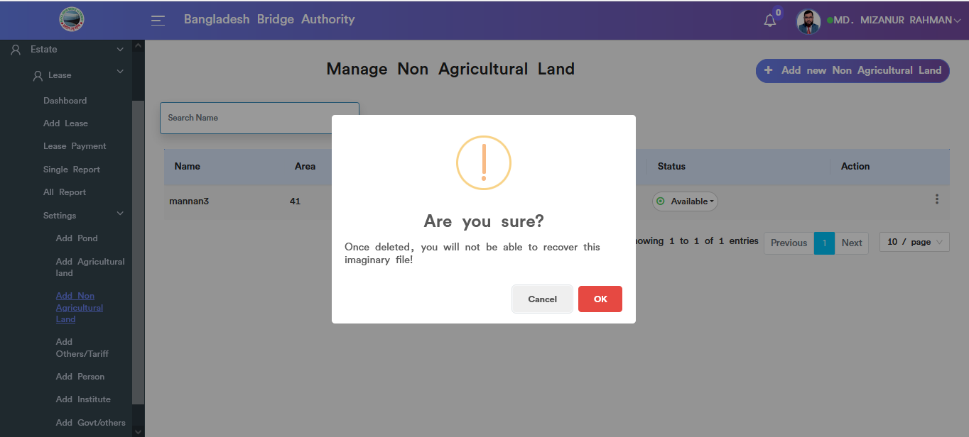

Figure 4.5.3.4: Add non agriculture land (settings) Delete

### 4.5.3.5:Add Non Agriculture land (Settings) Search

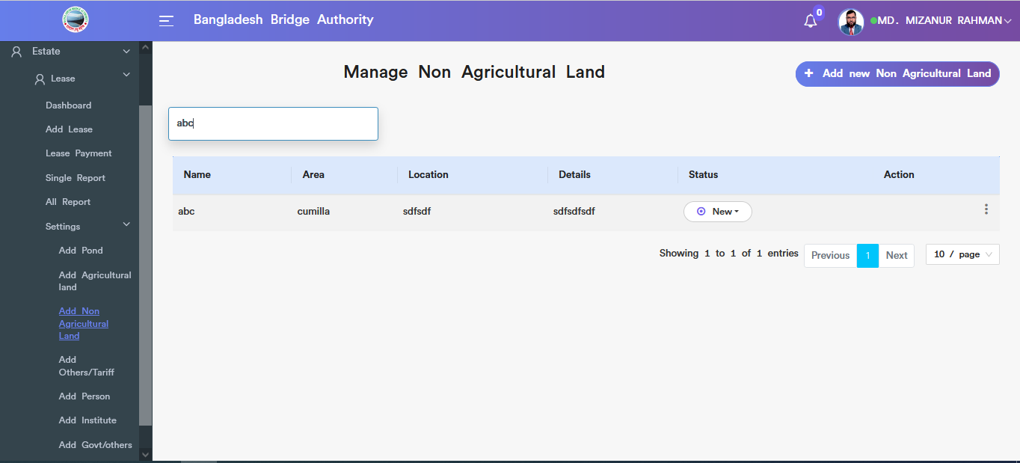

Figure 4.5.3.5: Add non agriculture land (settings) Search

### 4.5.4.1: Add Others/Tariff (Settings) Add new others/tariff input field

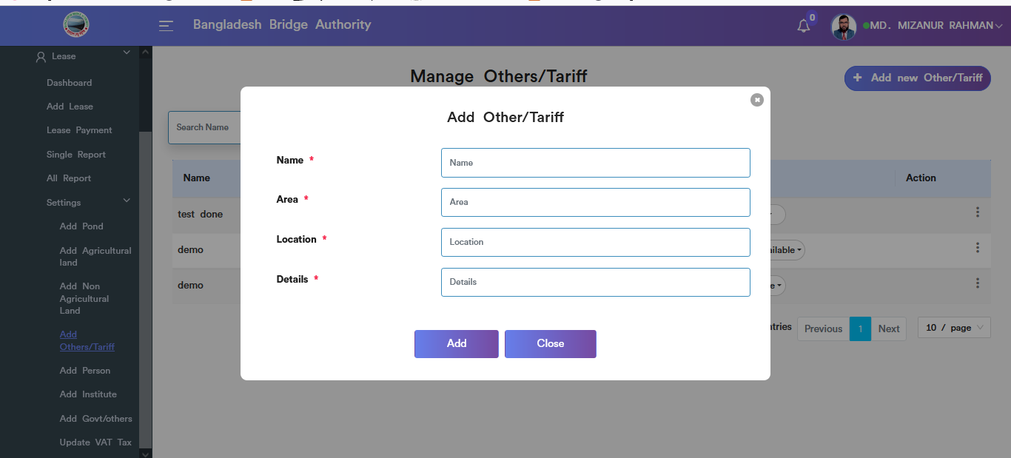

Figure 4.5.4.1: add new others/tariff input field

### 4.5.4.2: Add Others/Tariff (Settings) view details others/tariff

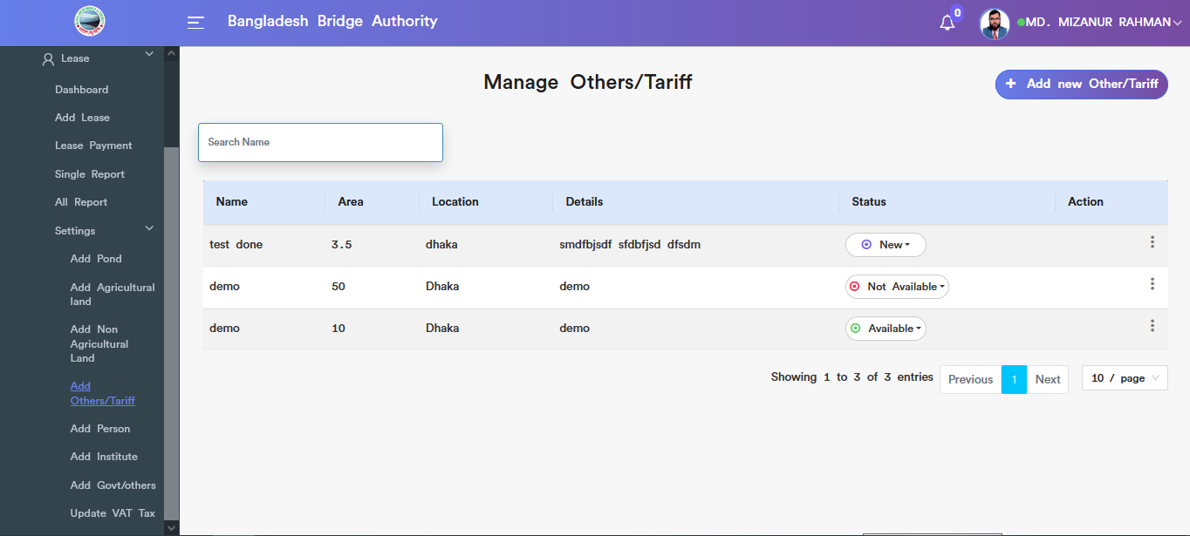

Figure 4.5.4.2: view details of others/tariff

### 4.5.4.3: Add Others/Tariff (Settings) update

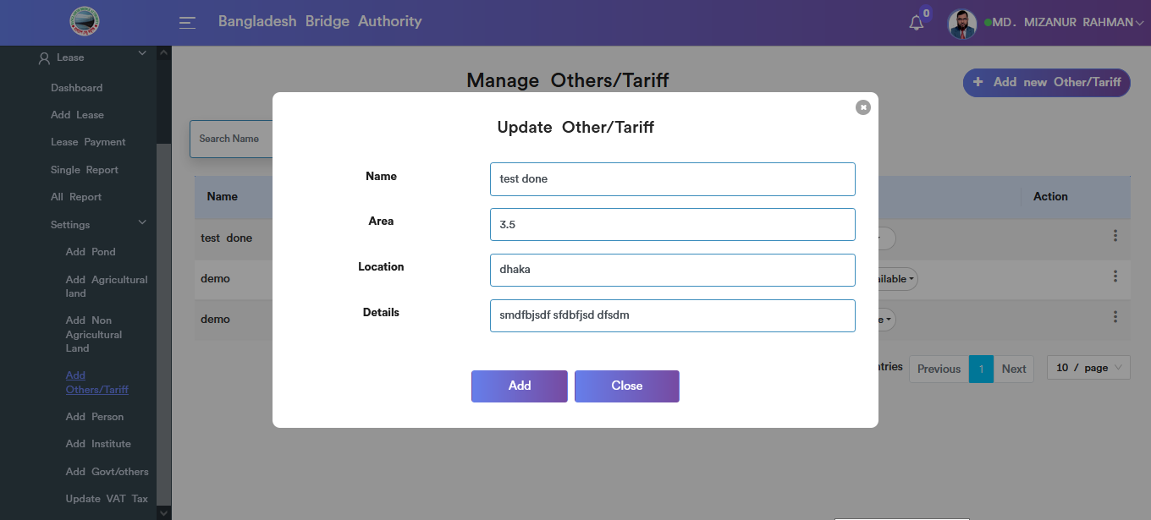

Figure 4.5.4.3: Add Other/tariff Data update input field

### 4.5.4.4: Add Others/Tariff (Settings) Delete

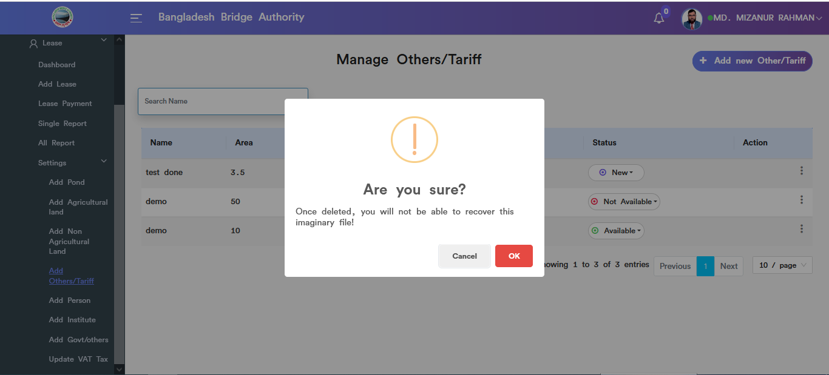

Figure 4.5.4.4: Other/tariff data Delete

### 4.5.4.5: Add Others/Tariff (Settings) Search

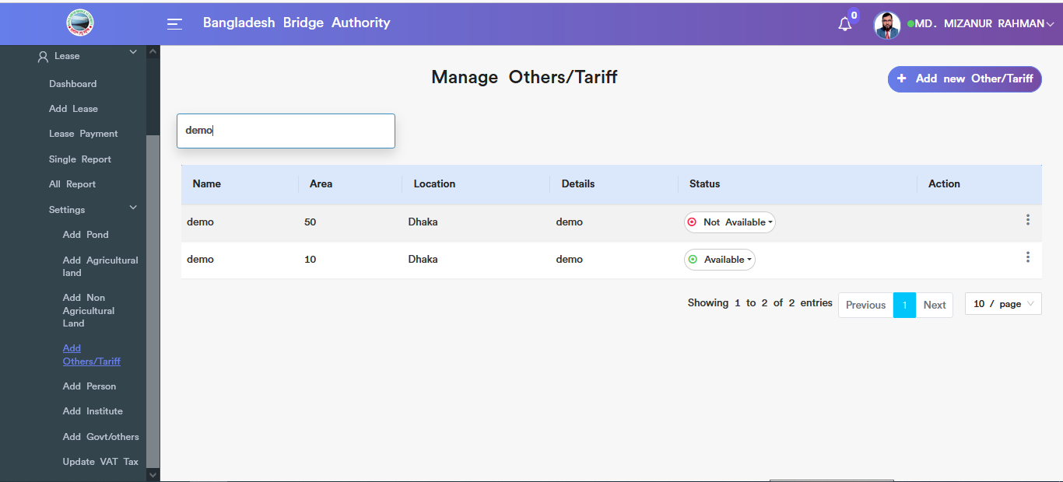

Figure 4.5.4.5: Other/tariff data search

### 4.5.5.1: Add Person (Settings) Add person input field

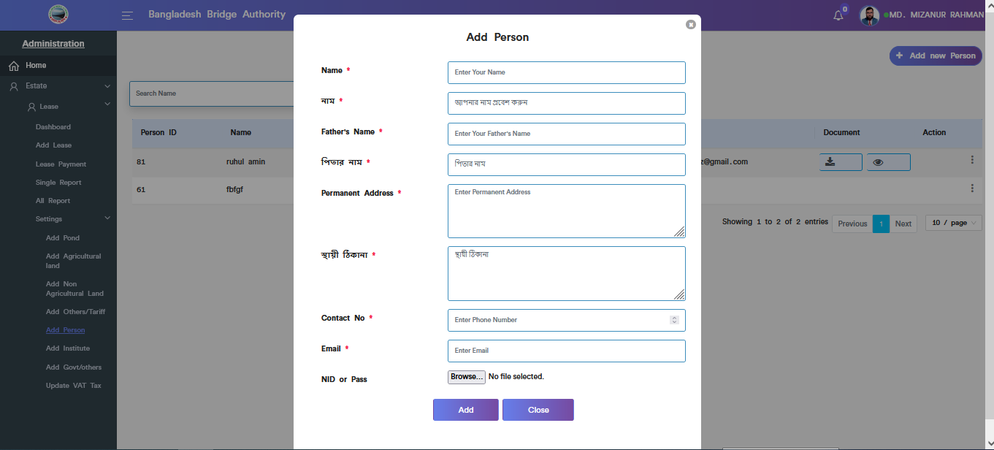

Figure 4.5.5.1: add person input field

### 4.5.5.2: Add Person (Settings) view of add person details

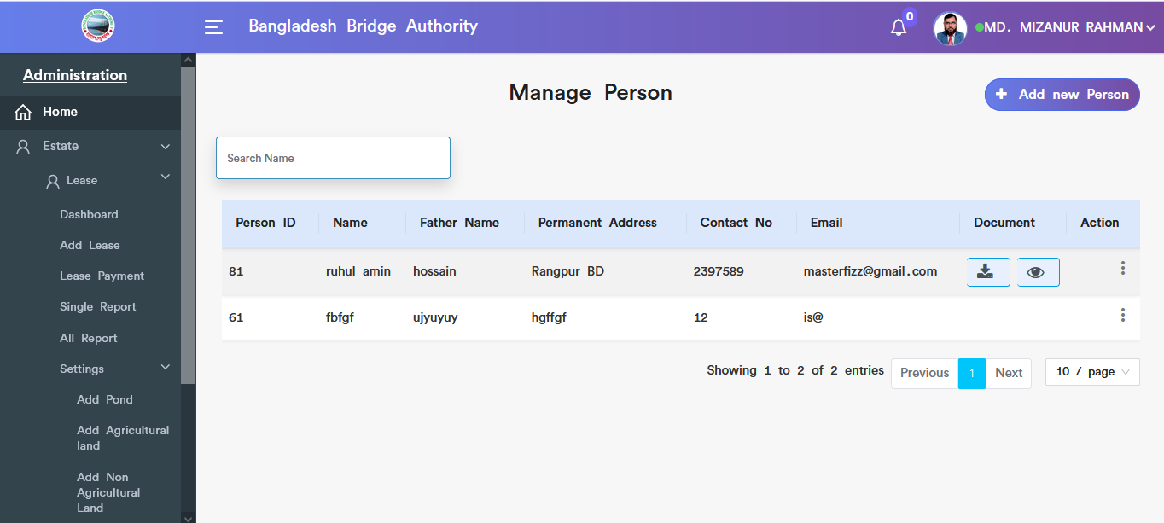

Figure 4.5.5.2: view of add person details

### 4.5.5.3: Add Person (Settings) view document

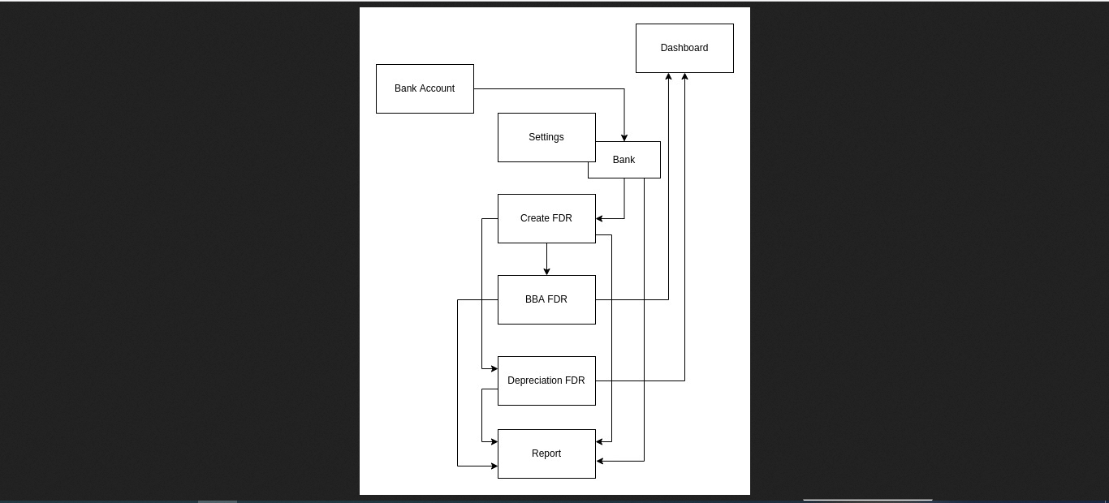

Figure 4.5.5.3: person’s view document

### 4.5.5.4: Add Person (Settings) Download document

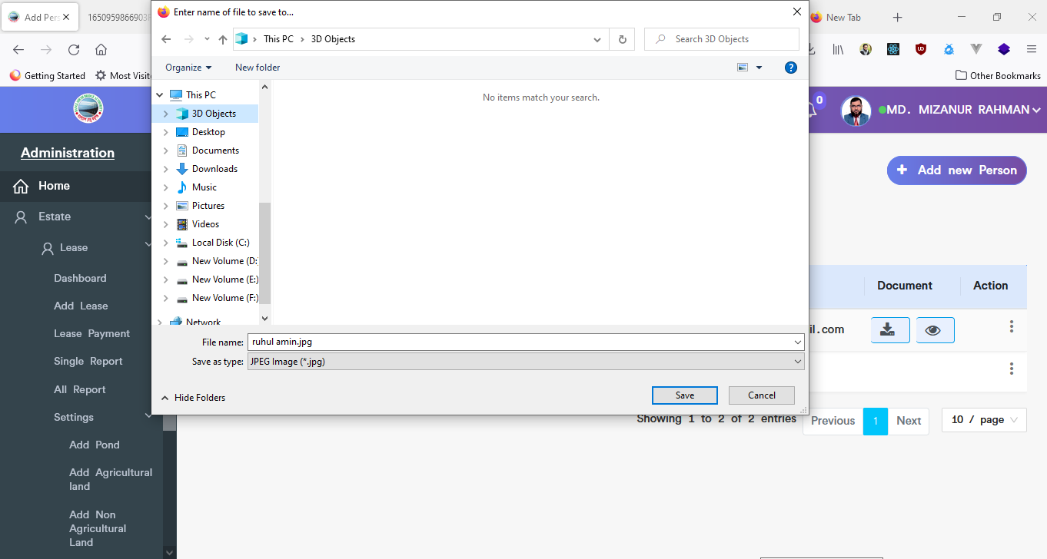

Figure 4.5.5.4: person’s download document

### 4.5.5.5: Add Person (Settings) Update

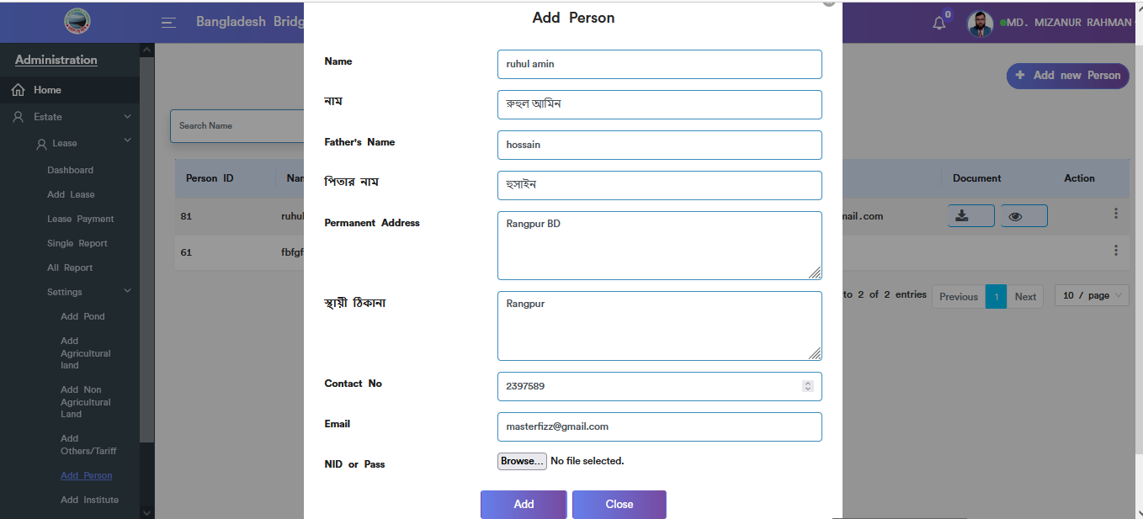

Figure 4.5.5.5: Add person (settings) update input field

### 4.5.5.6: Add Person (Settings) Delete

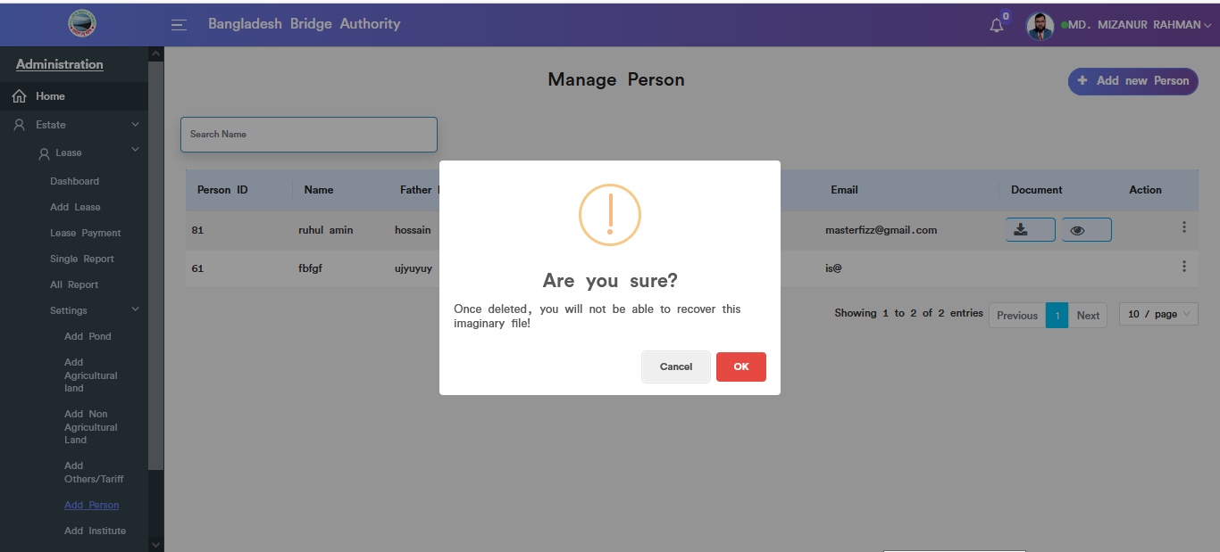

Figure 4.5.5.6: Add person (settings) Delete

### 4.5.5.7: Add Person (Settings) Search

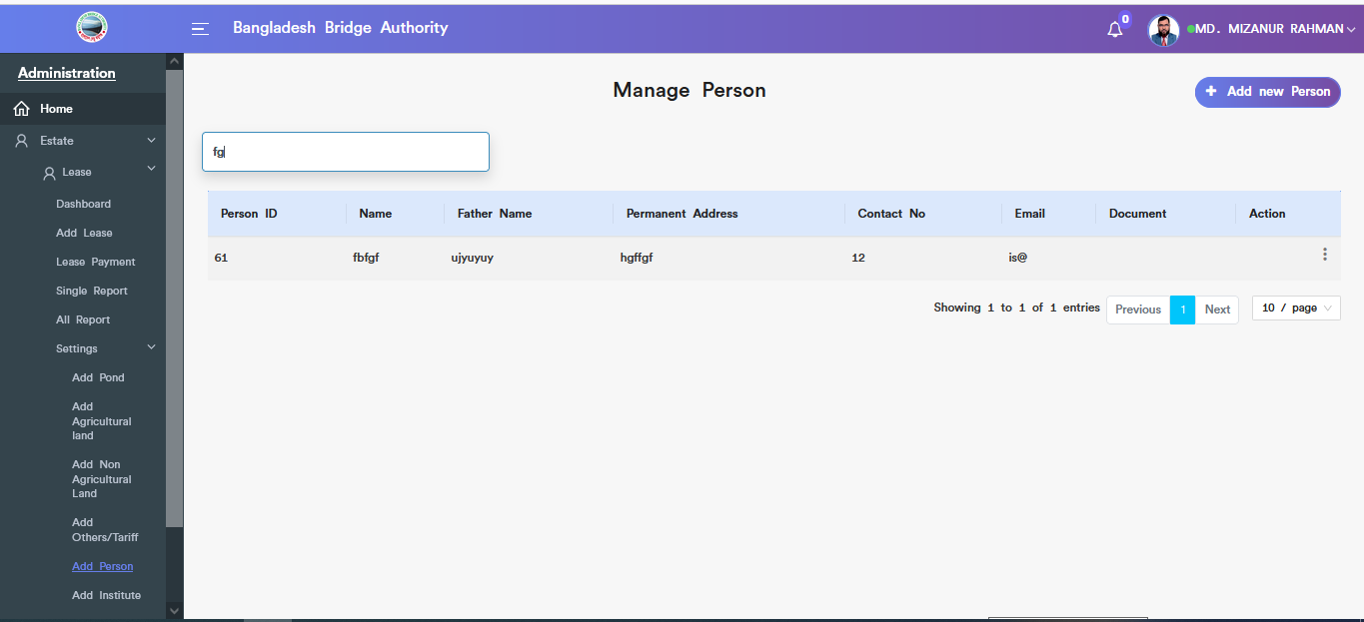

Figure 4.5.5.7: search person

### 4.5.6.1: Add Institute (Settings) add new institute input field

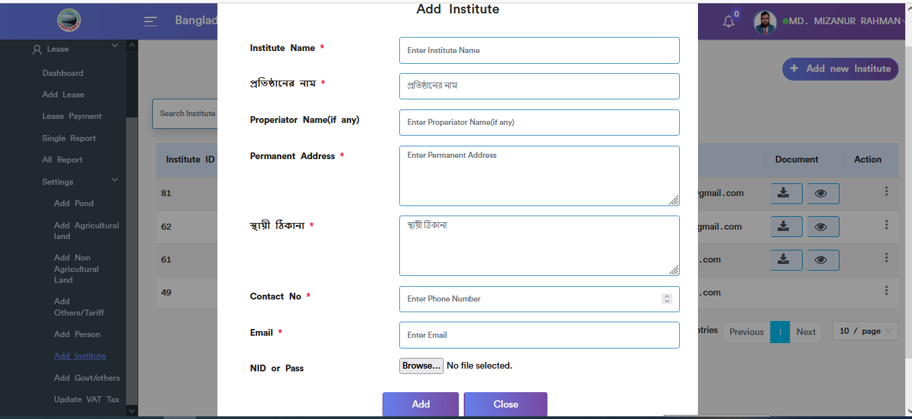

Figure 4.5.6.1: add institute input field

### 4.5.6.2: Add Institute (Settings) Add institute view details

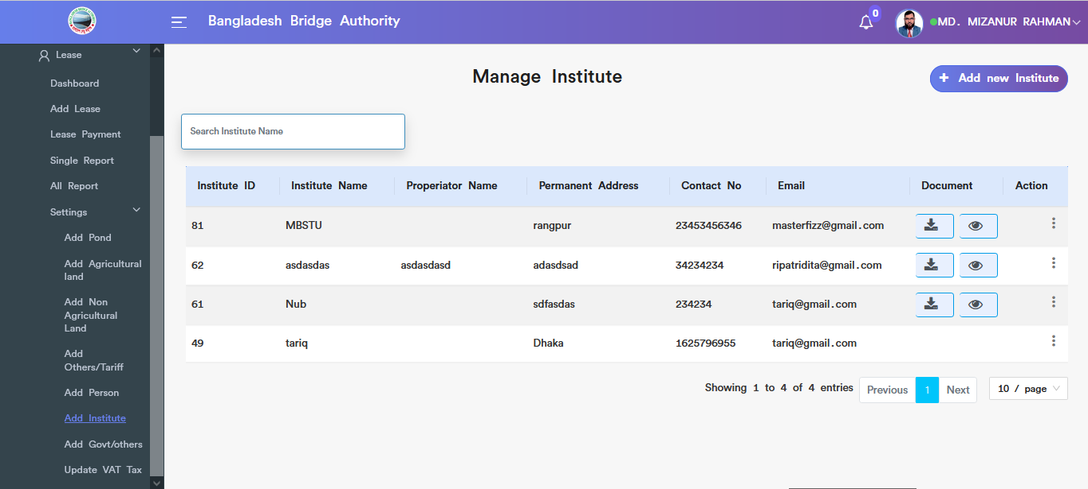

Figure 4.5.6.2: add institute view details

### 4.5.6.3: Add Institute (Settings) download document

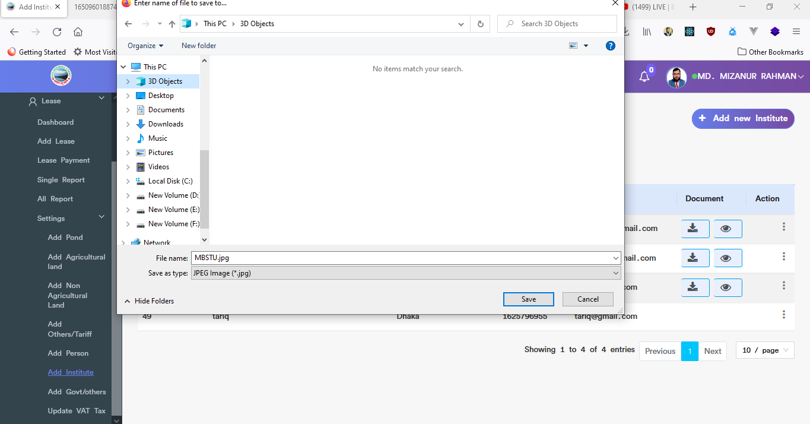

Figure 4.5.6.3: institute download document

### 4.5.6.4: Add Institute (Settings) view document

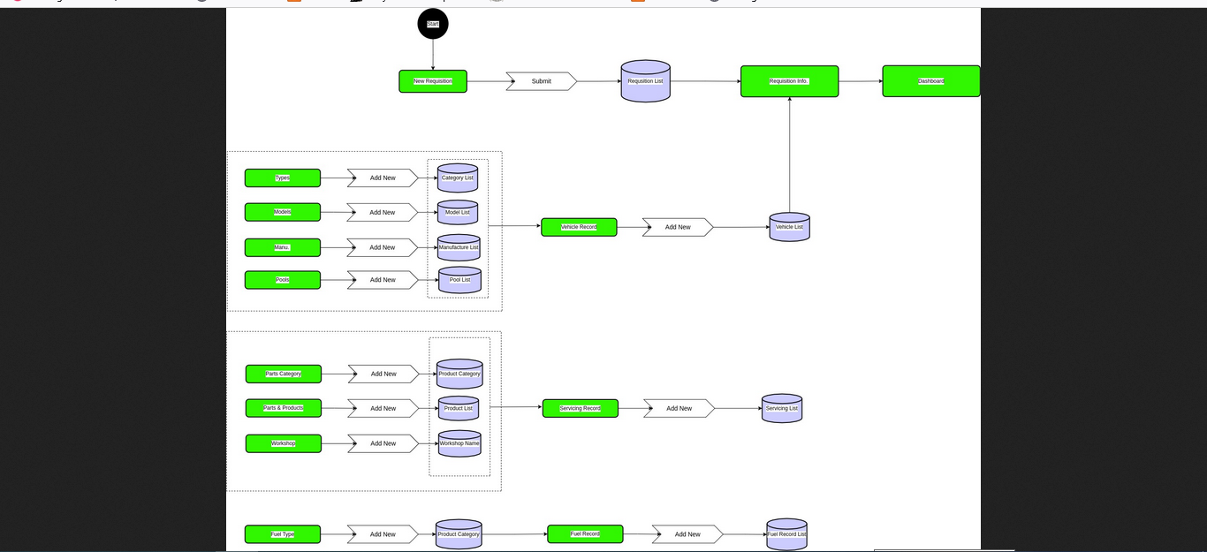

Figure 4.5.6.4: view institute document

### 4.5.6.5: Add Institute (Settings) Update

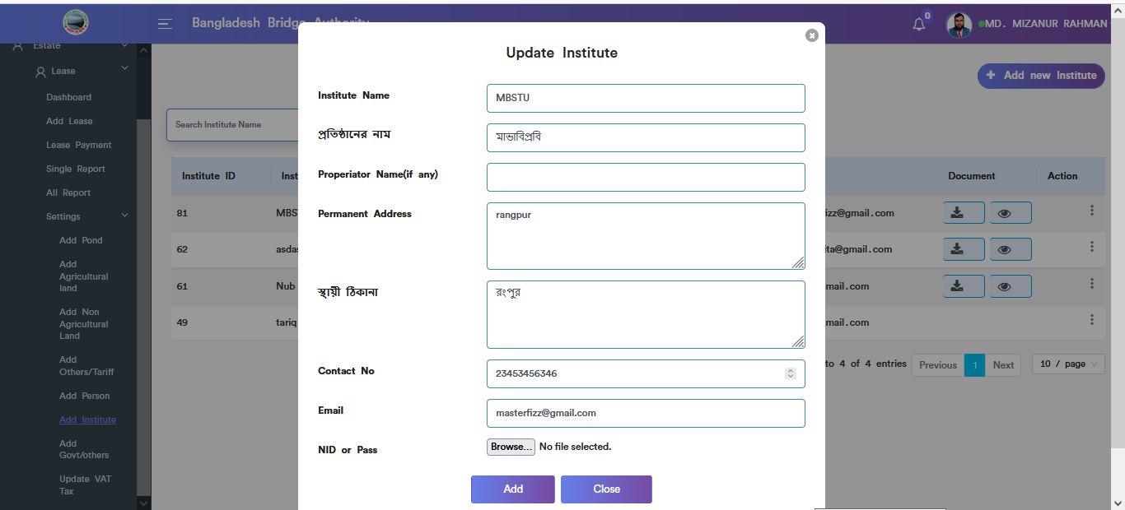

Figure 4.5.6.5: institute update input field

### 4.5.6.6: Add Institute (Settings) Delete

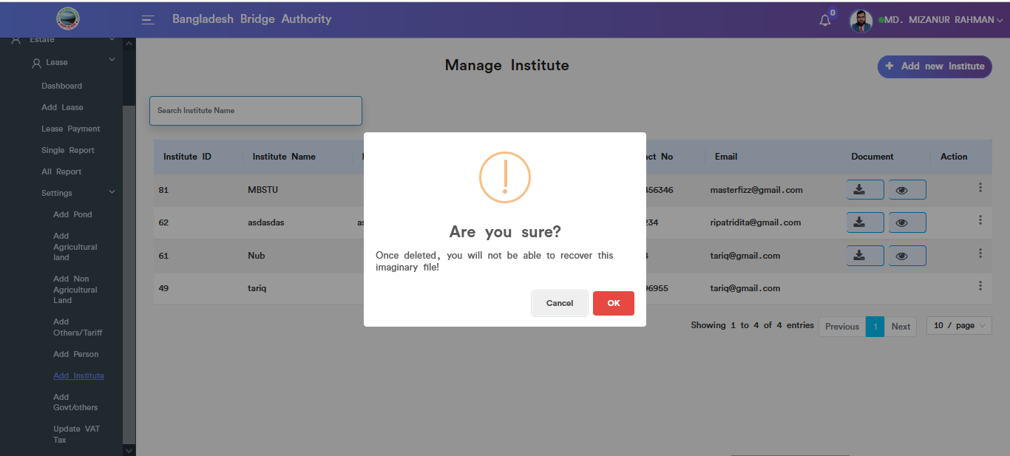

Figure 4.5.6.6: institute data delete

### 4.5.7.1: Add Govt/Others (Settings) add new govt/others input field

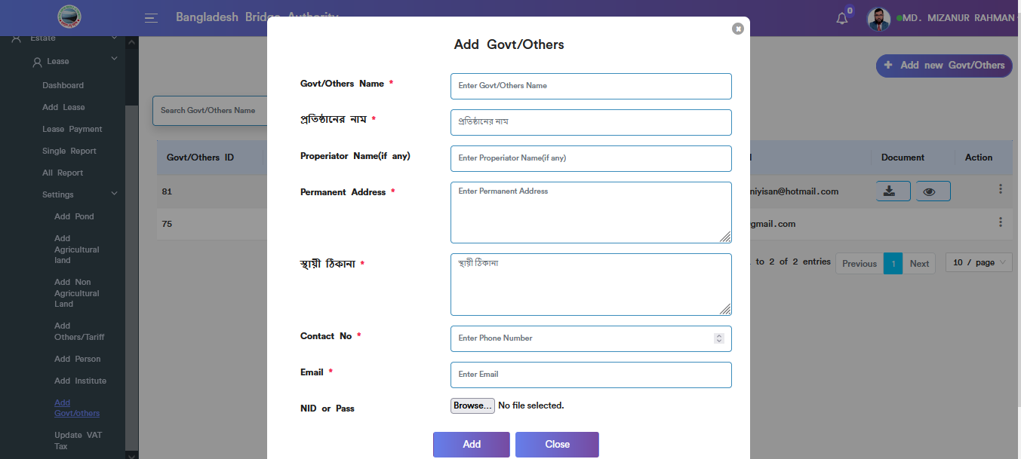

Figure 4.5.7.1: add new govt/others input field

### 4.5.7.2: Add Govt/Others (Settings) add govt/others view details

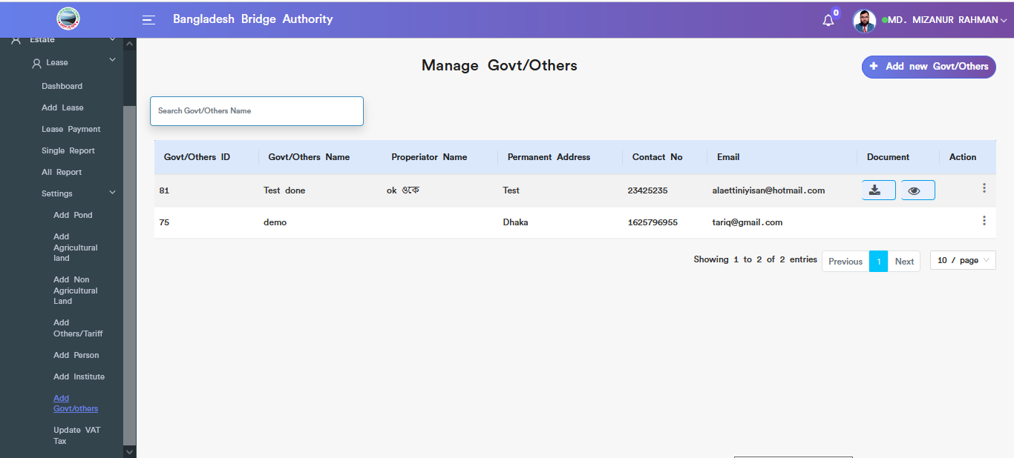

Figure 4.5.7.2: add govt/others view details

### 4.5.7.3: Add Govt/Others (Settings) download document

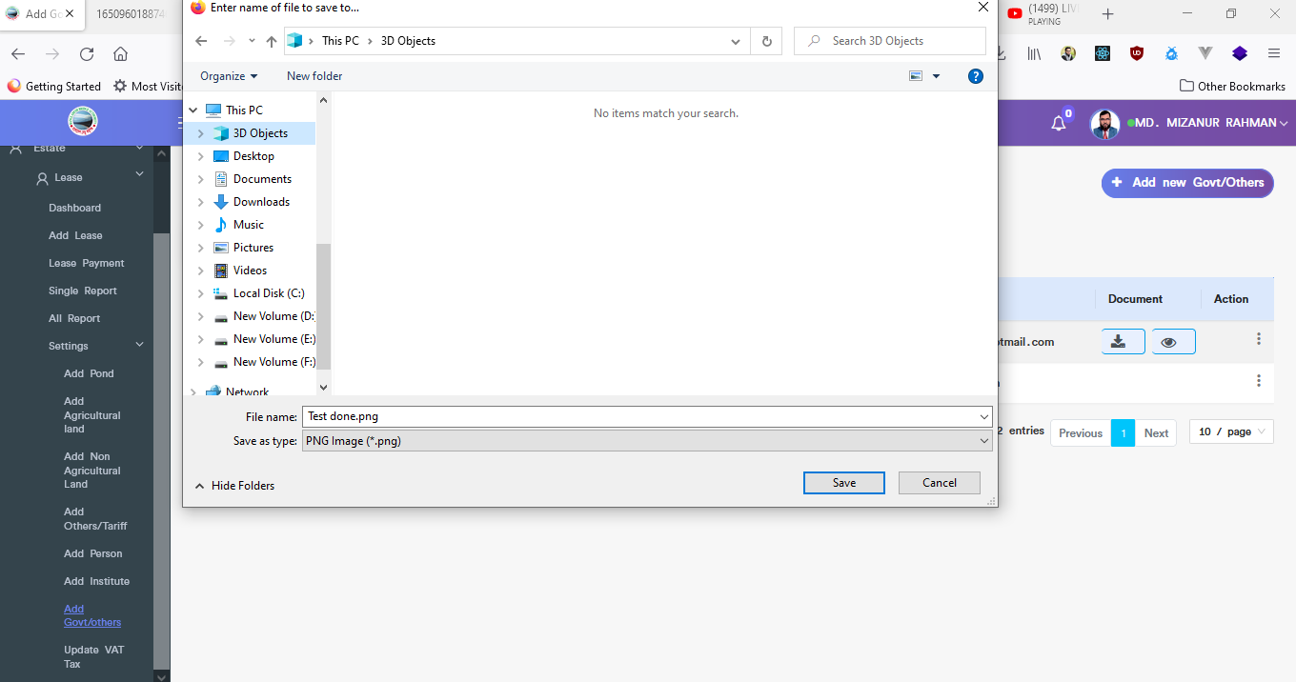

Figure 4.5.7.3: govt/others download document

### 4.5.7.4: Add Govt/Others (Settings) view document



Figure 4.5.7.4: govt/others view document

### 4.5.7.5: Add Govt/Others (Settings) Update

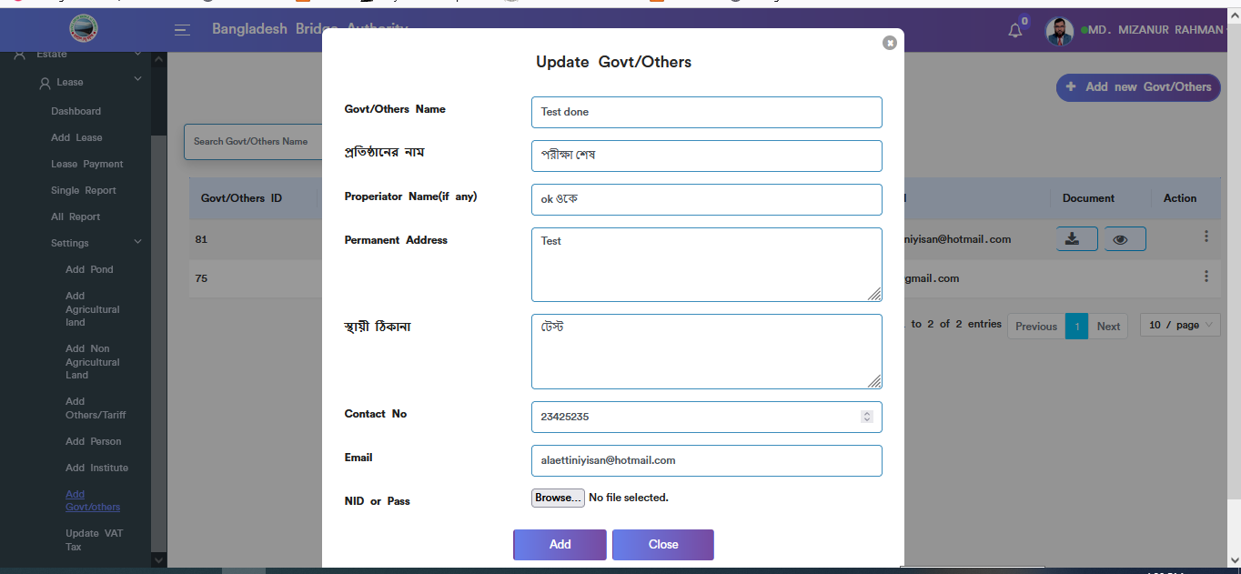

Figure 4.5.7.5: govt/others update input field

### 4.5.7.6: Add Govt/Others (Settings) Delete

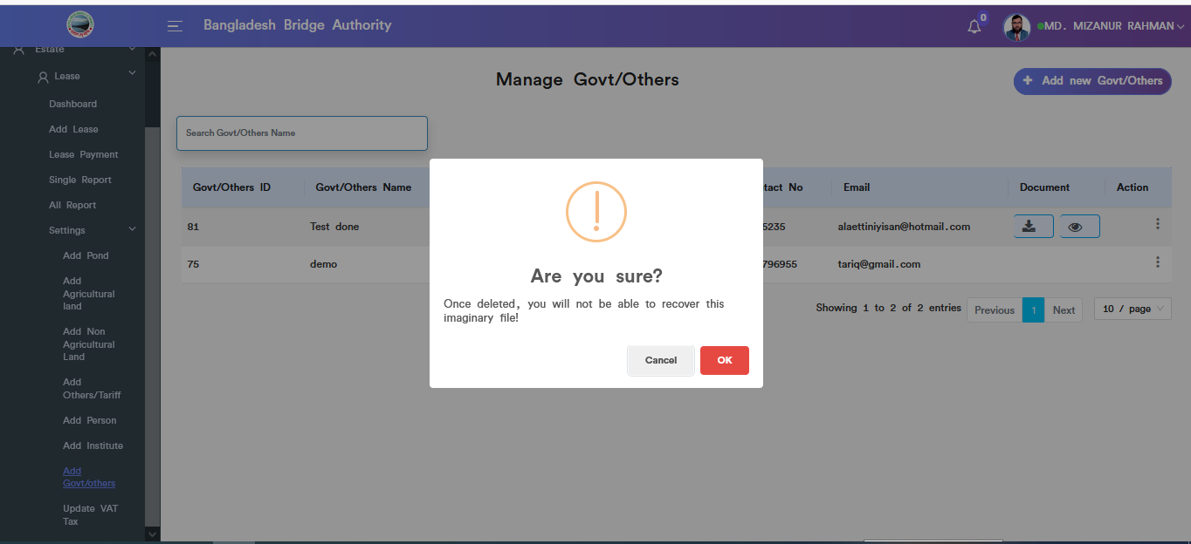

Figure 4.5.7.6: govt/others data delete

### 4.5.8.1: Update Vat/Tax (Settings) View details

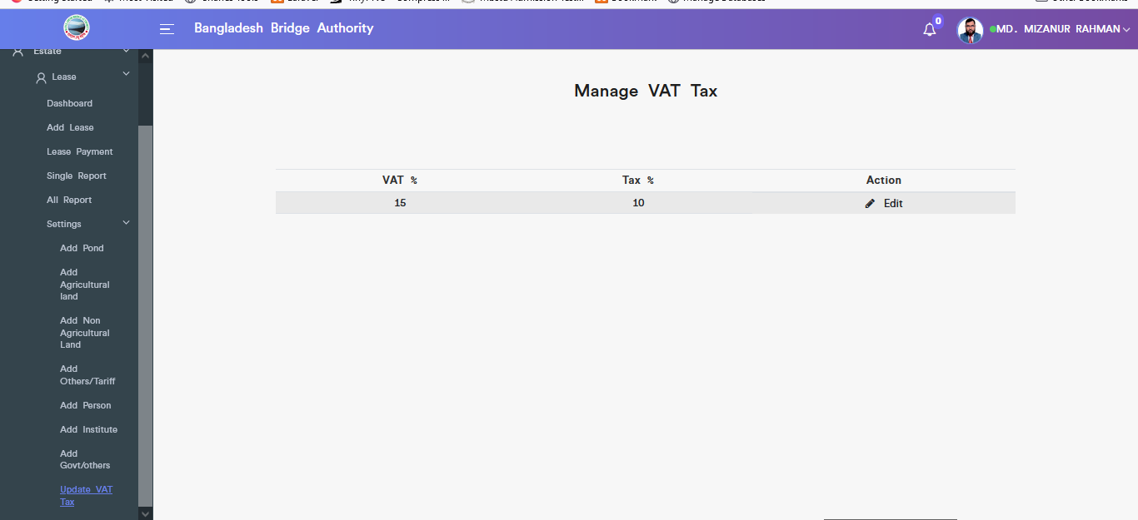

Figure 4.5.8.1: view details update vat tax

### 4.5.8.2: Update Vat/Tax (Settings) Update

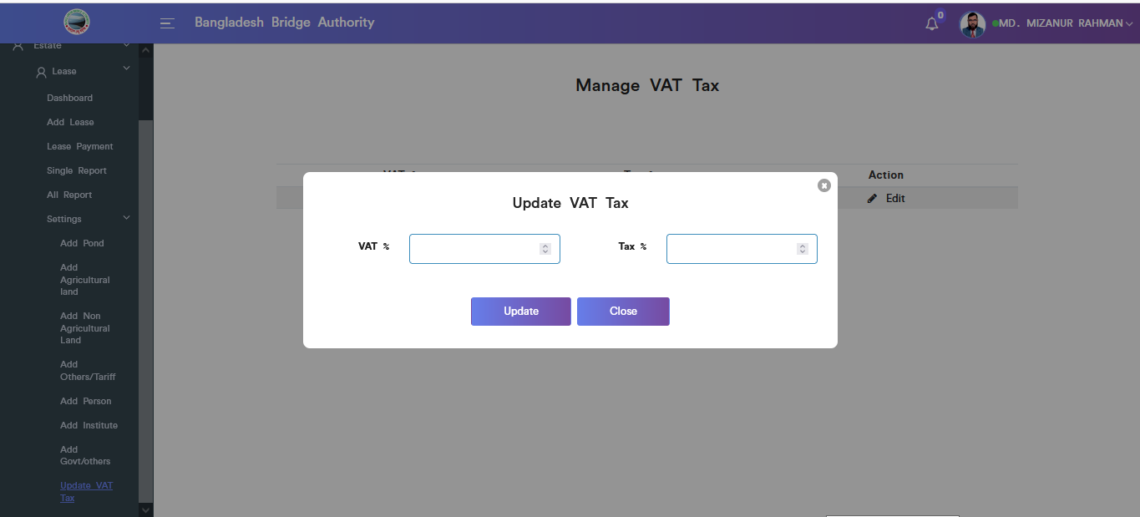

Figure 4.5.8.2: Update vat/tex (settings) update input field

# 5.TRANSPORT (SUB MODULE)

After clicking into Transport, it will redirect to the (Transport Sub Module) dashboard with some menus.

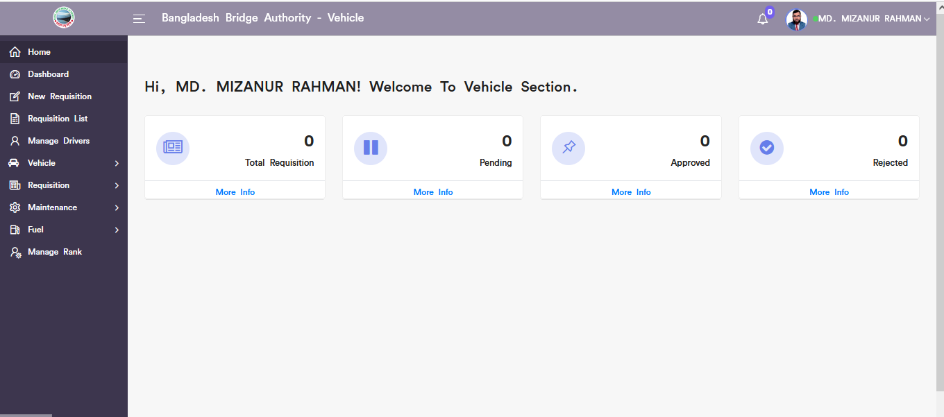

Figure 5: Dashboard of the transport (sub module).

There are four segments on the right side of the Transport Dashboard Such as **Total Requisition, Pending ,** **Approved,** And **Rejected.**

To get the details info about (**Total Requisition,Pending,Approved,Rejected**) just click on the view after that it will redirect to the relevant details info page.

# 6.TRANSPORT MENUS OVERVIEW

**Transport Menus Overview**

## 6.1: New Requisition Menu Overview

**Overview of New Requisition**

### 6.1.1: (New Requisition) Add new requisition input field

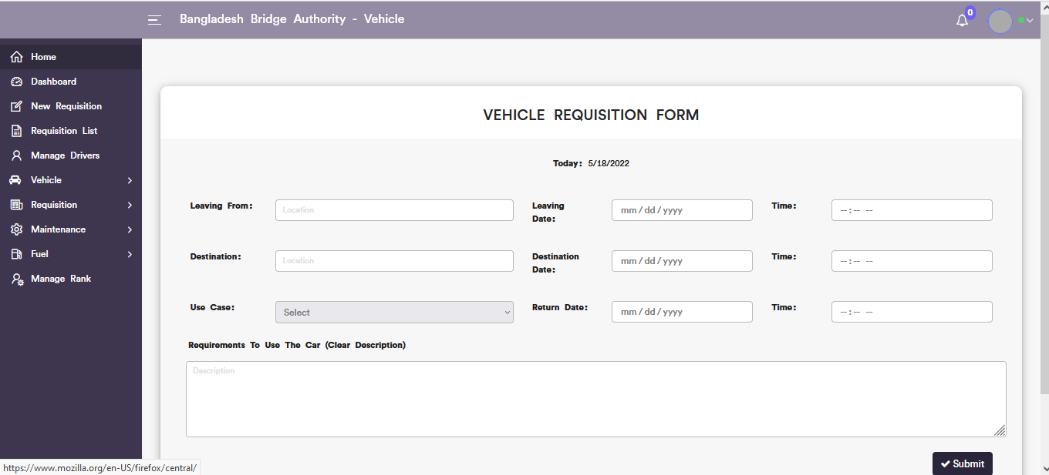

Figure 6.1.1: add new requisition input field

## 6.2: Requisition List Menu Overview

### 

### 6.2.1: ( Requisition List)View of Requisition List

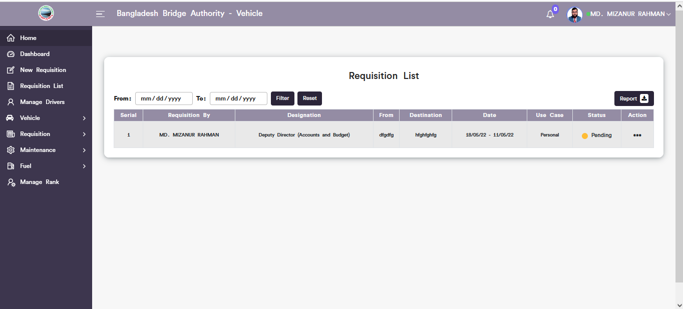

Figure 6.2.1: view of requisition list

### 6.2.2: ( Requisition List) Update

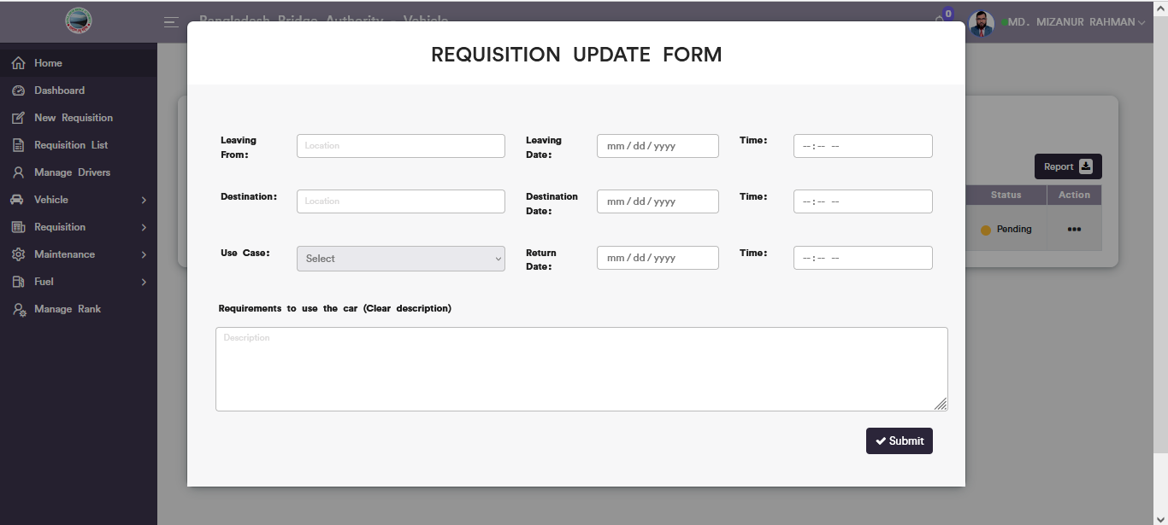

Figure 6.2.2: requisition update input field

### 6.2.3: ( Requisition List) Download Requisition list

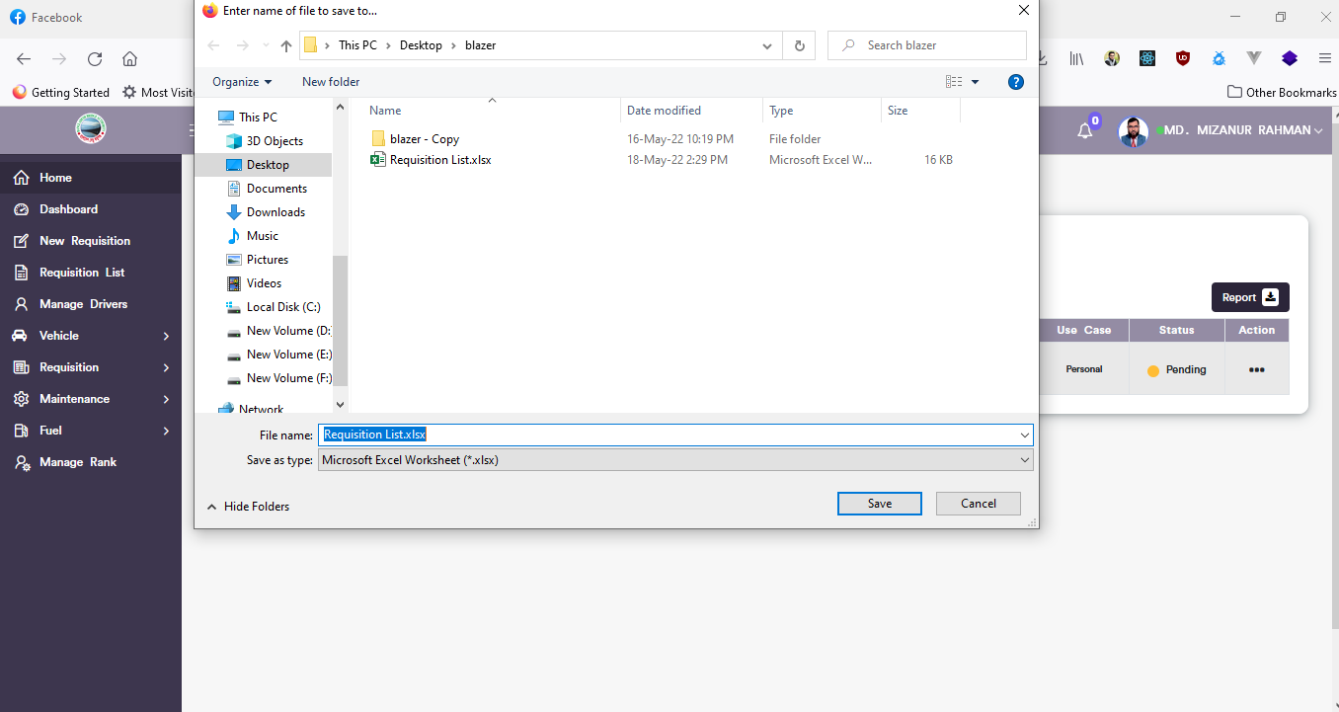

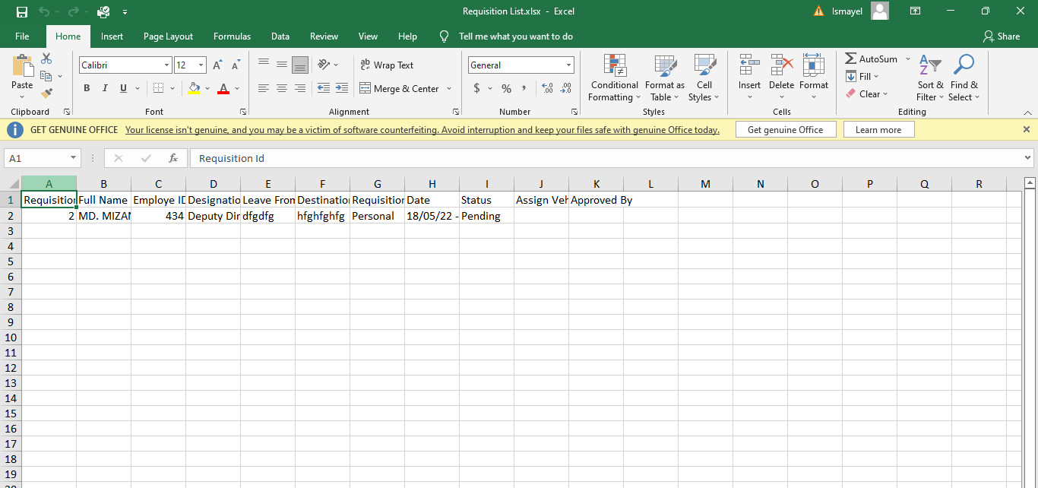

Figure 6.2.3: download requisition list

## 6.3: Manage Drivers List Menu Overview

**Overview of Manage Drivers**

### 6.3.1: ( Manage Drivers) Add new (Outsource driver record form)

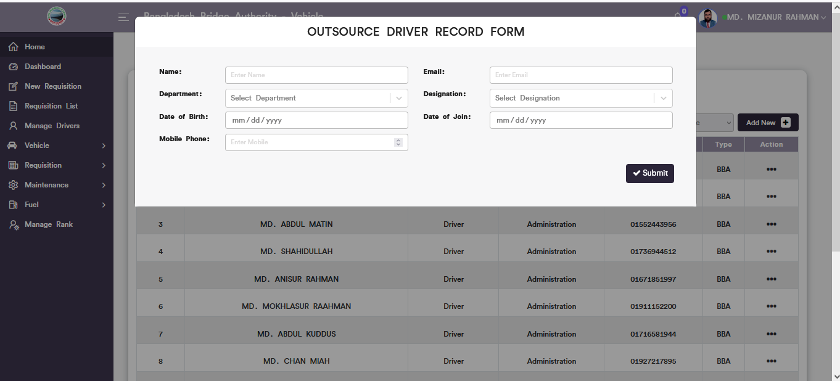

Figure 6.3.1: add new(outsource driver record form)

### 6.3.2: ( Manage Drivers)view of details

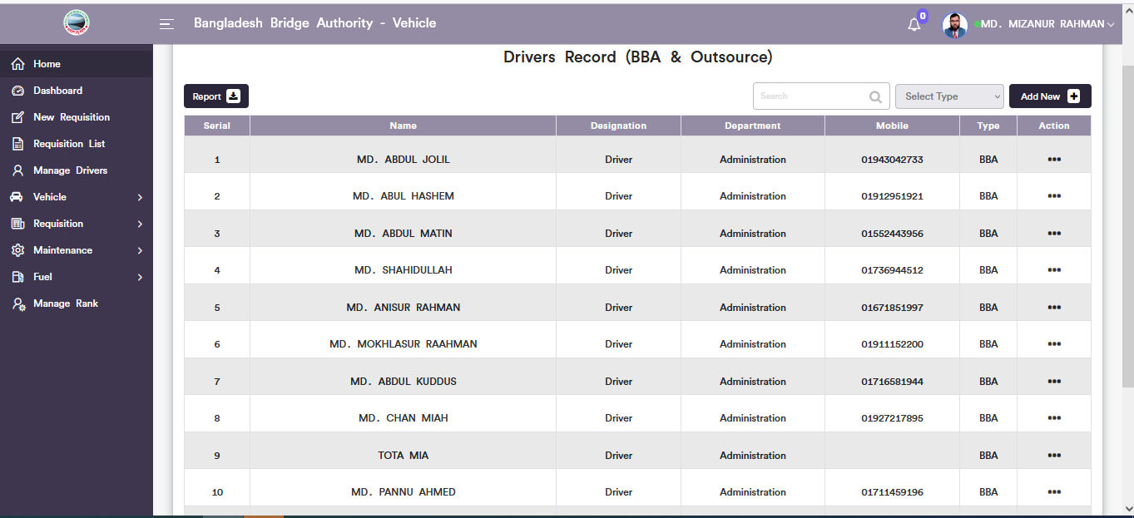

Figure 6.3.2: view details of drivers record

### 6.3.3: ( Manage Drivers) Download the report

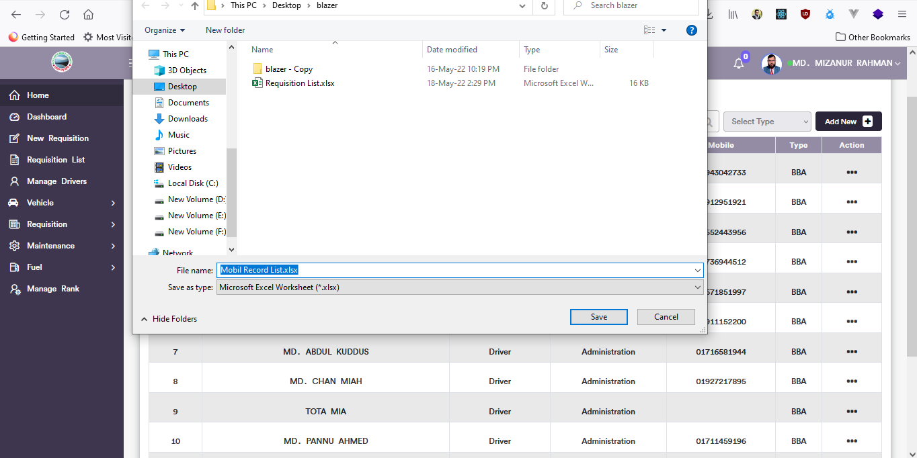

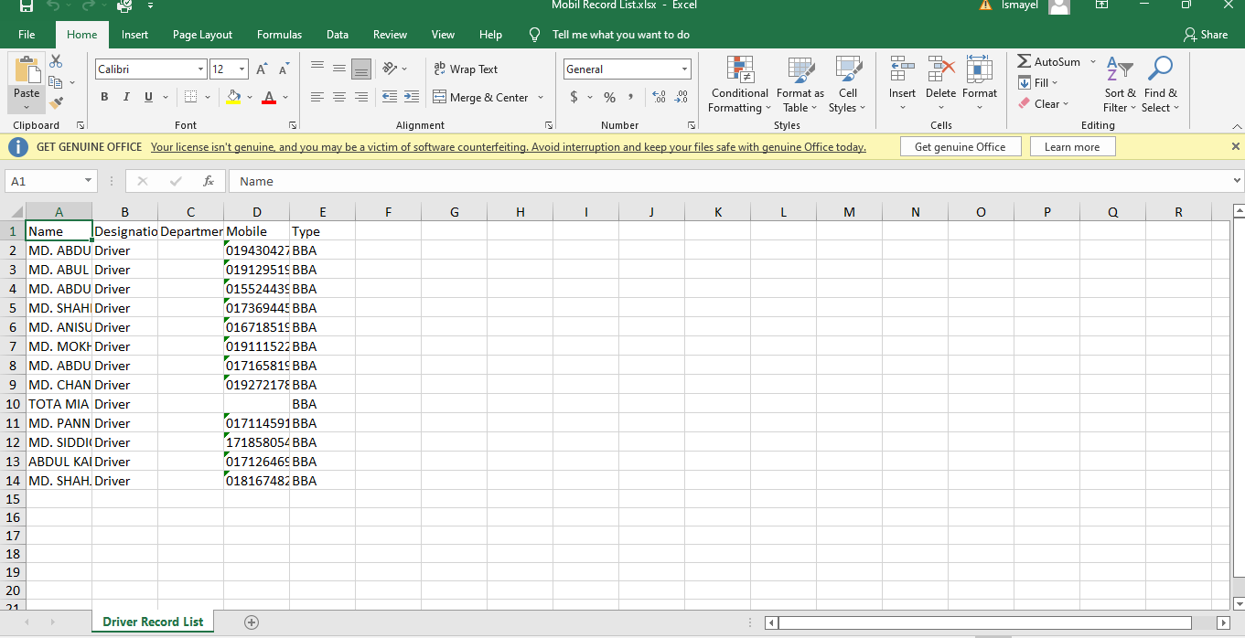

Figure 6.3.3: manage driver download reports

### 6.3.4: ( Manage Drivers)Search Driver

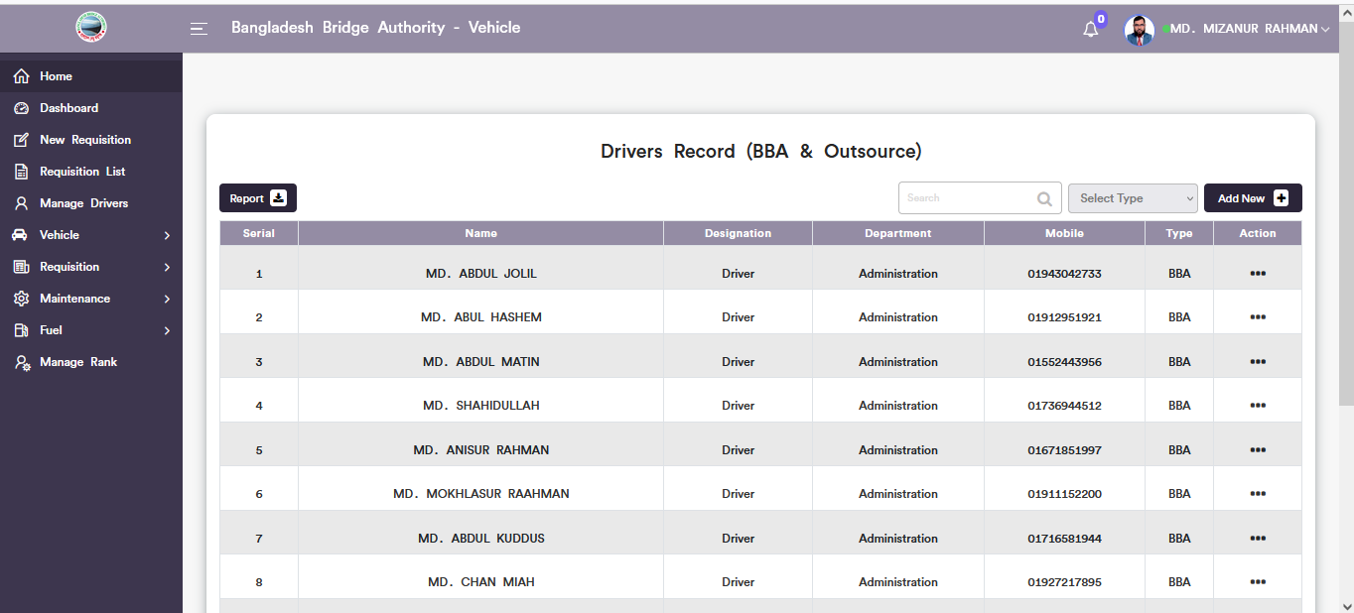

Figure 6.3.4: Search driver

## 6.4: Vehicle Menu Overview

**Overview of Vehicle**

### 6.4.1.1: Vehicle Record (Vehicle )Add vehicle

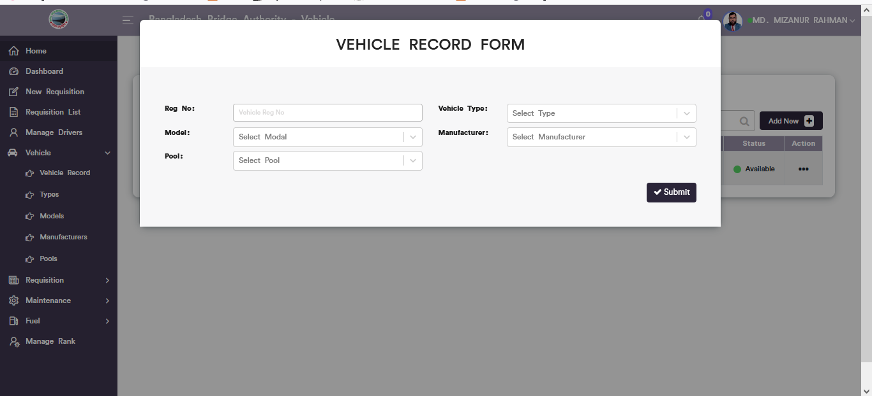

Figure 6.4.1.1: add vehicle record input from

### 6.4.1.2: Vehicle Record (Vehicle )View of Details

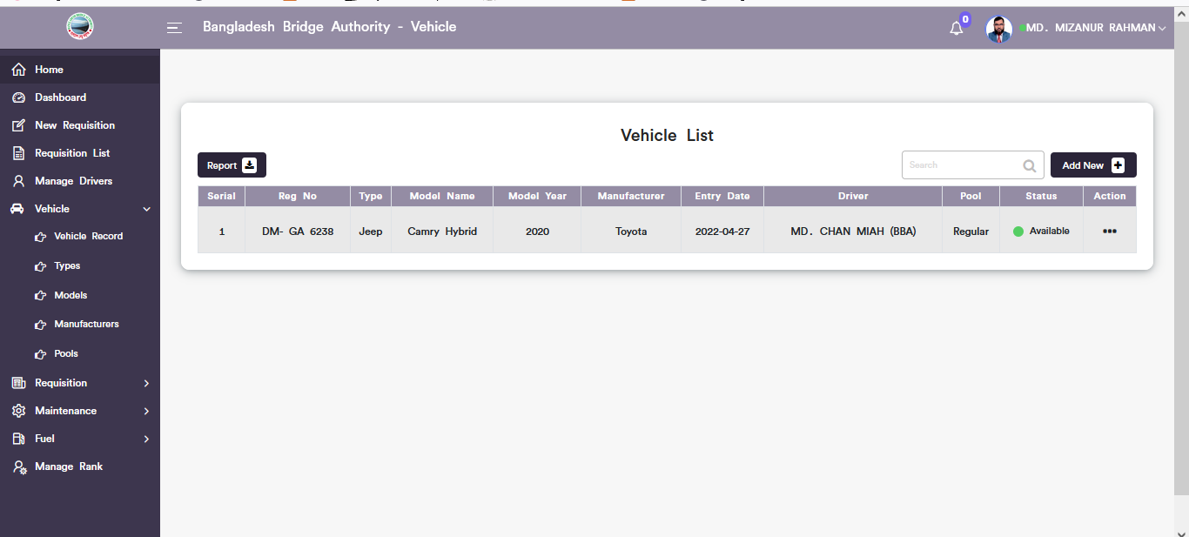

Figure 6.4.1.2: Vehicle records view details

### 6.4.1.3: Vehicle Record (Vehicle )Vehicle Update

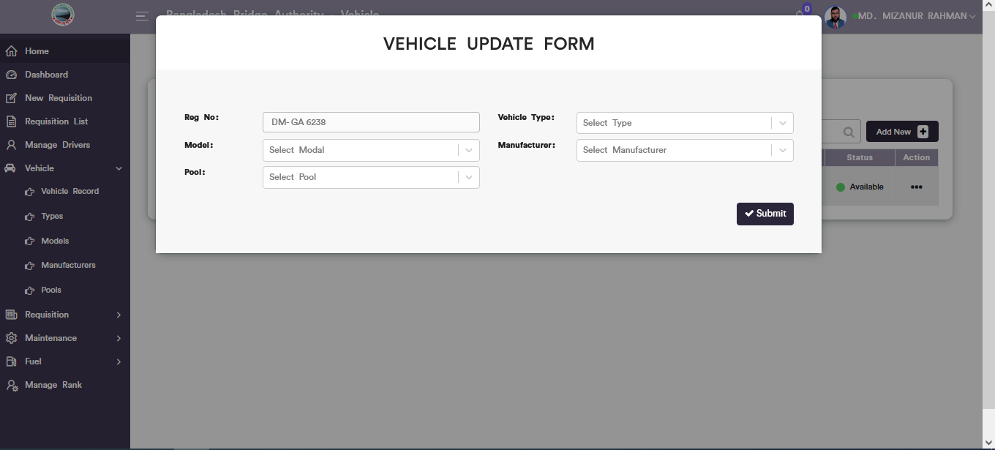

Figure 6.4.1.3: Vehicle records update form

### 6.4.1.4: Vehicle Record (Vehicle )Driver Update

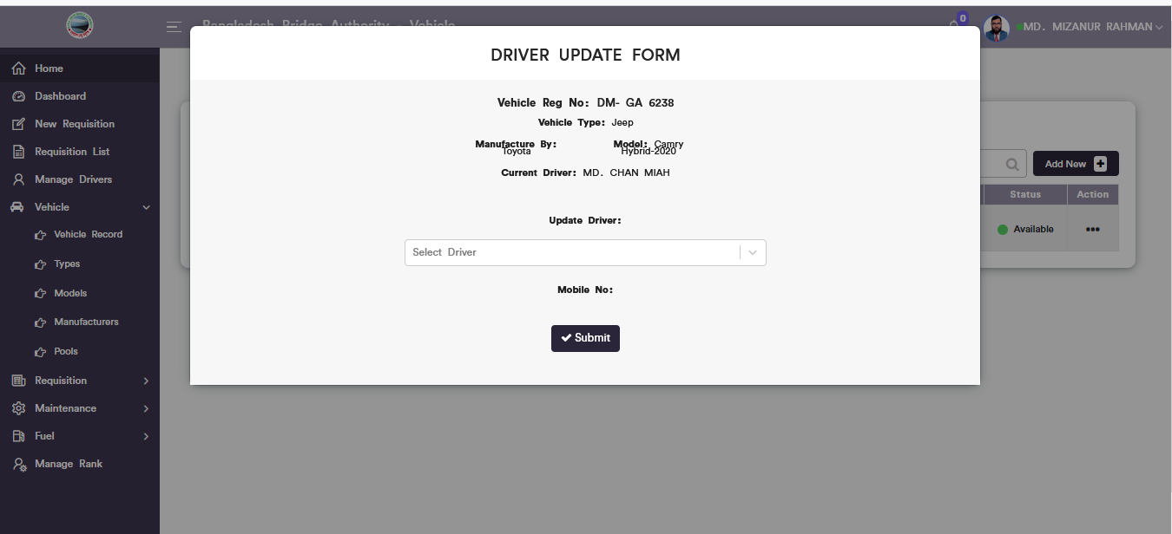

Figure 6.4.1.4: Vehicle records Driver update

### 6.4.1.5: Vehicle Record (Vehicle )Download Report

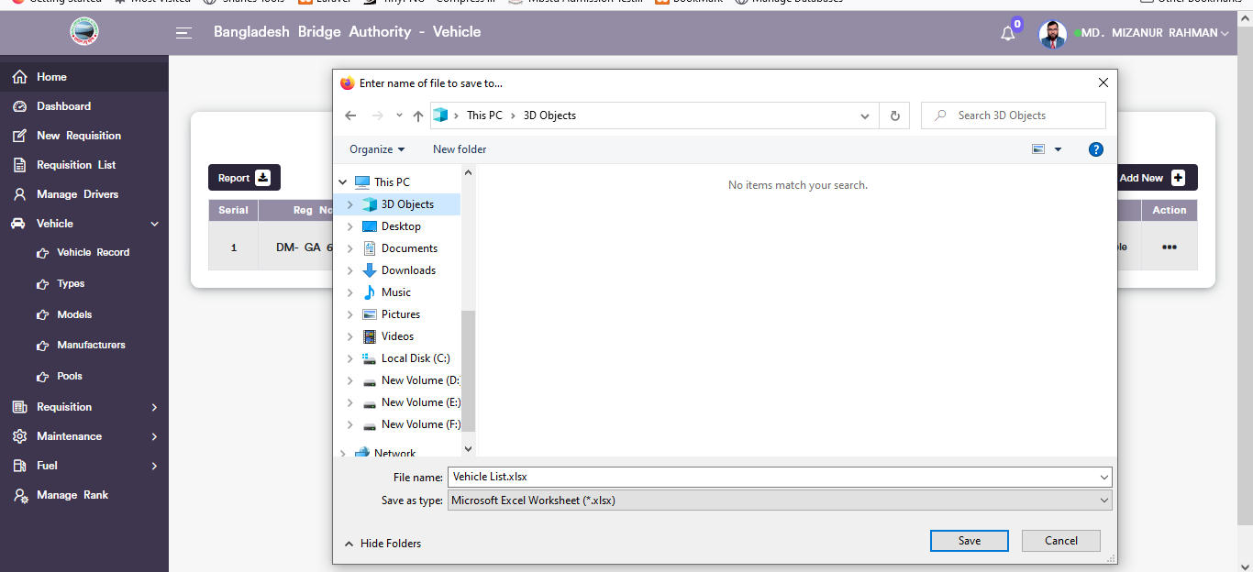

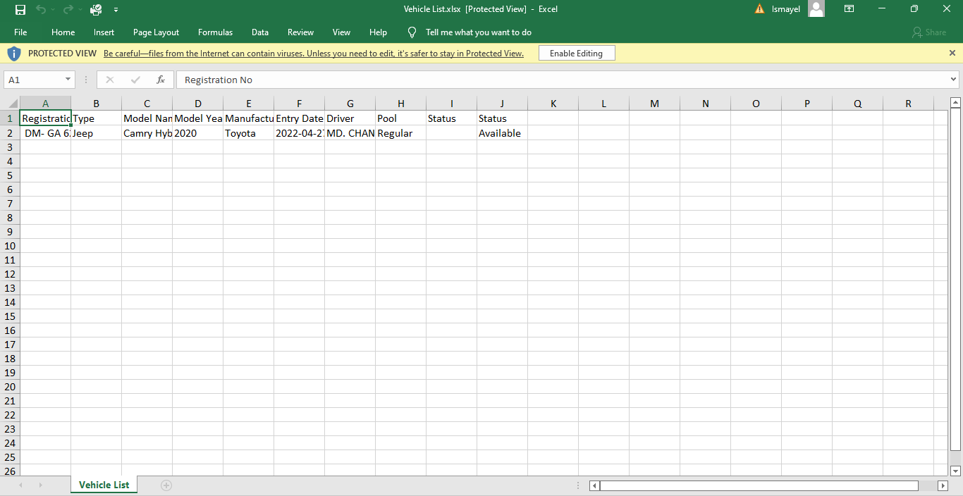

Figure 6.4.1.5: Vehicle records Download report

### 6.4.1.6: Vehicle Record (Vehicle )Search

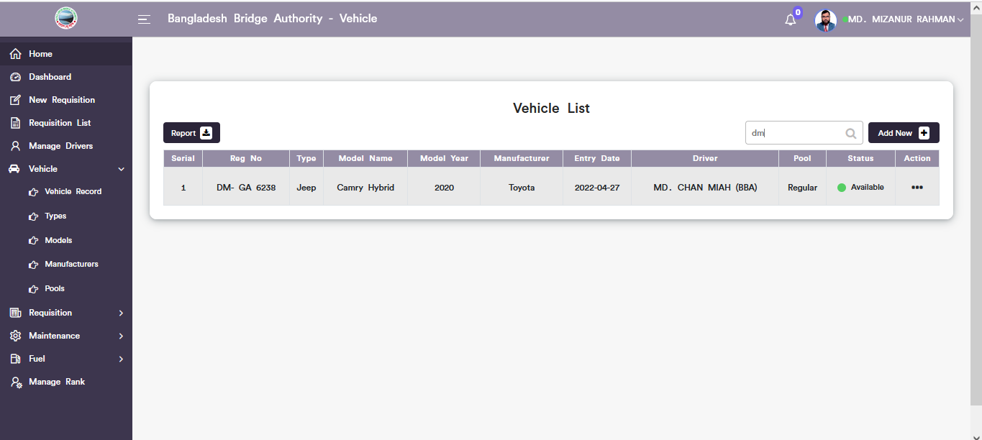

Figure 6.4.1.6: Vehicle records Search

### 6.4.2.1: Types (Vehicle )Add New(Vehicle Category Record form)

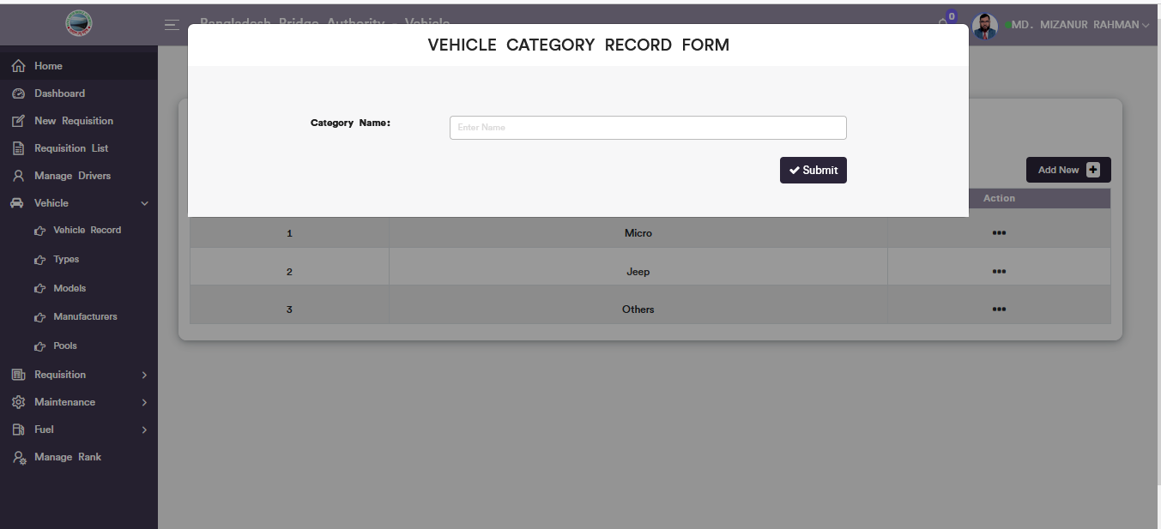

Figure 6.4.2.1: vehicle category record form

### 6.4.2.2: Types (Vehicle )View of details

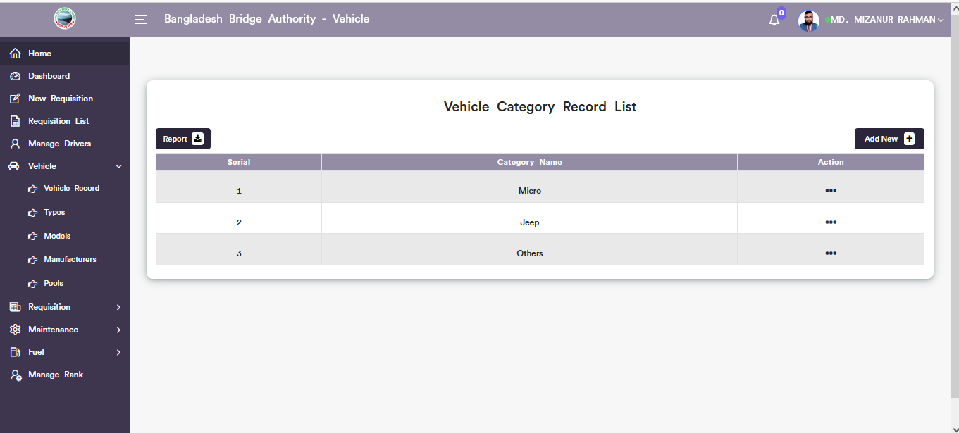

Figure 6.4.2.2: View of vehicle type list

### 6.4.2.3: Types (Vehicle )Download Report

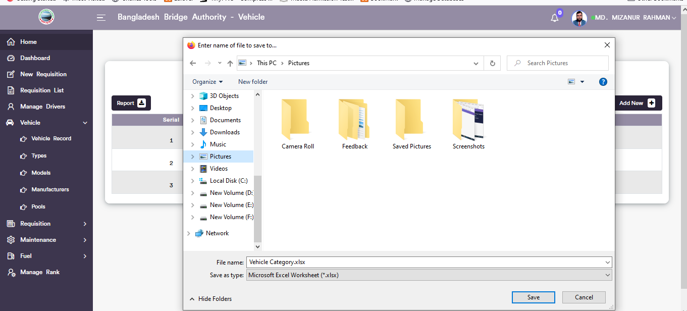

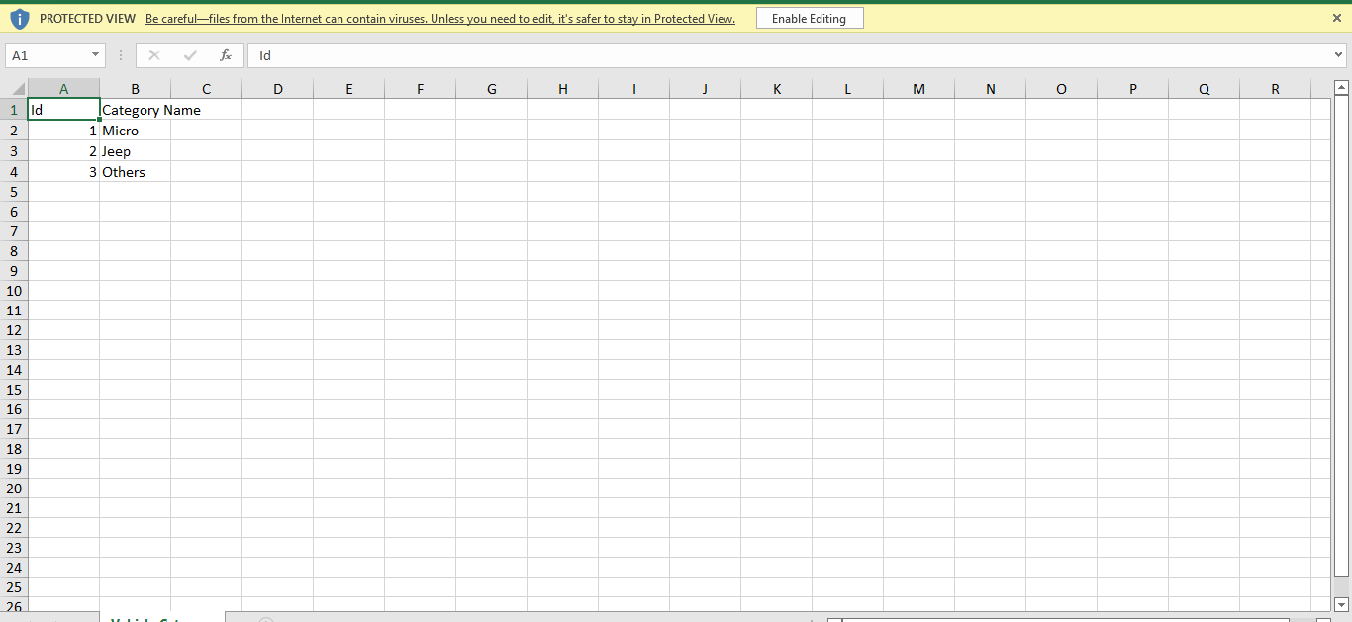

Figure 6.4.2.3: vehicle category record list download

### 6.4.2.4: Types (Vehicle ) Vehicle Category Update

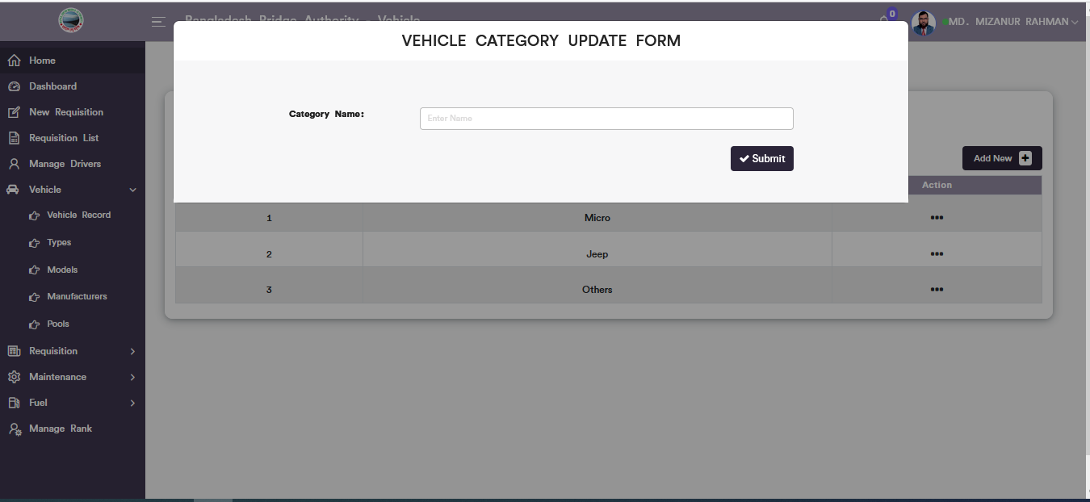

Figure 6.4.2.4: Types ( vehicle)vehicle category Update

### 6.4.3.1: Models (Vehicle )Vehicle Model record from

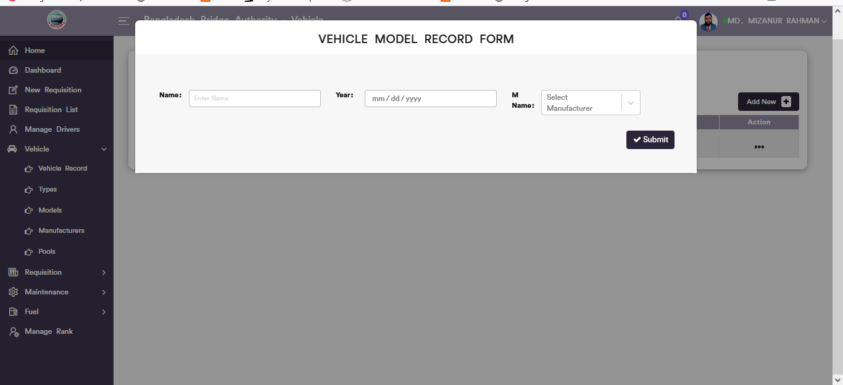

Figure 6.4.3.1: vehicle Model record form

### 6.4.3.2: Models (Vehicle )View of models details list

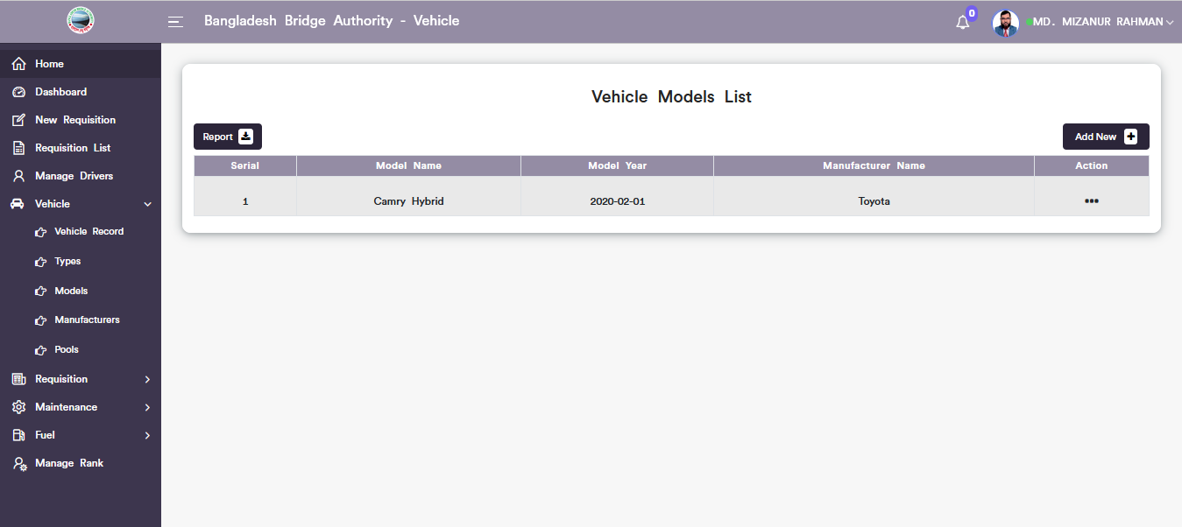

Figure 6.4.3.2: Vehicle models list

### 6.4.3.3: Vehicle Model Update Form

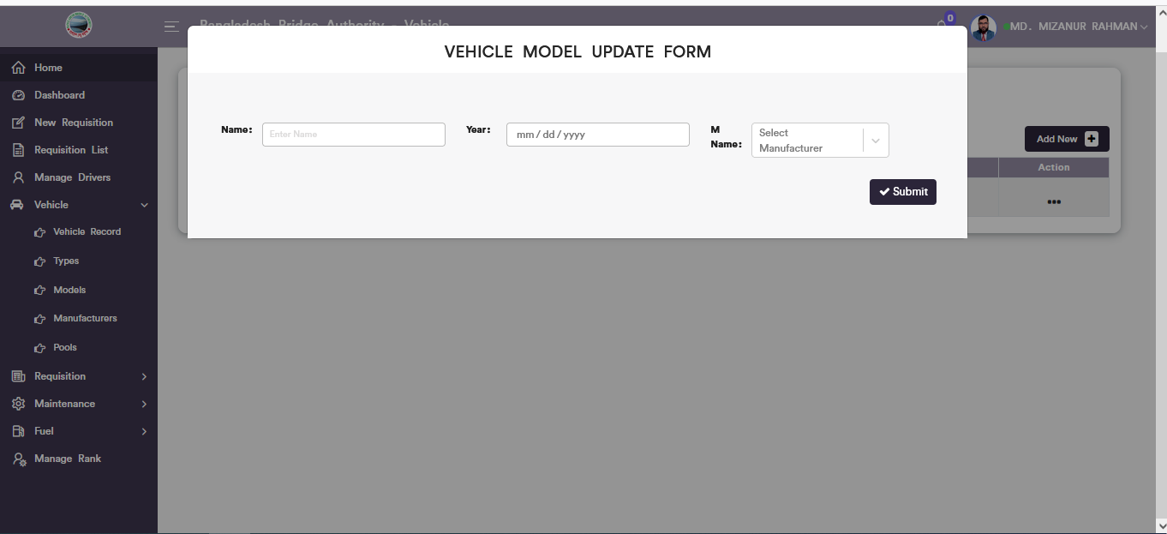

Figure 6.4.3.3: vehicle model update form

### 6.4.3.4: Models (Vehicle ) Download Model list Report

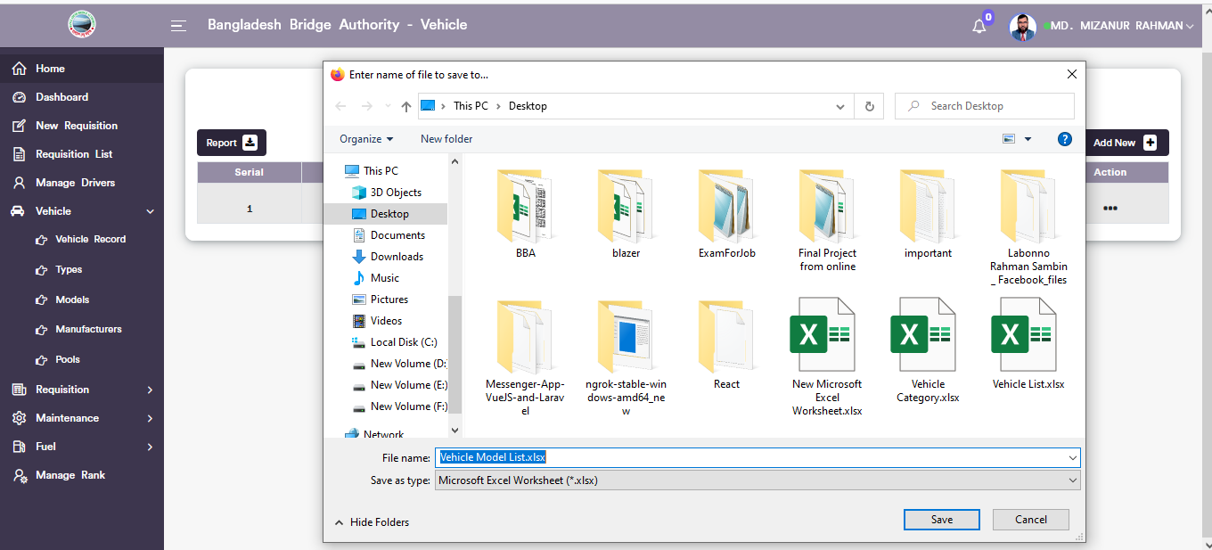

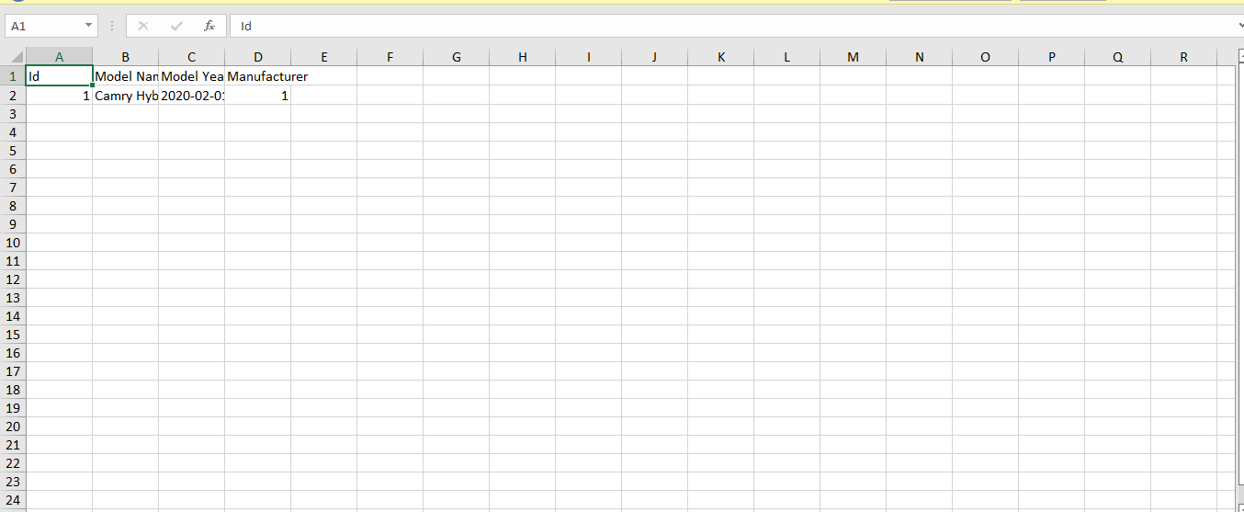

Figure 6.4.3.4:vehicle model list Download report

### 6.4.4.1: Manufacturers (Vehicle )Vehicle Manufacturer record from

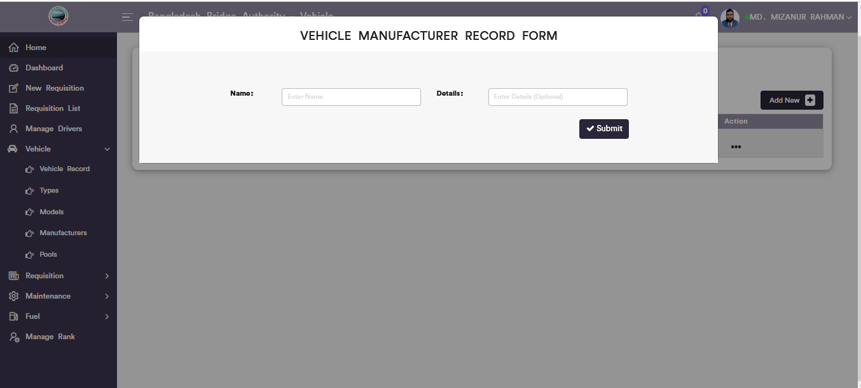

Figure 6.4.4.1: vehicle manufacturer record form

### 6.4.4.2: Manufacturers (Vehicle )View of manufacturers details list

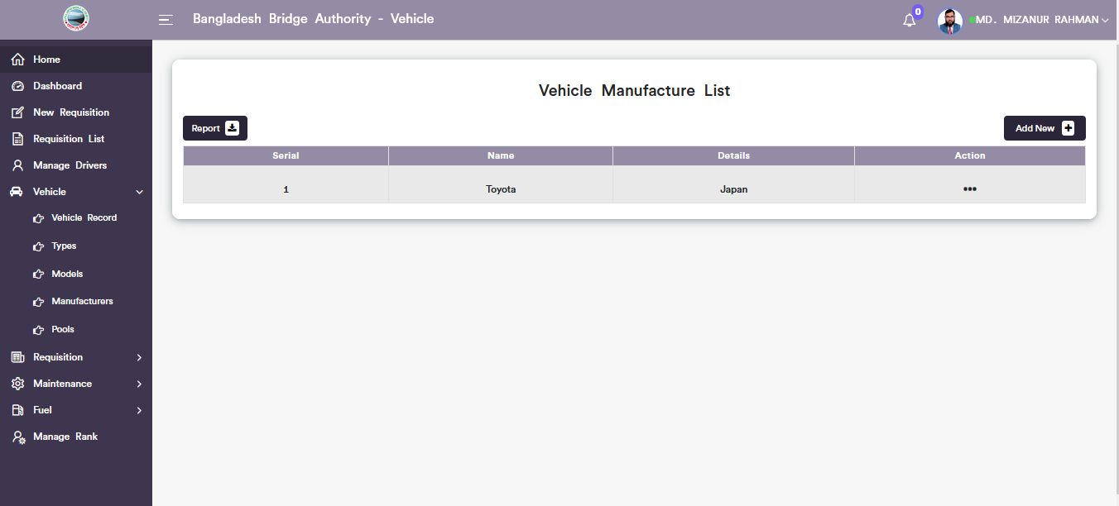

Figure 6.4.4.2: vehicle manufacturer list

### 6.4.4.3: Manufacturers (Vehicle )Download Report

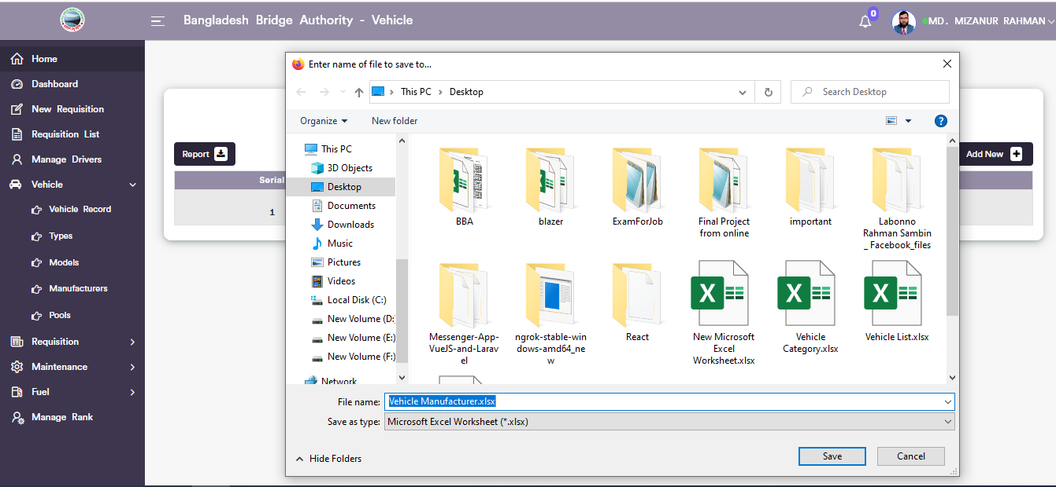

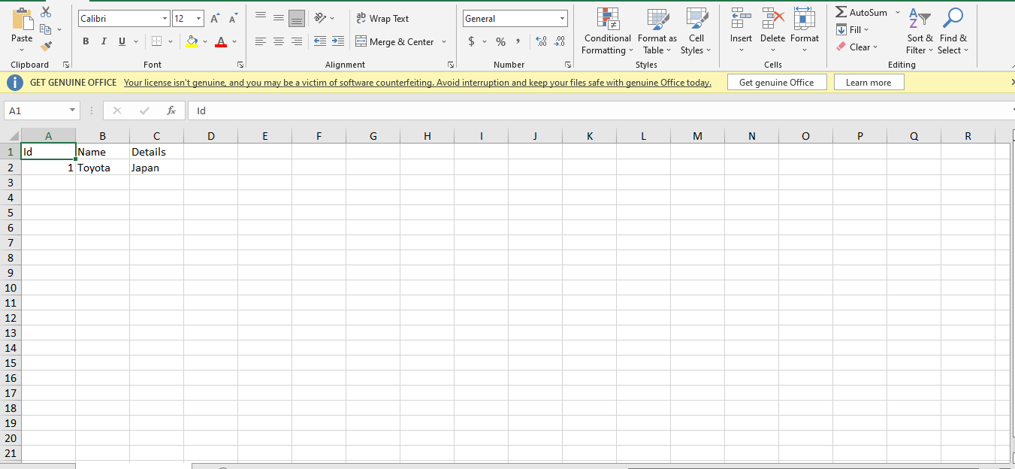

Figure 6.4.4.3: vehicle manufacturers Download report

### 6.4.5.1: Pools (Vehicle )Vehicle pool record form

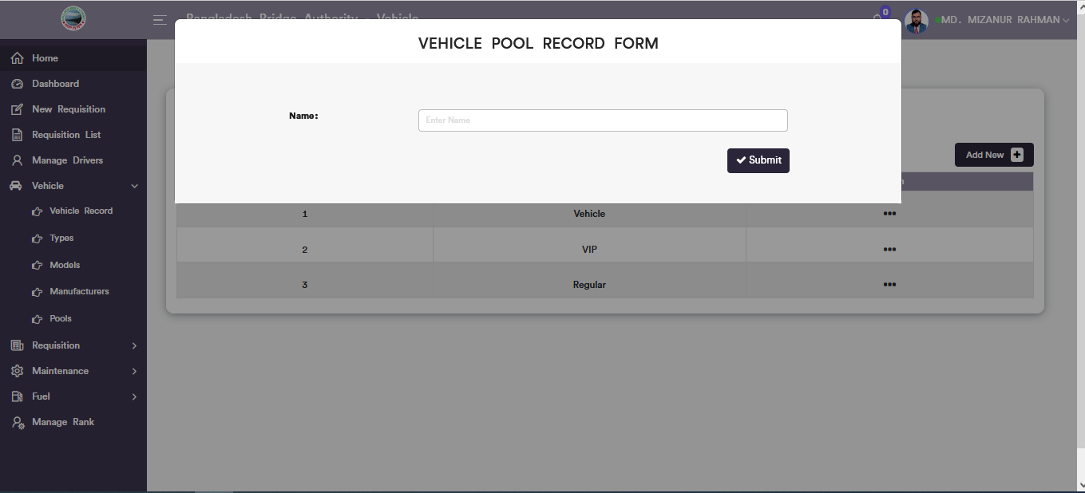

Figure 6.4.5.1: vehicle pool record form

### 6.4.5.2: Pools (Vehicle )View of details vehicle pool list

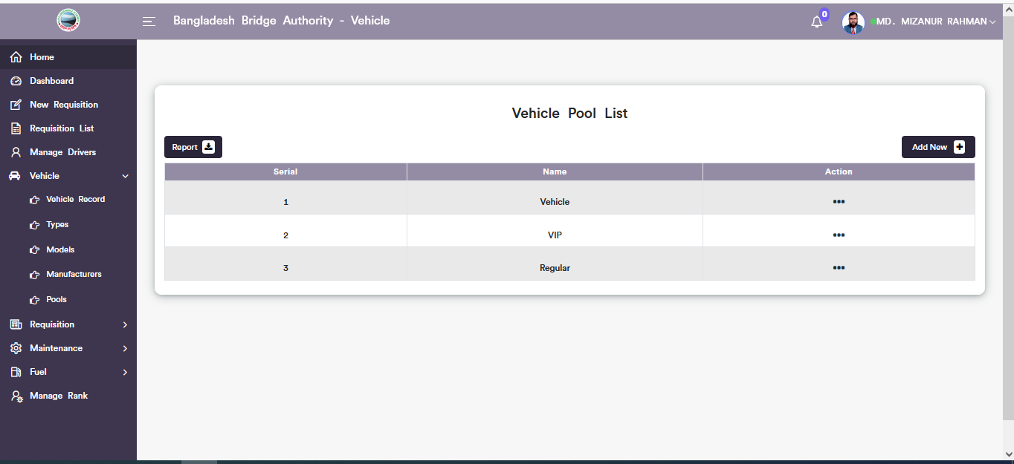

Figure 6.4.5.2: vehicle pool record form list

### 6.4.5.3: Vehicle Pool Update Form

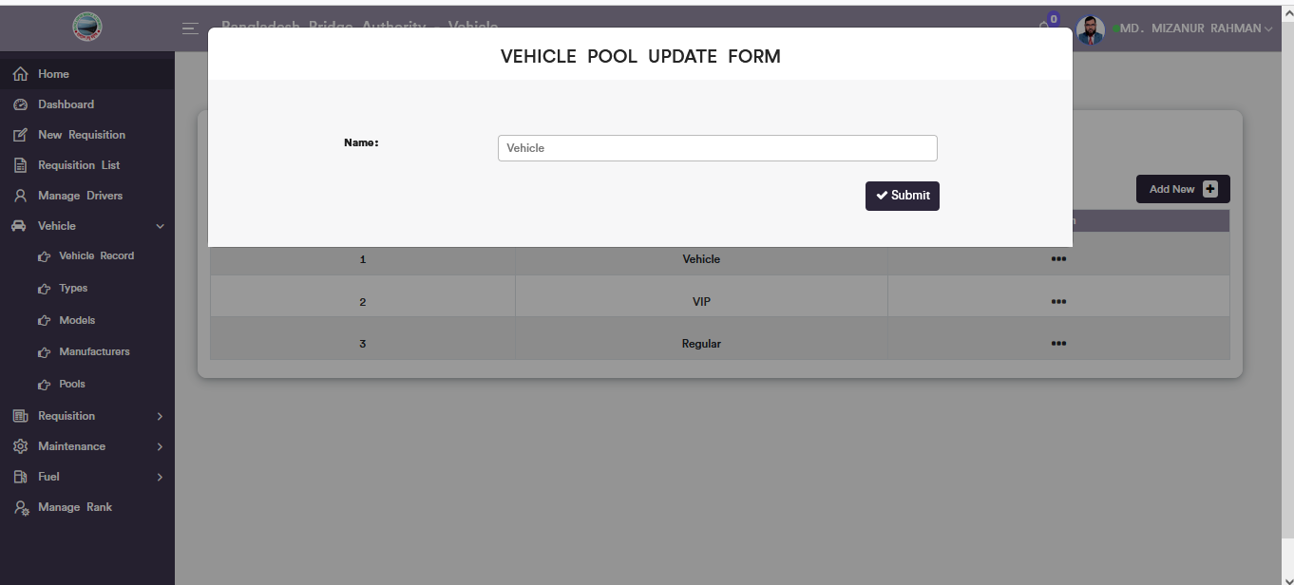

Figure 6.4.5.3: vehicle pool update form

### 6.4.5.4: Pools (Vehicle )Download Report

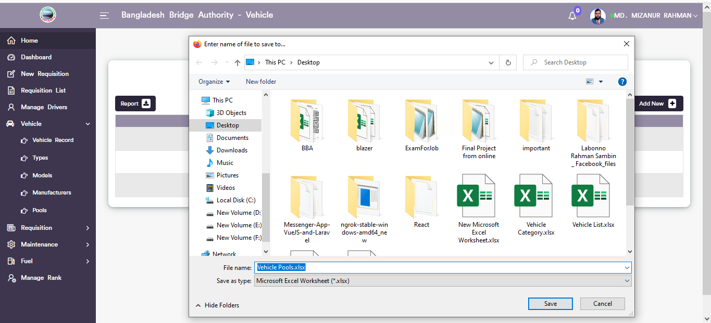

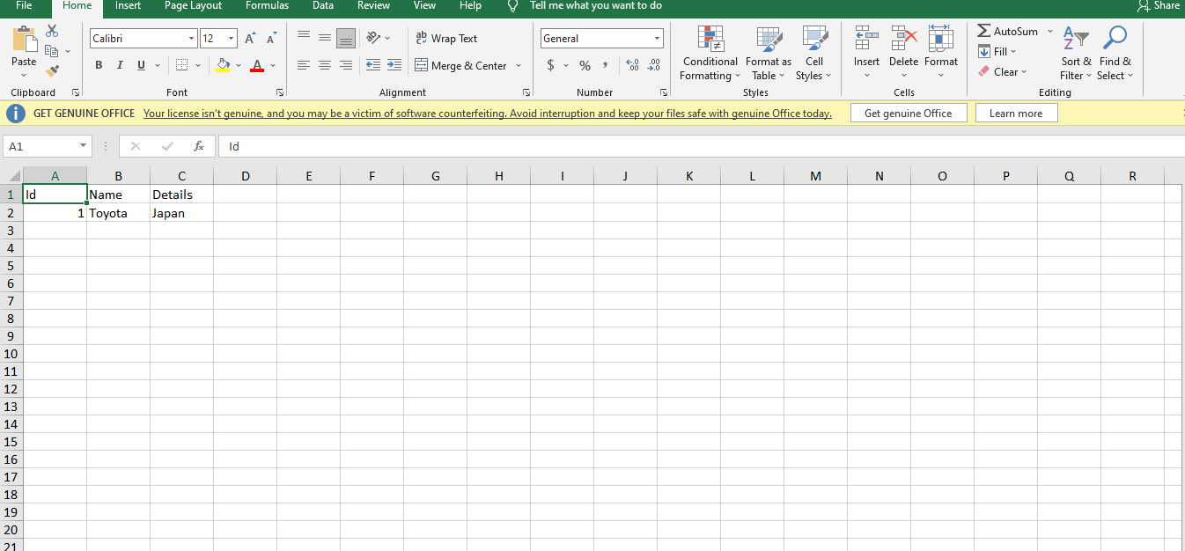

Figure 6.4.5. vehicle pools list download report

### 6.4.6: Settings (Vehicle )

In the settings sub menu there are two options and they are **1. Vehicle user**,and **2.Vehicle routes.**

### 6.4.6.1: Settings (Vehicle )Vehicle common user add form, vehicle common user list, edit and download report.

**1.Vehicle User**

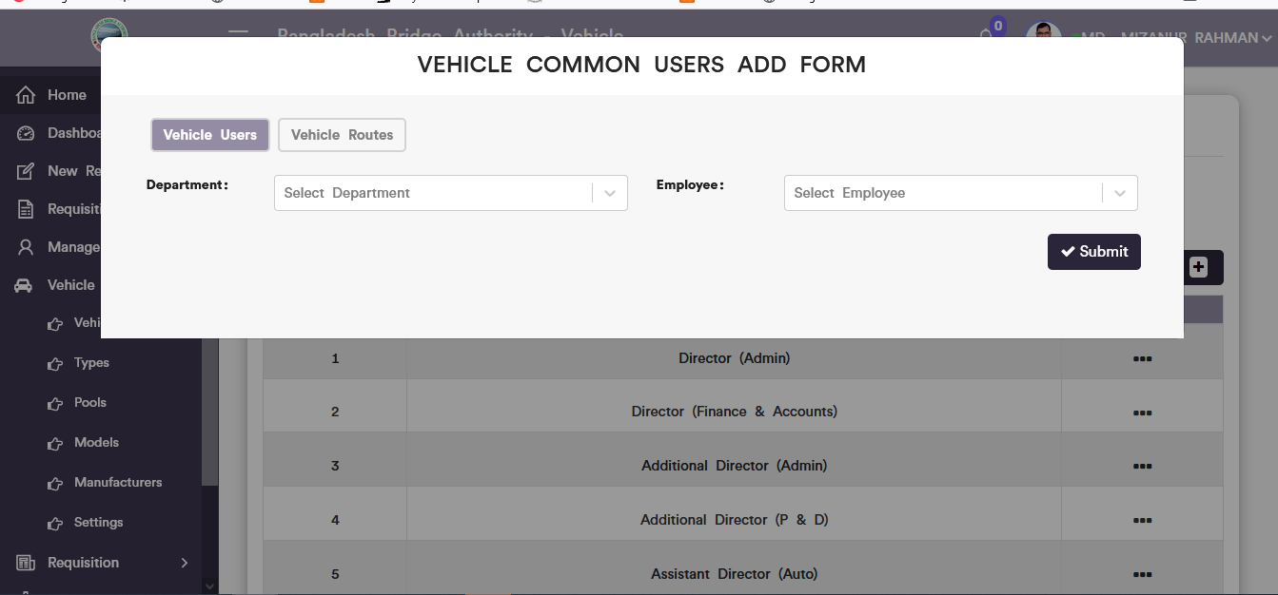

Figure 6.4.6.1.1. vehicle common users add form

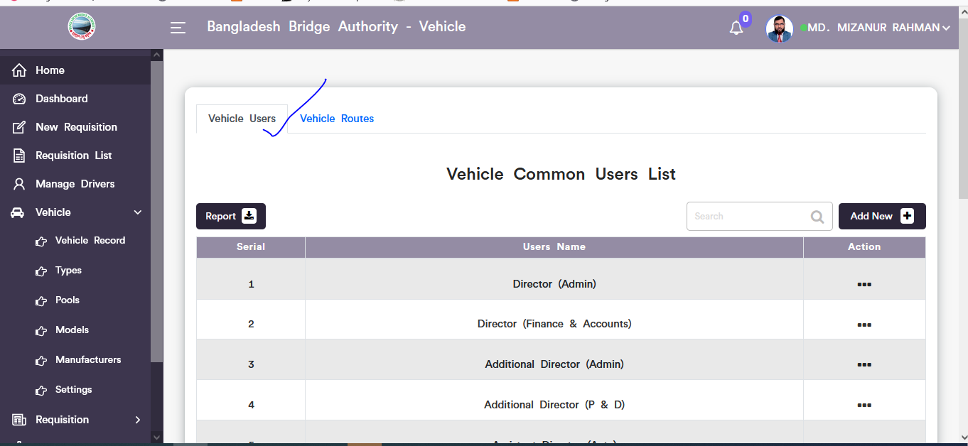

Figure 6.4.6.1.2. vehicle common users list

Click on the dotted button then choose update option after that looks like pop-up vehicle common user update modal will display. User can update input field data as user required.

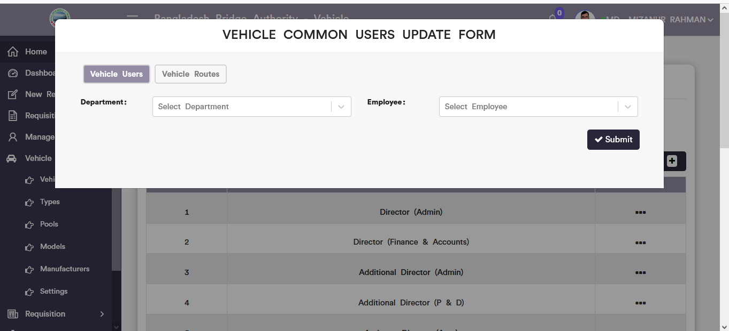

Figure 6.4.6.1.3. vehicle common users update form

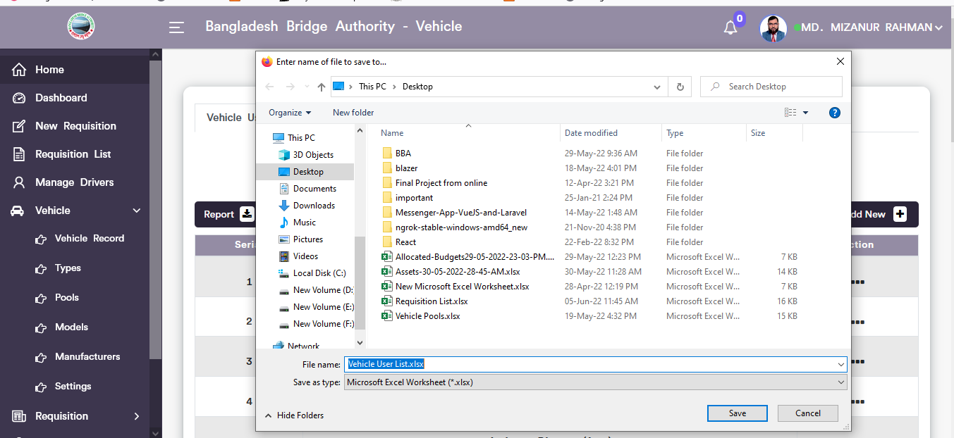

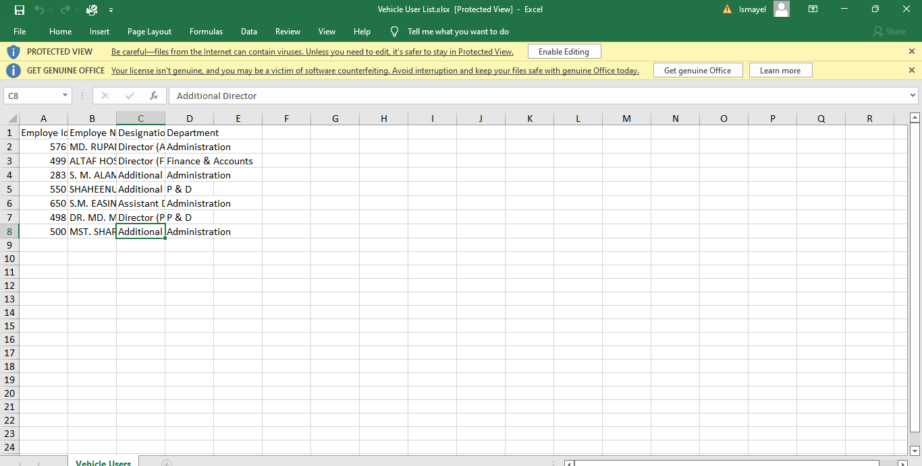

Figure 6.4.6.1.4. vehicle common users report download

### 6.4.6.2: Settings (Vehicle )Vehicle common Route add form, vehicle route list, edit and download report.

**1.Vehicle Route List**

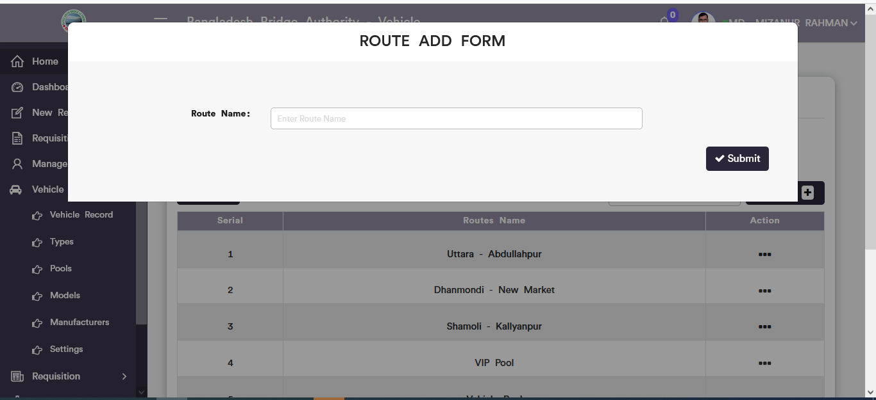

Figure 6.4.6.2.1 vehicle routes add form

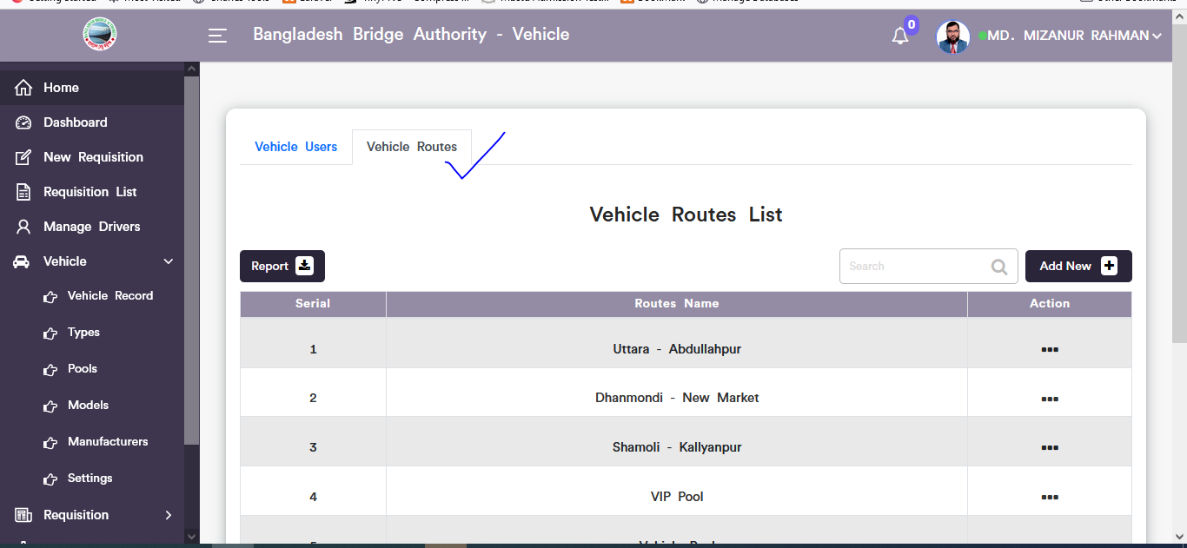

Figure 6.4.6.2.2. vehicle routes list

Click on the dotted button then choose update option after that looks like pop-up route update modal will display. User can update input field data as user required.

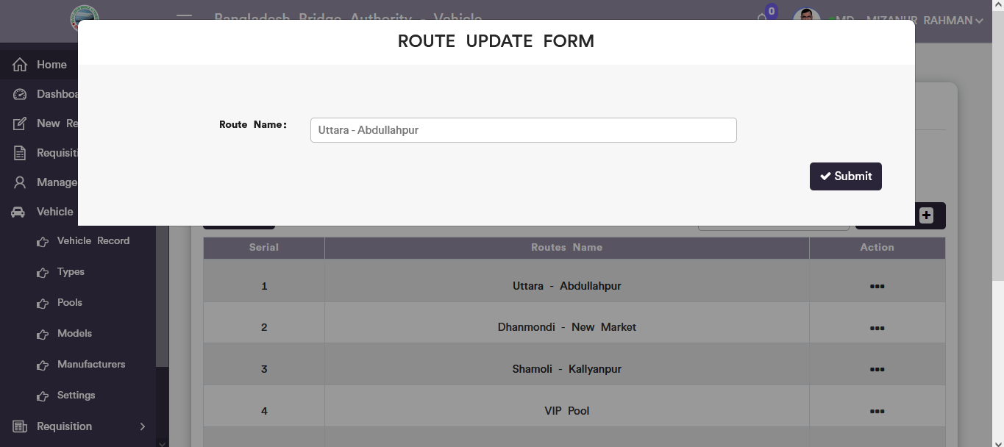

Figure 6.4.6.2.3. vehicle route update form

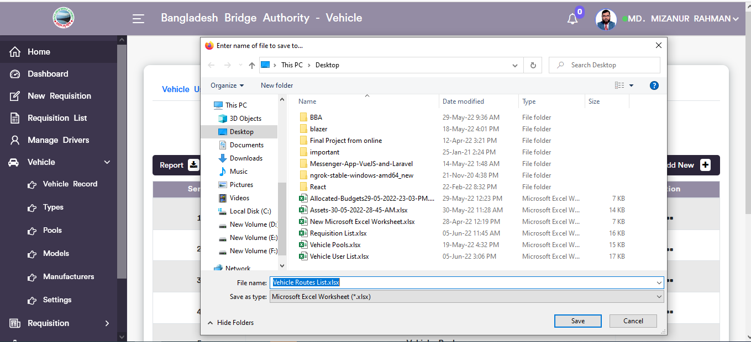

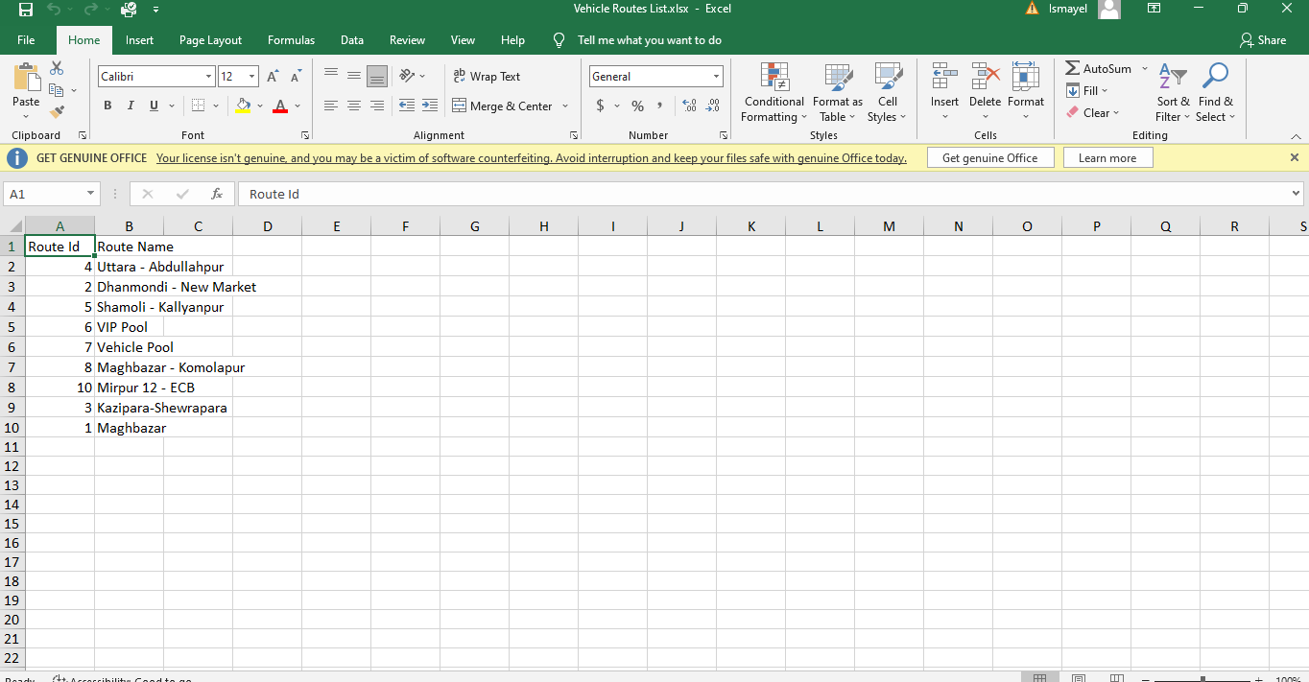

Figure 6.4.6.2.4. vehicle route list report download

## 6.5: Requisition Menu Overview

**Overview of Requisition**

### 6.5.1.1: Requisition Record (Requisition)View of all requisition list

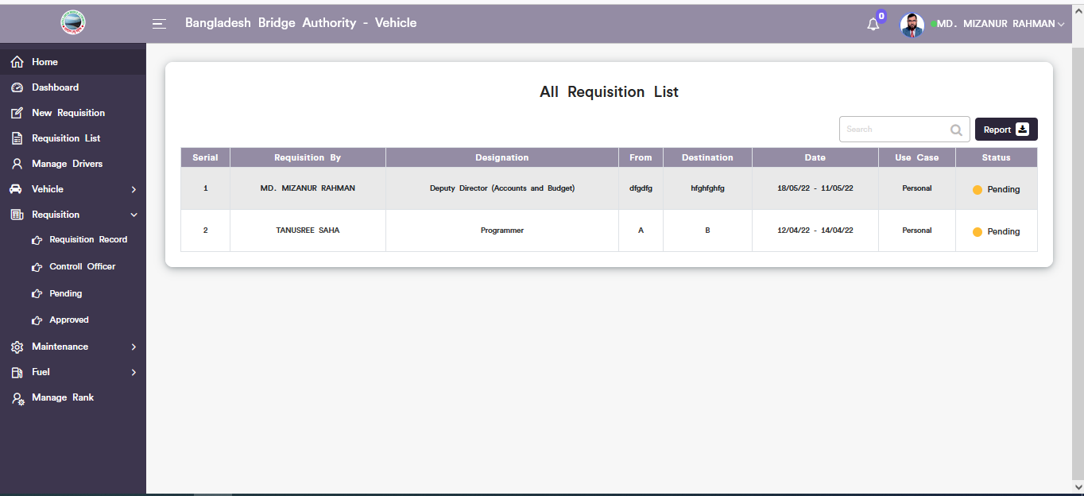

Figure 6.5.1.1: View of all requisition list

### 6.5.1.2: Requisition Record (Requisition)Report download

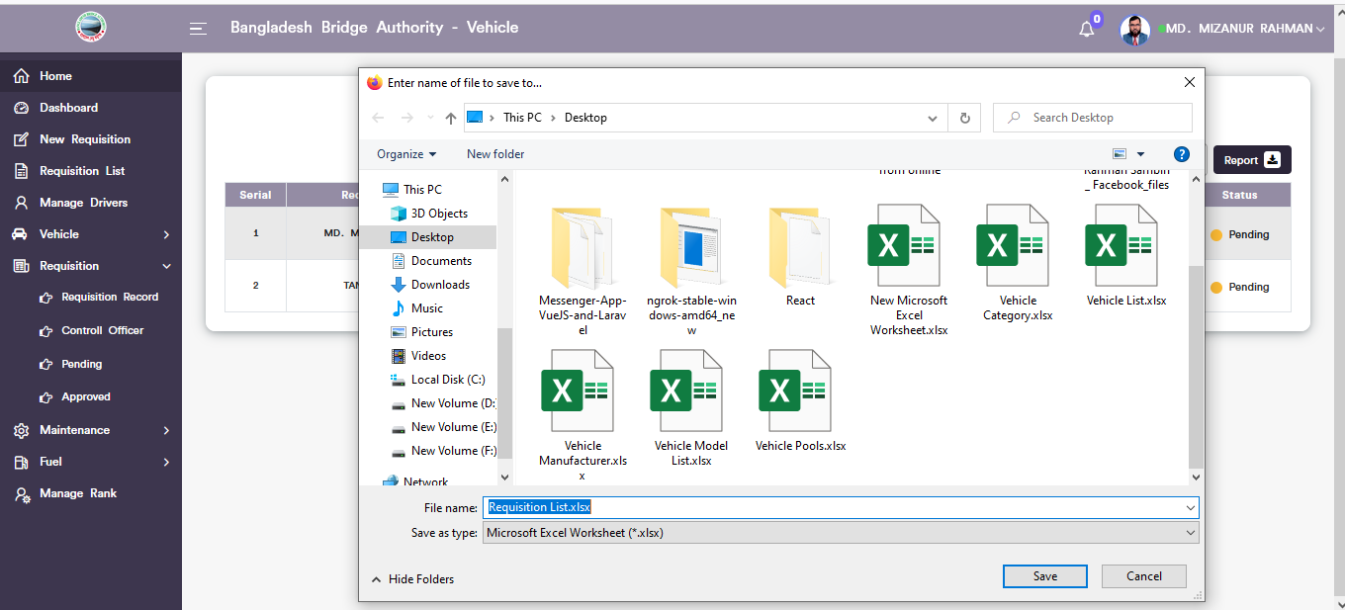

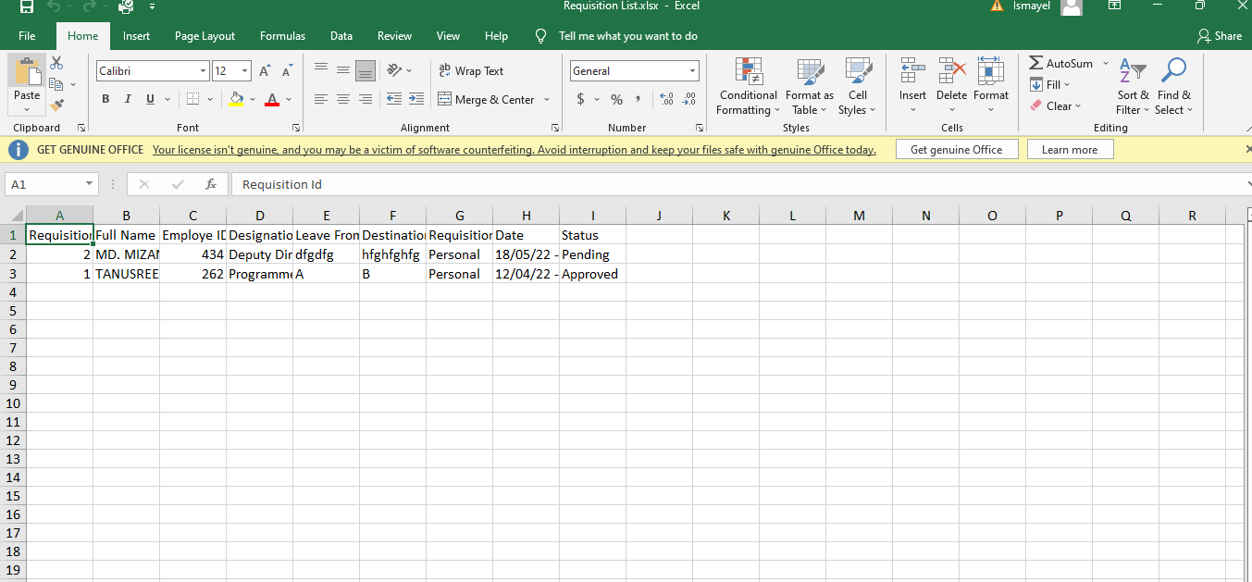

Figure 6.5.1.2: all requisition list report download

### 6.5.1.3: Requisition Record (Requisition)Search

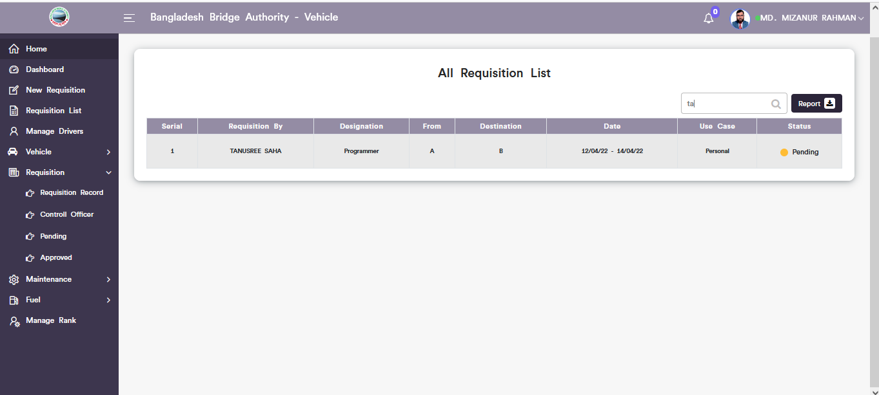

Figure 6.5.1.3: search data from all requisition list

### 6.5.2.1: Control Officer (Requisition)View of pending requestion for controller officer.

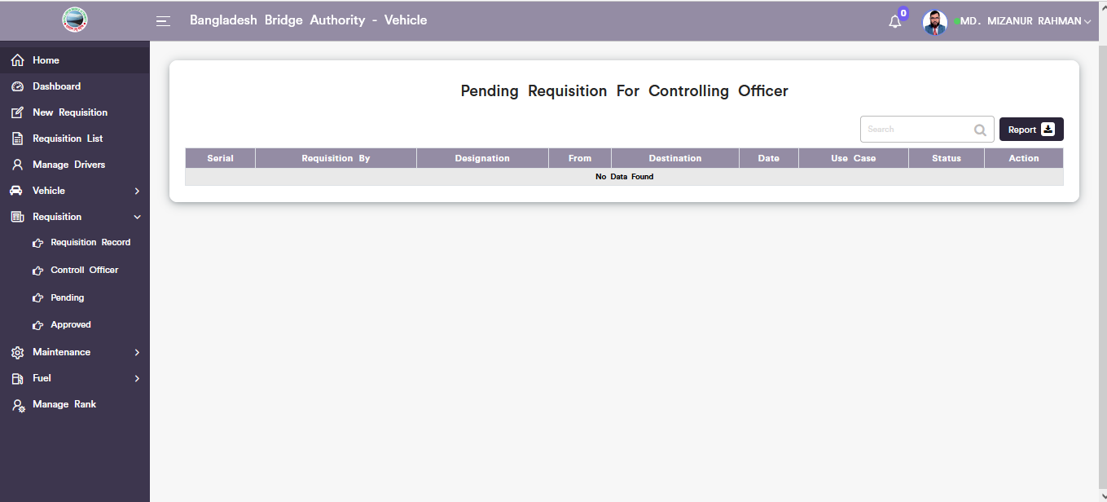

Figure 6.5.2.1: pending Requisition for controlling officer

### 6.5.2.2: Control Officer (Requisition)Download report.

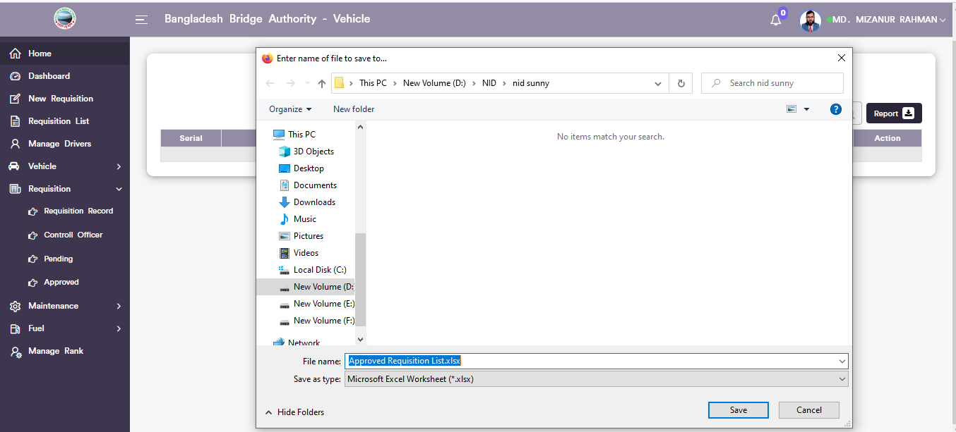

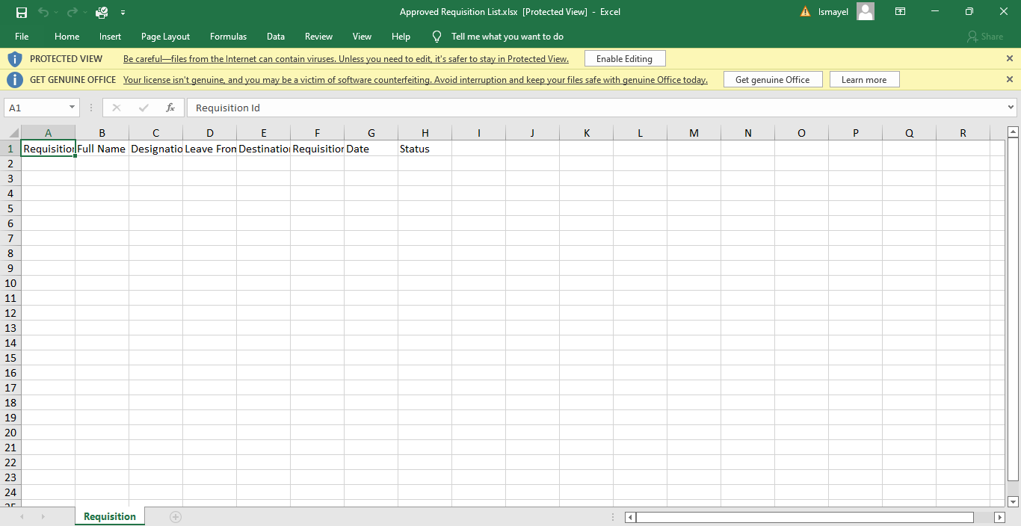

Figure 6.5.2.2: Control officer pending requisition Download report

### 6.5.3.1: Pending (Requisition)View of pending requisition list.

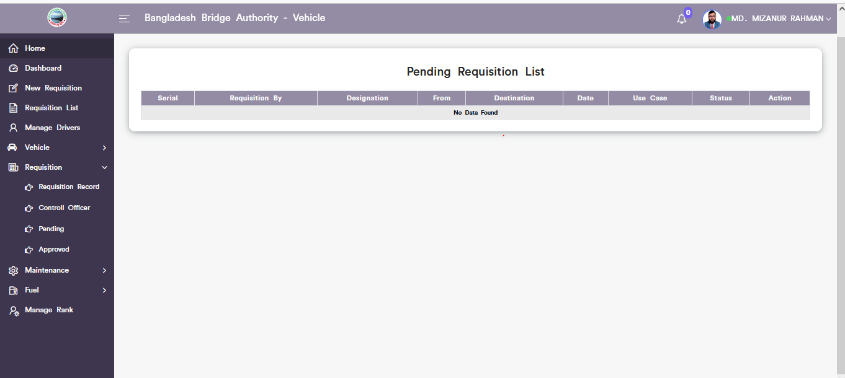

Figure 6.5.3.1: pending requisition list

### 6.5.4.1: Approved(Requisition)Approved requisition list.

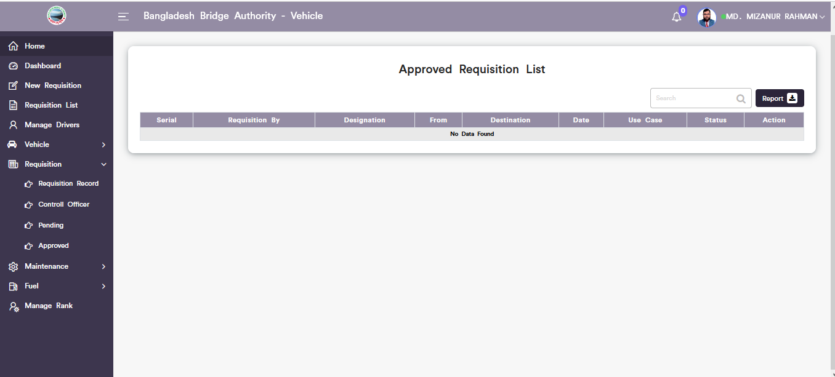

Figure 6.5.4.1: approved requisition list

## 6.6: Maintenance Menu Overview

**Overview of Maintenance**

### 6.6.1.1: Maintenance Record(Maintenance)Add new vehicle servicing

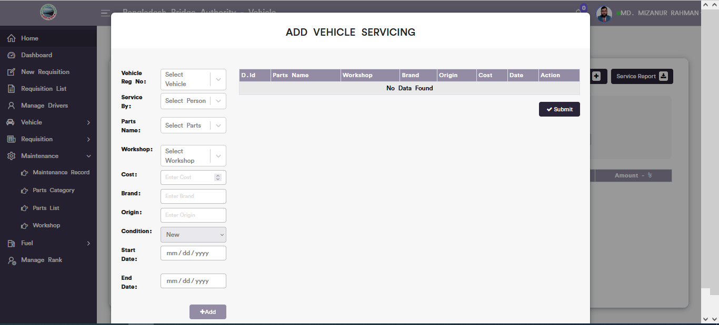

Figure 6.6.1.1: add new vehicle servicing

### 6.6.1.2: Maintenance Record(Maintenance)View of servicing list

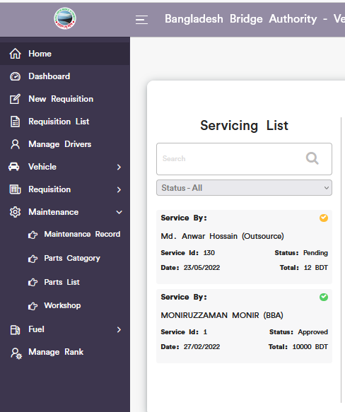

Figure 6.6.1.2: view of servicing list

### 6.6.1.3: Maintenance Record(Maintenance)Single Details servicing

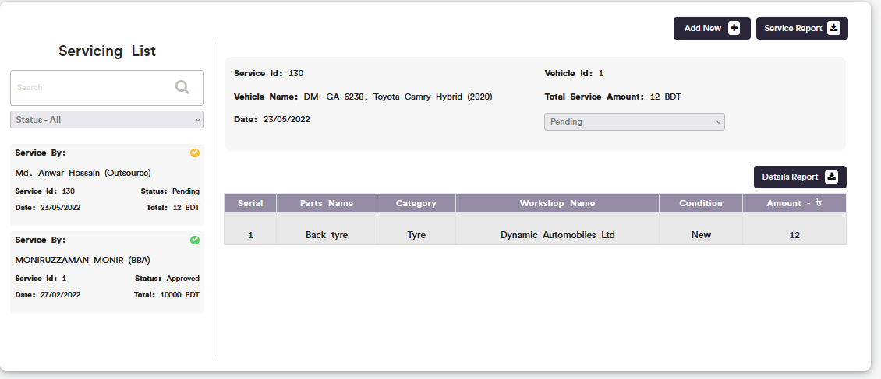

Figure 6.6.1.3: single details servicing information

### 6.6.1.4: Maintenance Record(Maintenance)Search

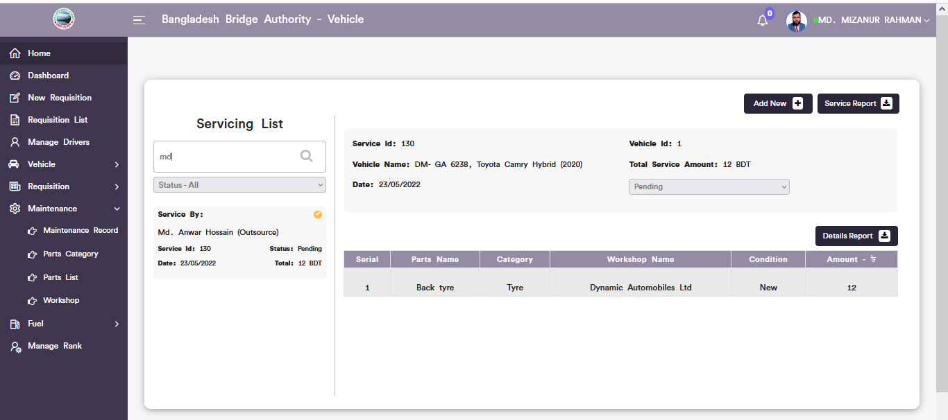

Figure 6.6.1.4: Maintenance record search from servicing list

### 6.6.1.5: Maintenance Record(Maintenance)Service report download

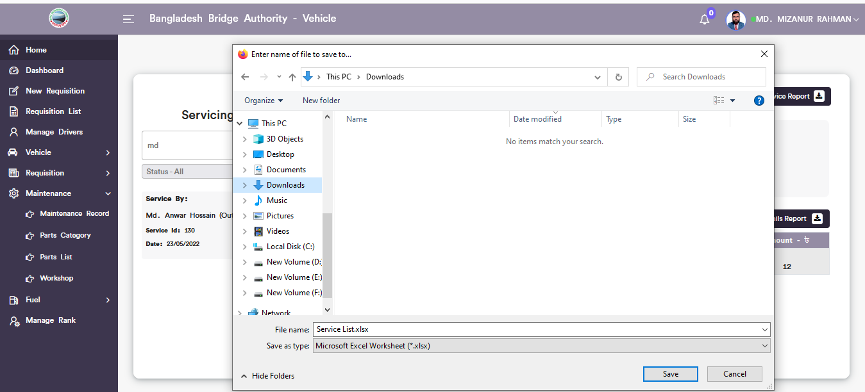

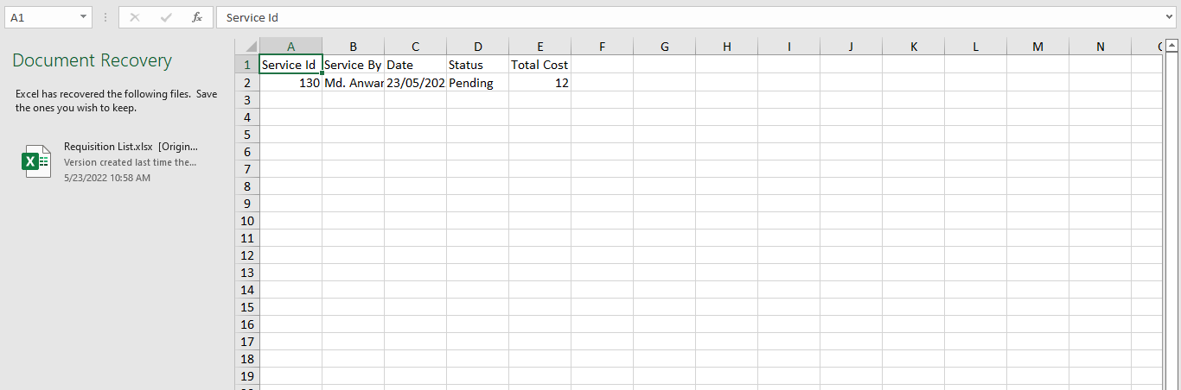

Figure 6.6.1.5: service list report download

### 6.6.1.6: Maintenance Record(Maintenance)Details report download

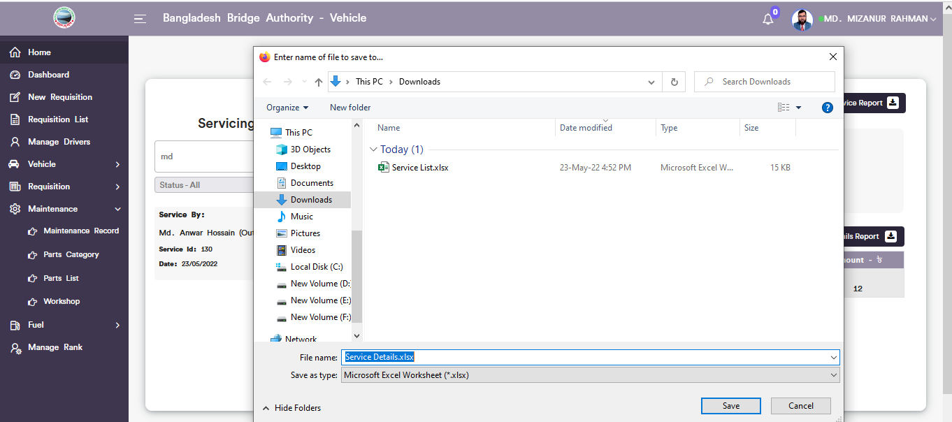

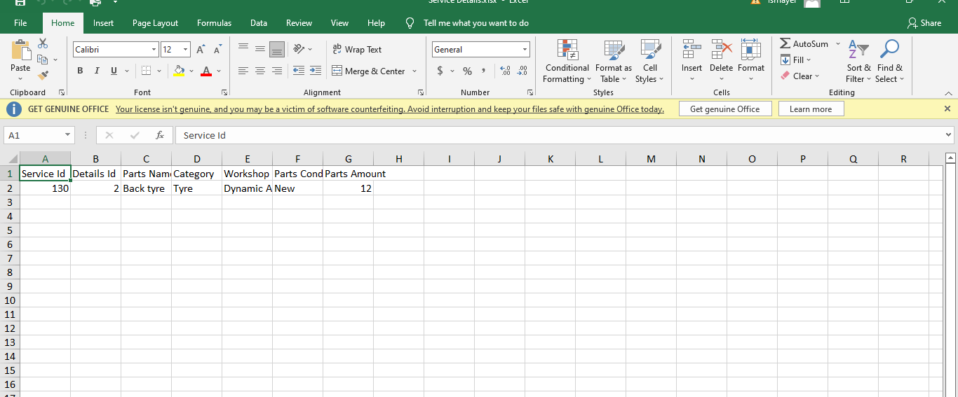

Figure 6.6.1.6: details service report download

### 6.6.2.1: Product Category(Maintenance)Add new Category

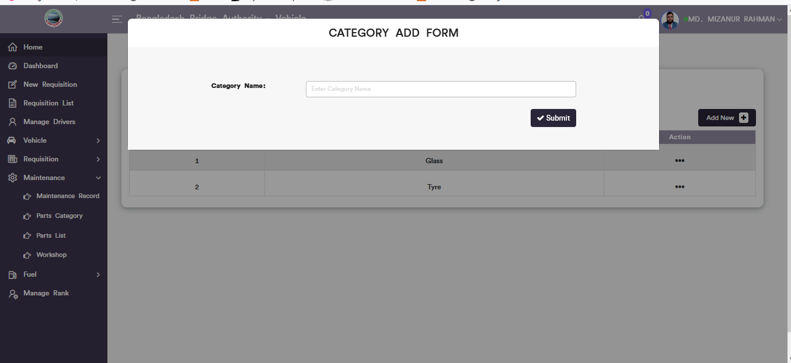

Figure 6.6.2.1: Product category add form

### 6.6.2.2: Product Category(Maintenance)Update category data



Figure 6.6.2.2: update Product category data

### 6.6.2.2: Product Category(Maintenance)Download Report

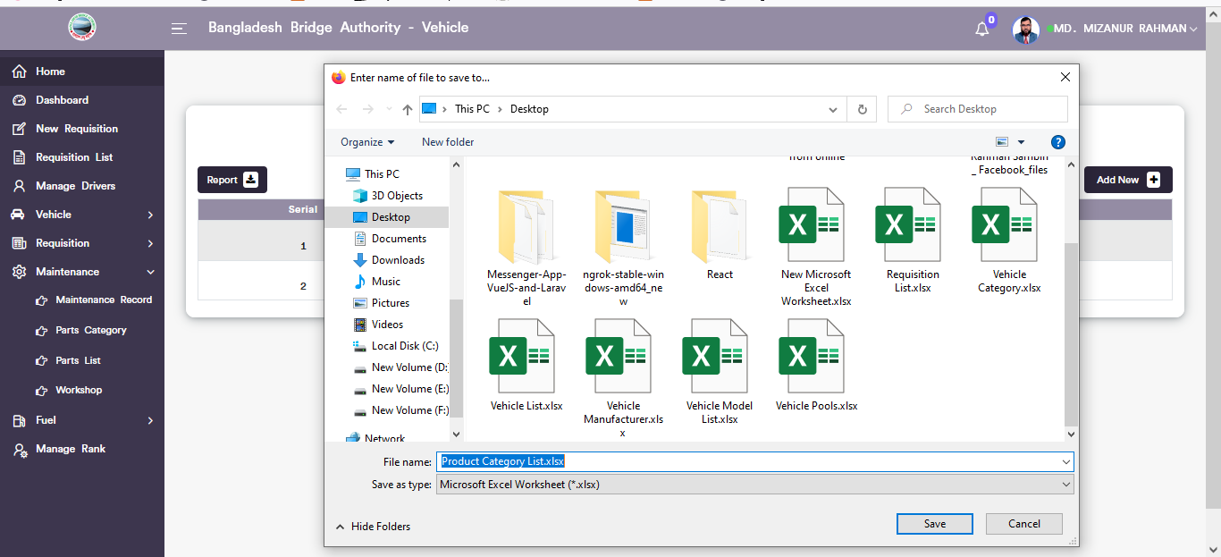

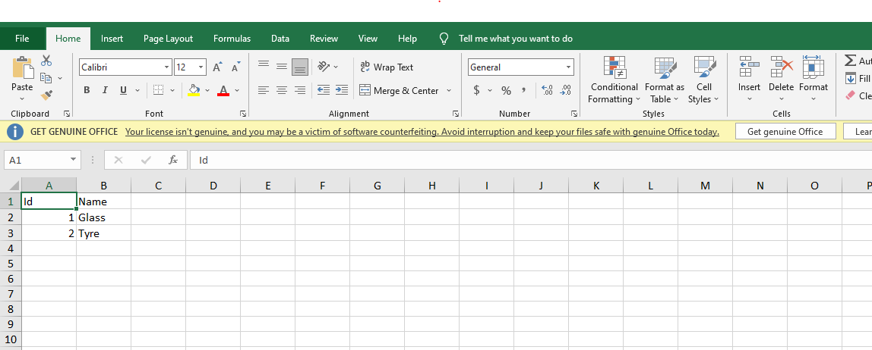

Figure 6.6.2.3: Product category Report Download

### 6.6.3.1: Product List(Maintenance)Add new product

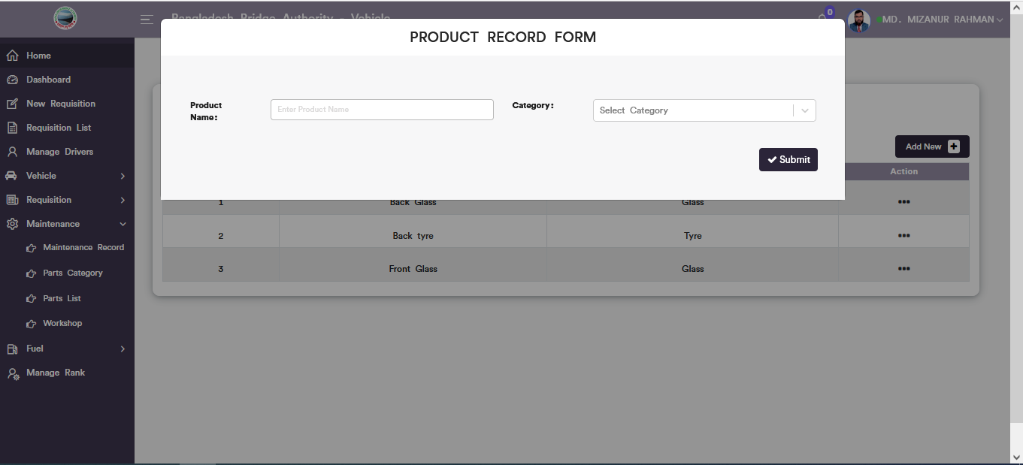

Figure 6.6.3.1: new product record form

### 6.6.3.2: Product List(Maintenance)Product Update

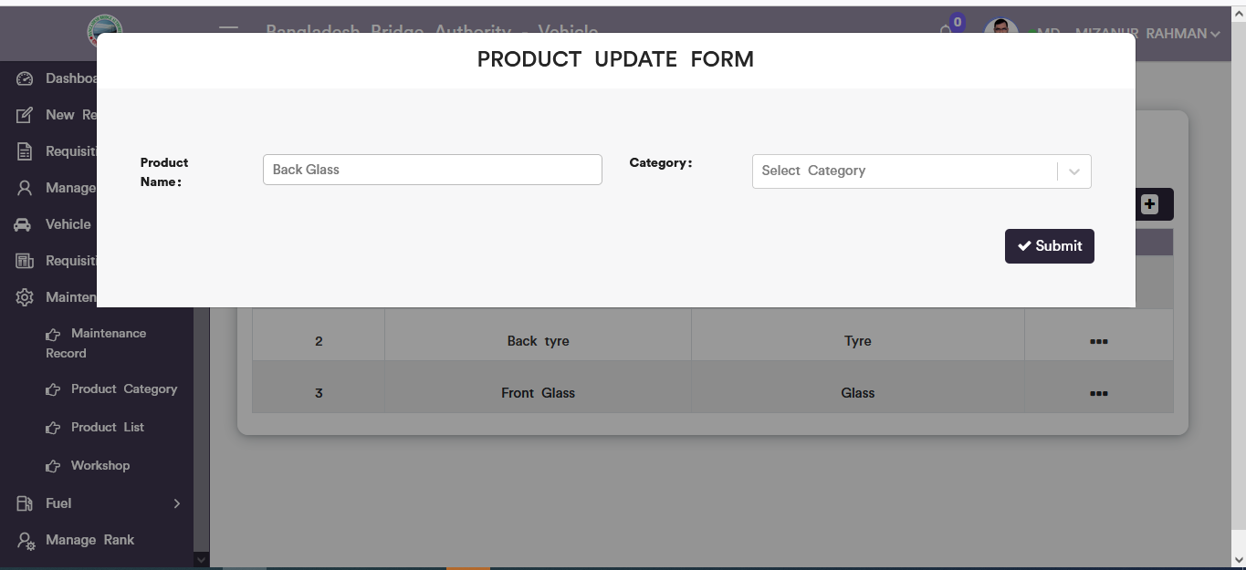

Figure 6.6.3.2: Product Update form

### 6.6.3.3: Product Lists(Maintenance)Download Report



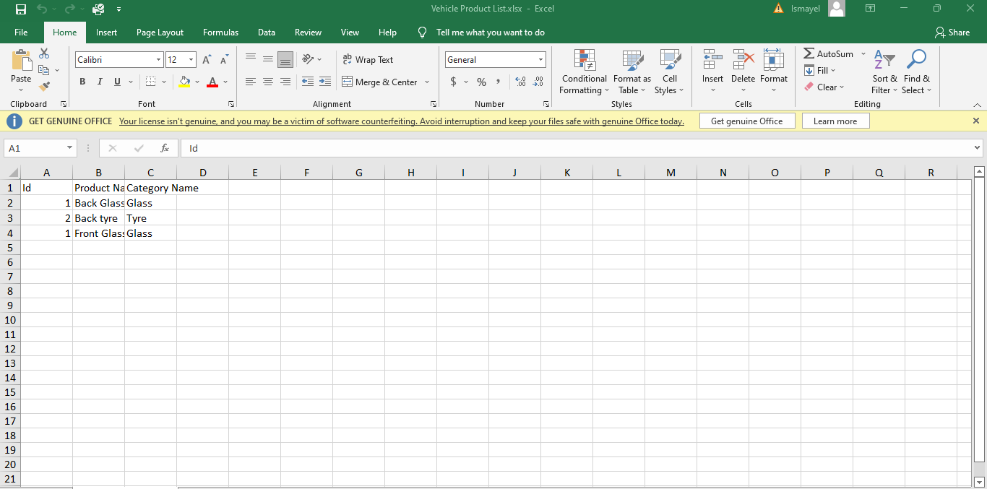

Figure 6.6.3.3: Product Lists Report Download

### 6.6.4.1: Workshop(Maintenance)Add workshop

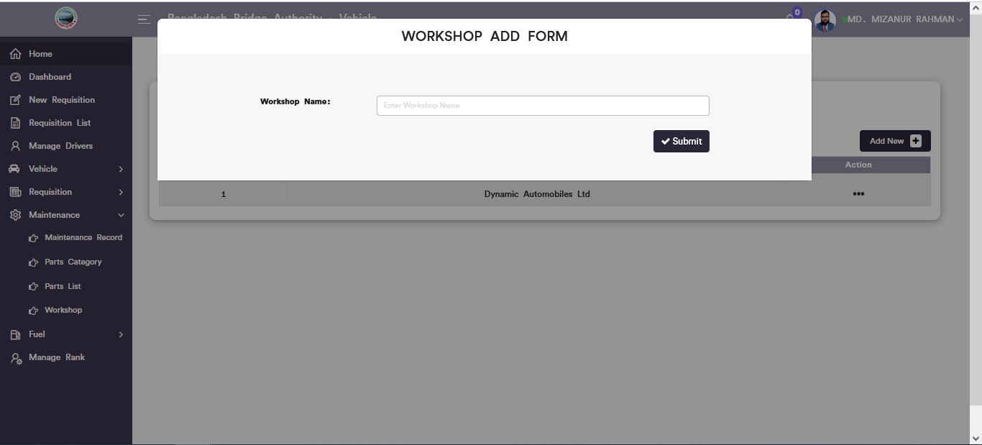

Figure 6.6.4.1: add new workshop input form

### 6.6.4.2: Workshop(Maintenance)Update workshop data

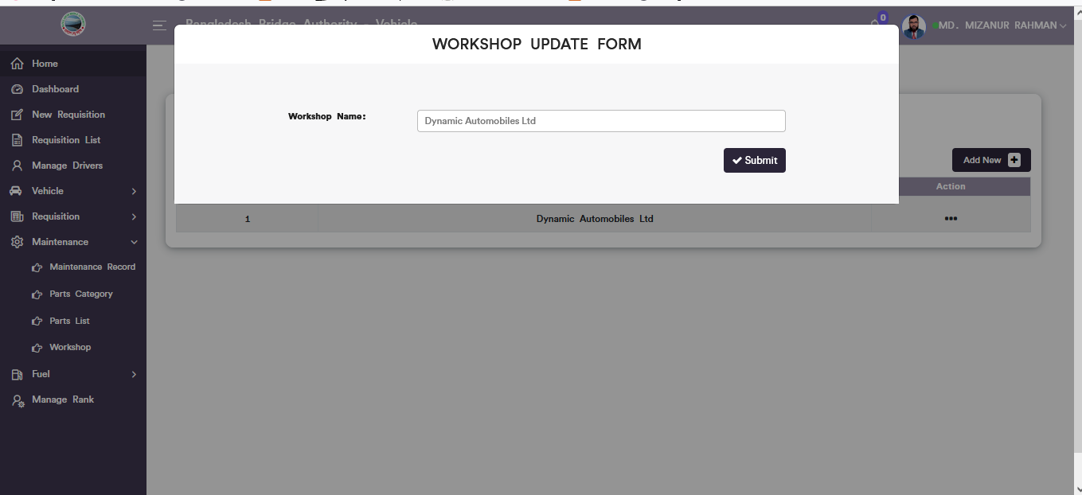

Figure 6.6.3.2: Workshop Update form

### 6.6.4.3: Workshop(Maintenance)Download Report

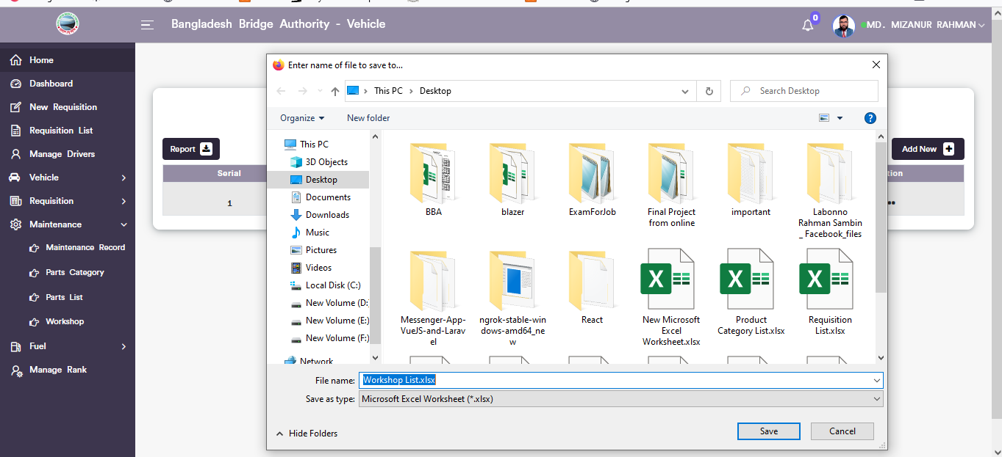

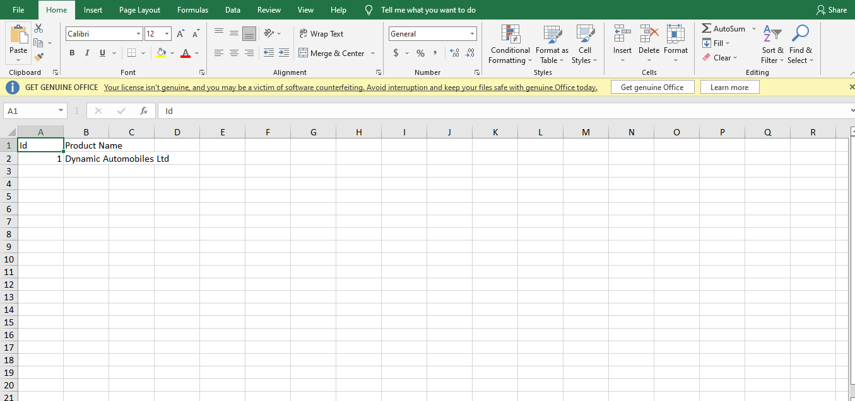

Figure 6.6.4.3: Workshop report Download

## 6.6: Fuel Menu Overview

**Overview of Fuel**

### 6.7.1.1: Fuel Record(Fuel)Add new fuel record form

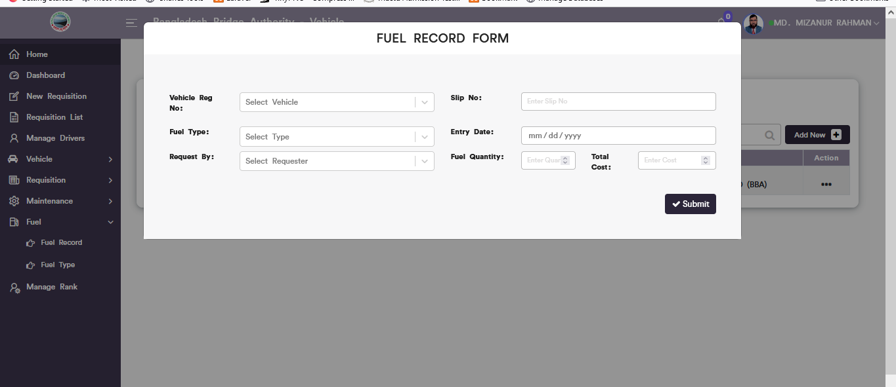

Figure 6.7.1.1: add new fuel record input form

### 6.7.1.2: Fuel record(Fuel)View of fuel record list

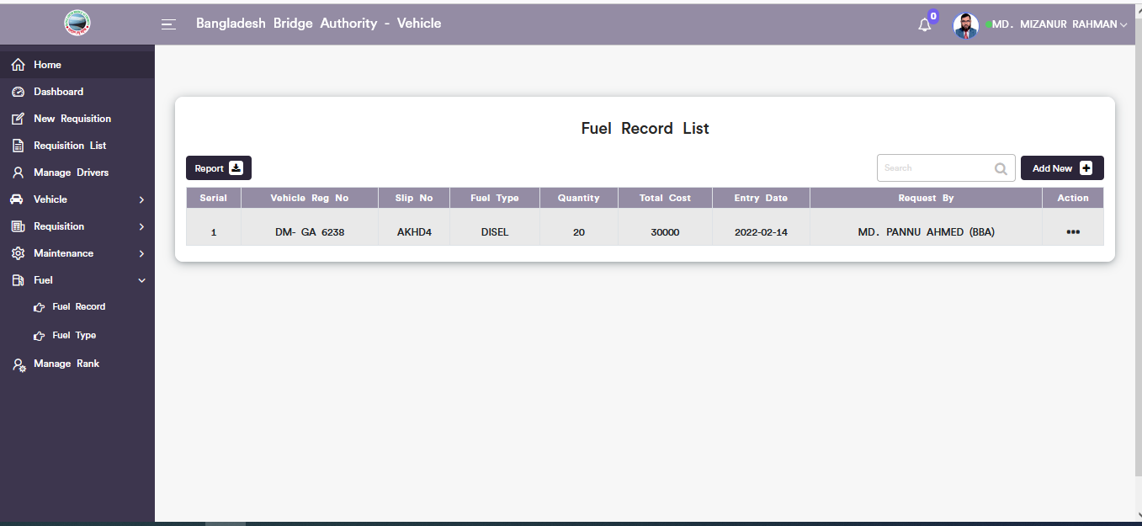

Figure 6.7.1.2: Fuel record list

### 6.7.1.3: Fuel Record(Fuel)Update fuel record data

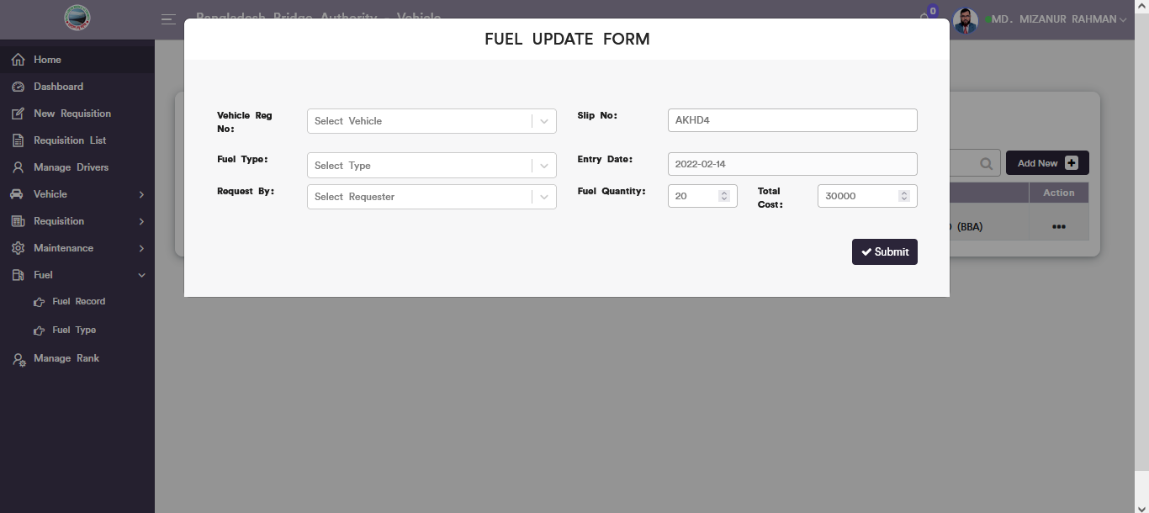

Figure 6.7.1.3: Update fuel record

### 6.7.1.4: Fuel Record(Fuel)Download Report

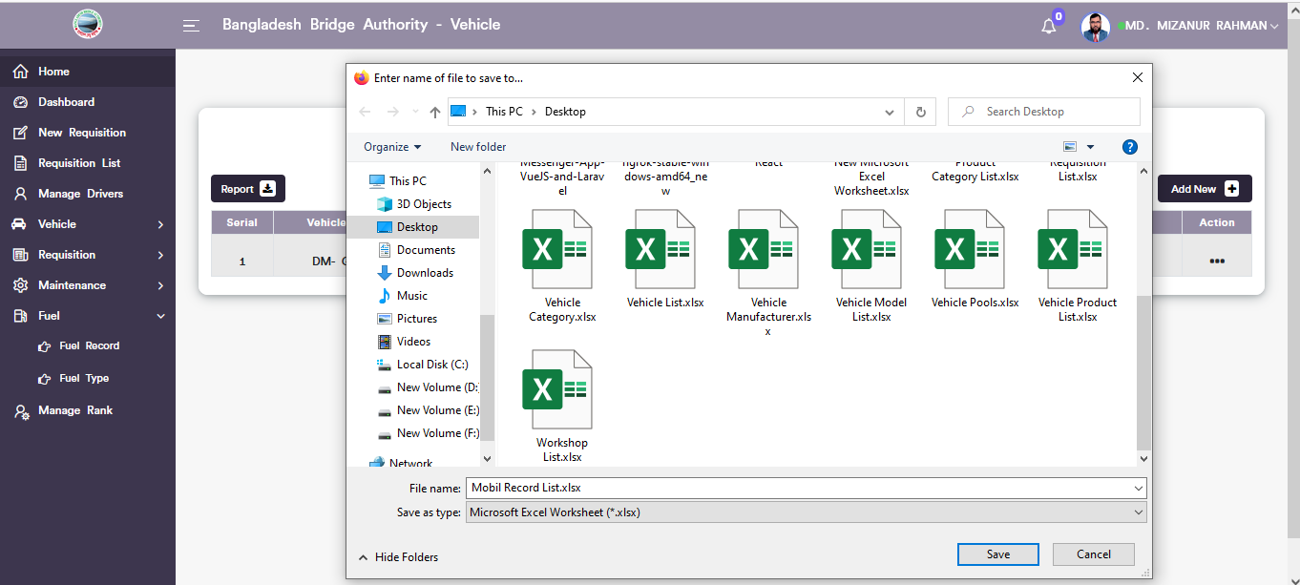

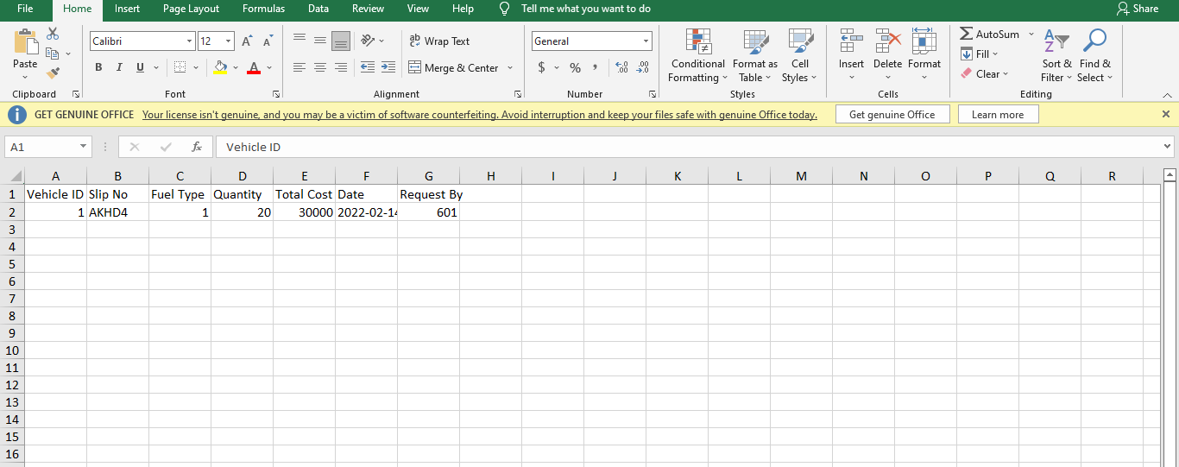

Figure 6.7.1.4: Download fuel record list

### 6.7.1.5: Fuel Record(Fuel)Search

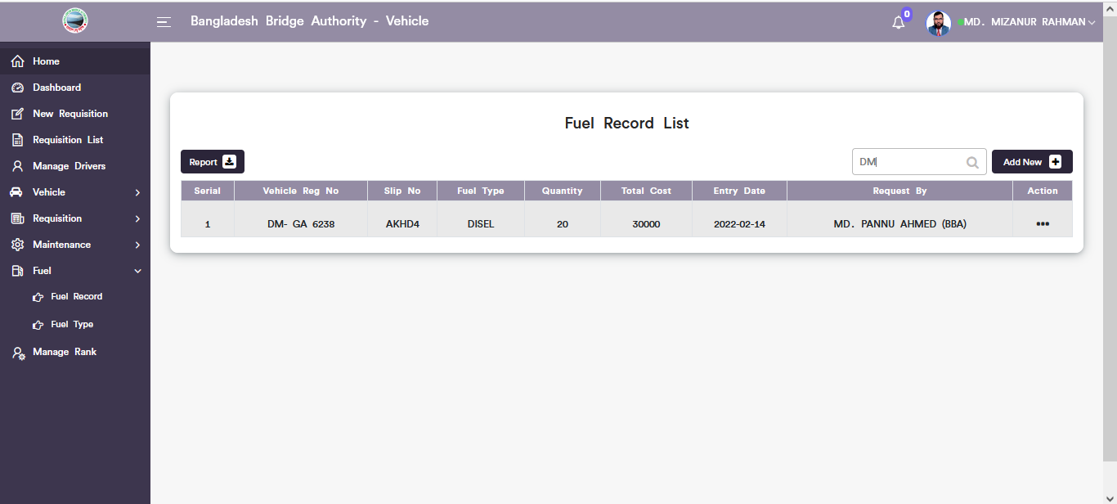

Figure 6.7.1.5: Search data from fuel record list

### 6.7.2.1: Fuel Type(Fuel)Add new fuel type form

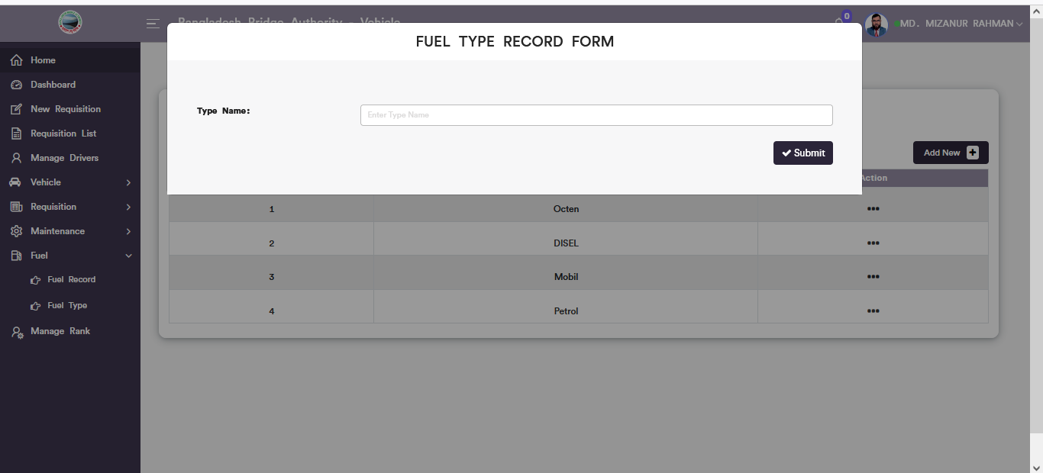

Figure 6.7.2.1: add new Fuel type input form

### 6.7.2.2: Fuel Type(Fuel)View of fuel type list

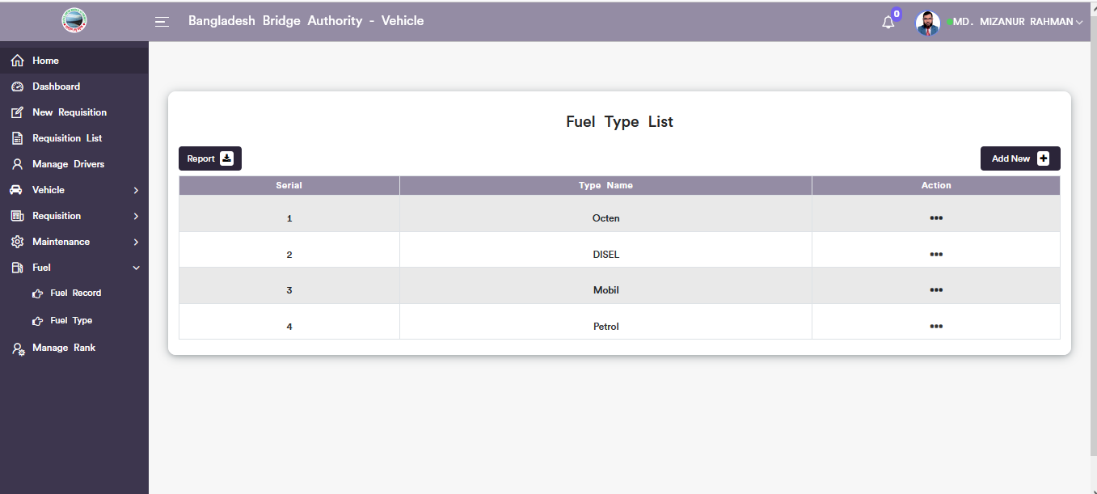

Figure 6.7.2.2: Fuel type list

### 6.7.2.3: Fuel Type(Fuel)Update fuel type data

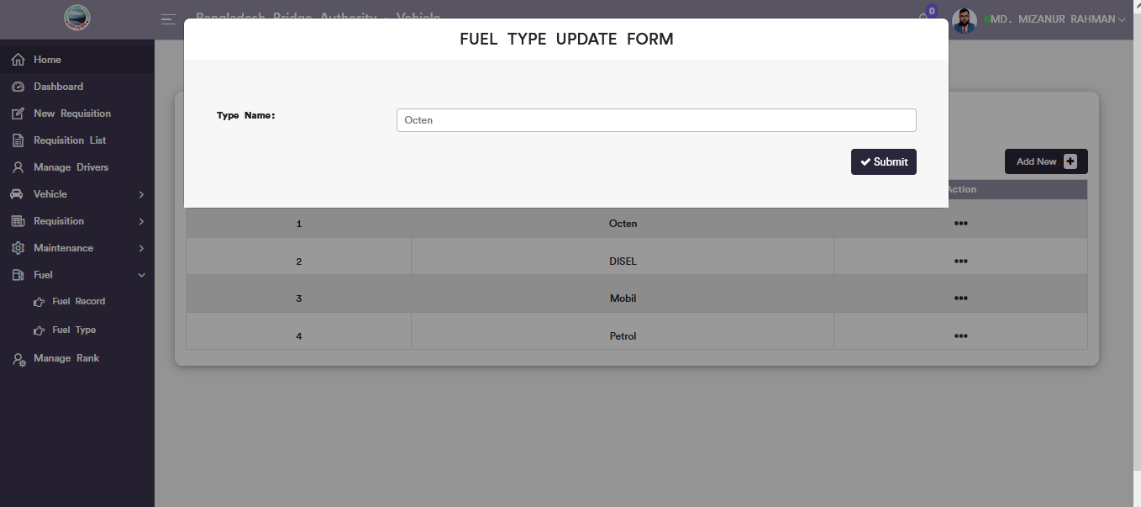

Figure 6.7.1.3: update fuel type data

### 6.7.2.4: Fuel Type(Fuel)Download Report

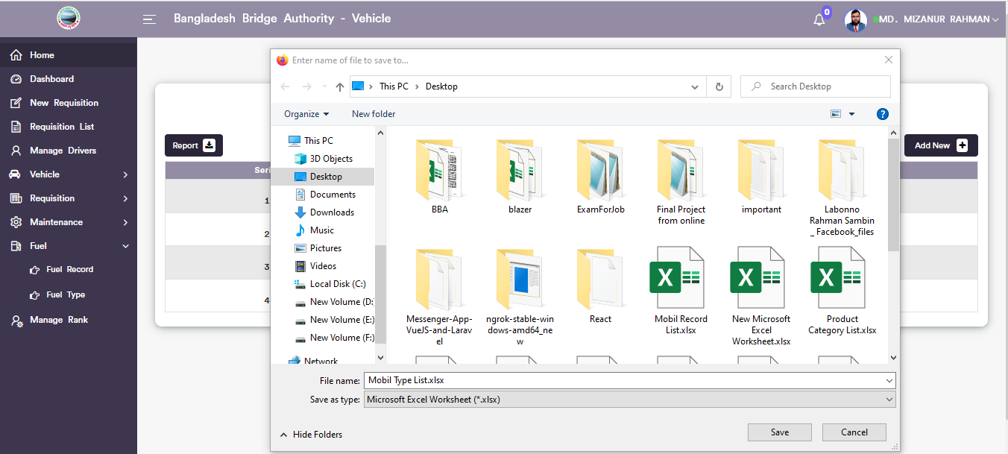

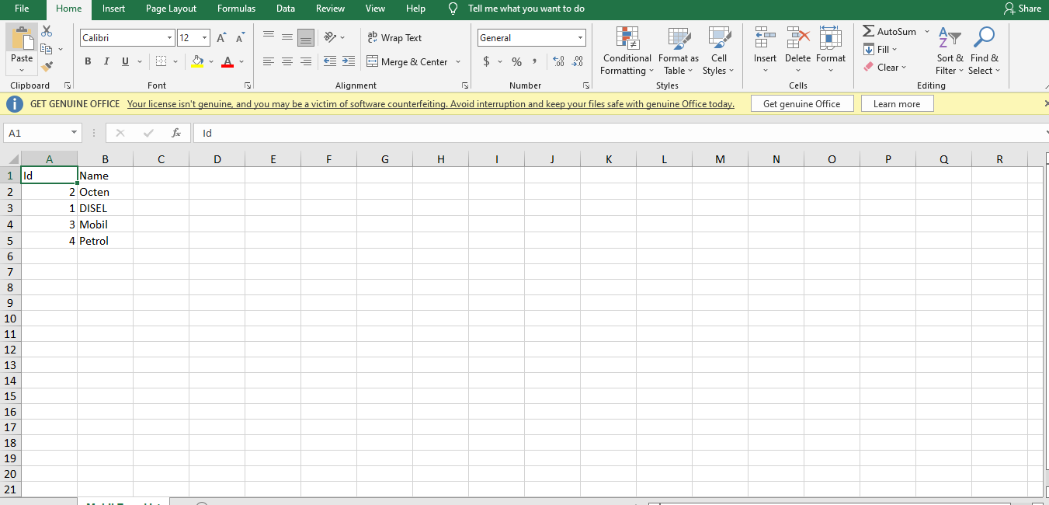

Figure 6.7.2.4: Download fuel type Report

## 6.8: Manage Rank Menu Overview

**Overview of Manage Rank**

### 6.8.1: (Manage Rank)View of requisition hierarchy rank list

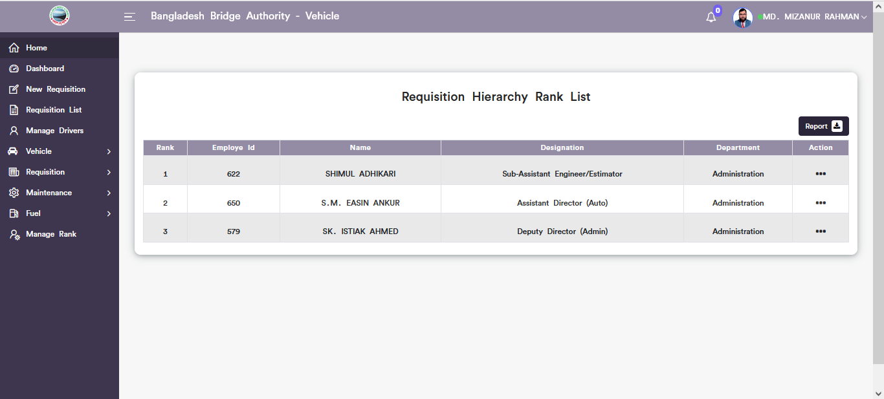

Figure 6.8.1: requisition hierarchy rank list

### 6.8.2: (Manage Rank)Update Requisition hierarchy

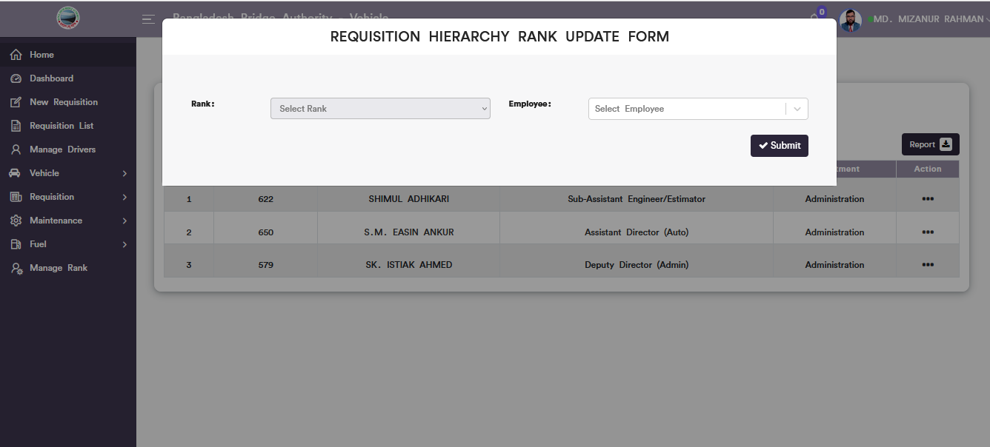

Figure 6.8.2: requisition hierarchy rank update form

### 6.8.3: (Manage Rank)Report download

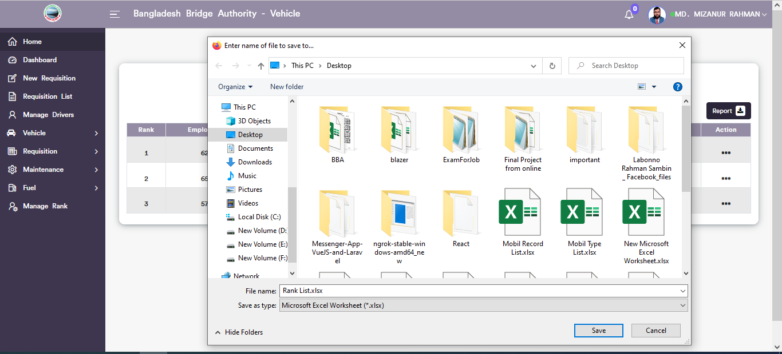

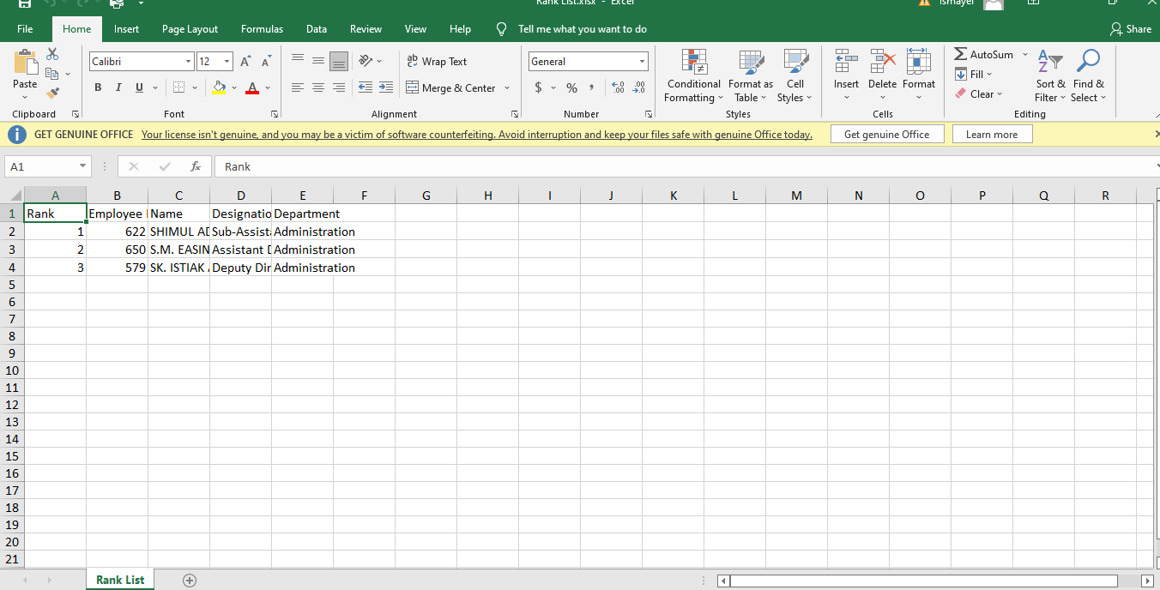

Figure 6.8.3: Requisition hierarchy rank Report download

# 7.IT (SUB MODULE)

After clicking into IT, it will redirect to the (IT Sub Module) dashboard with some menus.

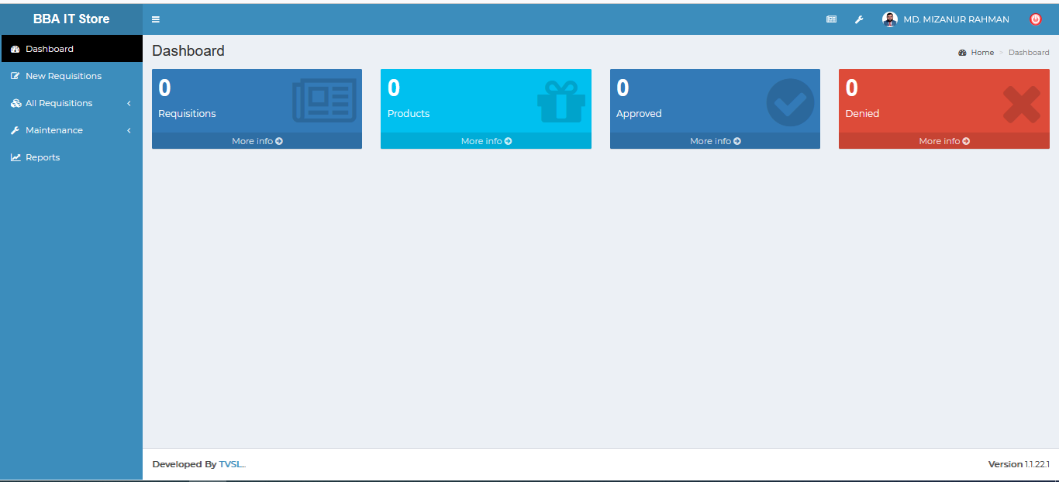

Figure 7: Dashboard of the IT (sub module).

There are four segments on the right side of the IT Dashboard Such as **Requisitions, Products ,** **Approved,** And **Denied.**

To get the details info about ( **Requisitions ,Products ,Approved, Denied**) just click on the view after that it will redirect to the relevant details info page.

# 8.IT MENUS OVERVIEW

## 8.1: New Requisitions Menu Overview

### 8.1.1:(New Requisitions)Make Request for product requisitions search

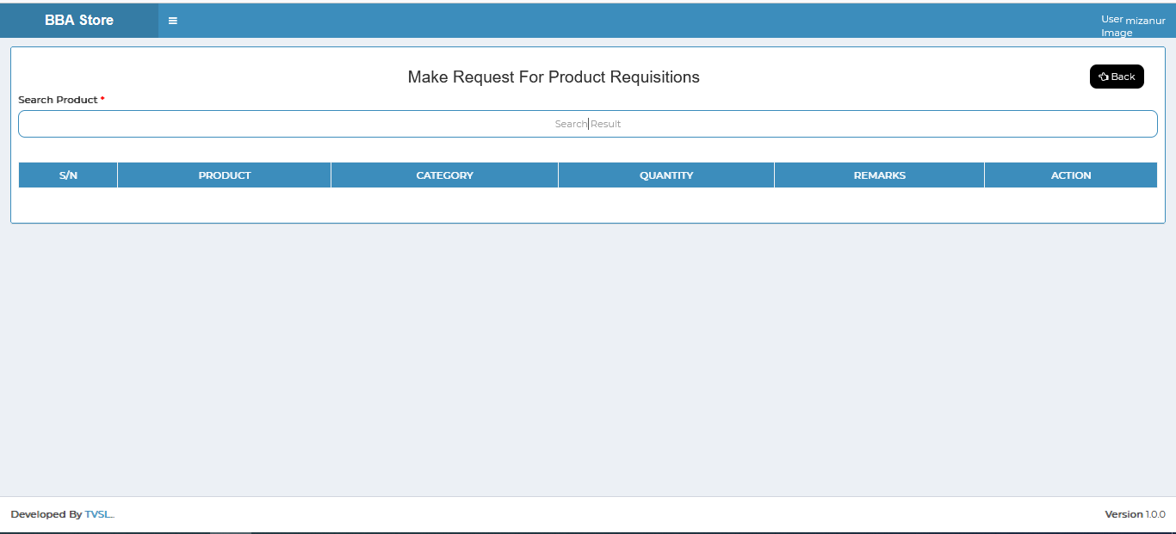

Figure 8.1.1: ( new requisitions) search input field

## 8.2: All Requisitions Menu Overview

**Overview of All Requisition**

### 8.2.1.1:View(All Requisition)all requisition status

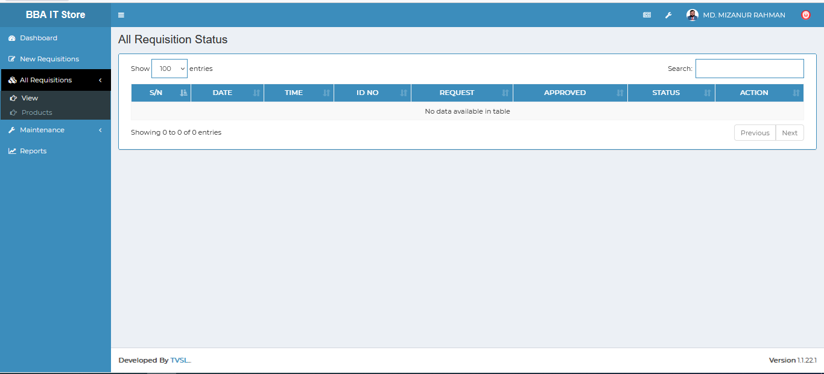

Figure 8.2.1.1: view( All requisition) view all requisition status

### 8.2.1.2:View(All Requisition)Search



Figure 8.2.1.2: view( All requisition) Search

### 8.2.2.1.:Products(All Requisition)view requisition product details

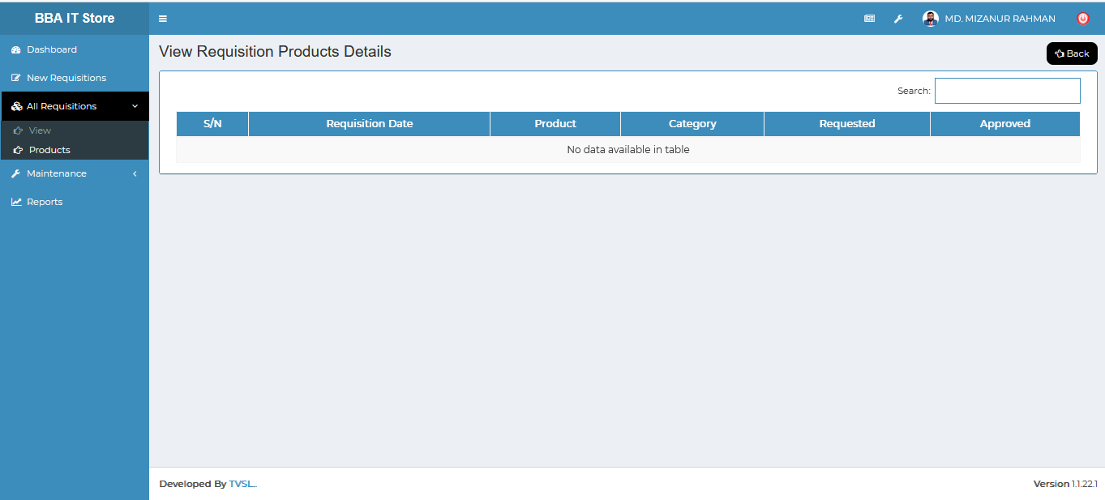

Figure 8.2.2.1: Products( All requisition) view requisition products details

### 8.2.2.2:Products(All Requisition)Search

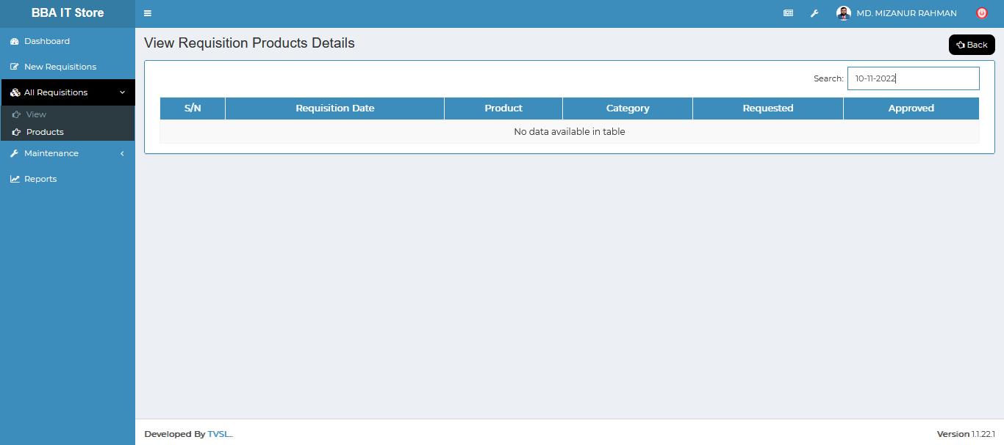

Figure 8.2.2.2: Products( All requisition) Search

## 8.3: Maintenance Menu Overview

**Overview of Maintenance**

### 8.3.1:Request(Maintenance)Requisition Products Search

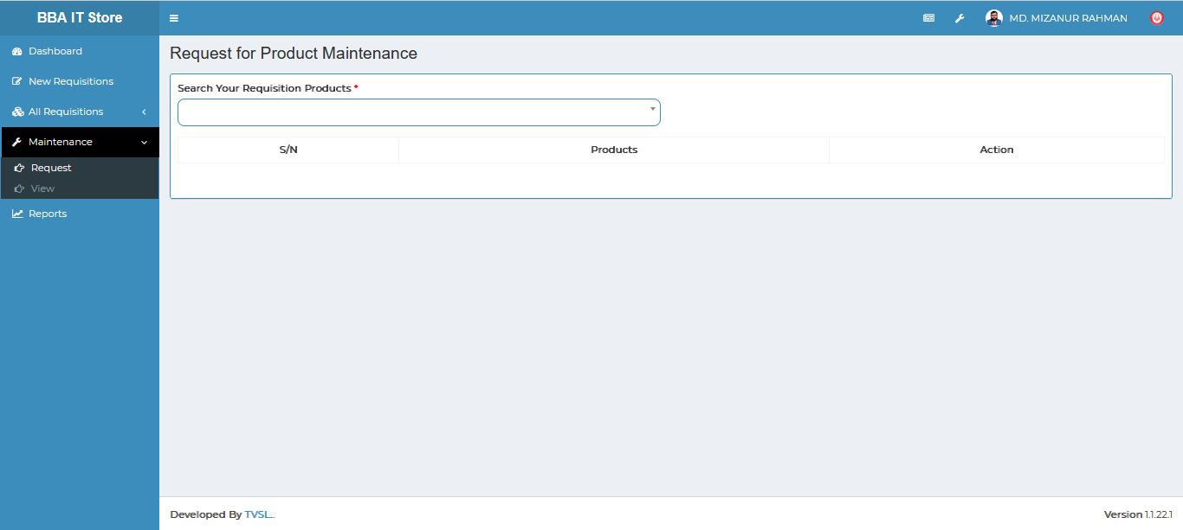

Figure 8.3.1: Request( maintenance)Request product search

### 8.3.2:View(Maintenance)Maintenance Products information.

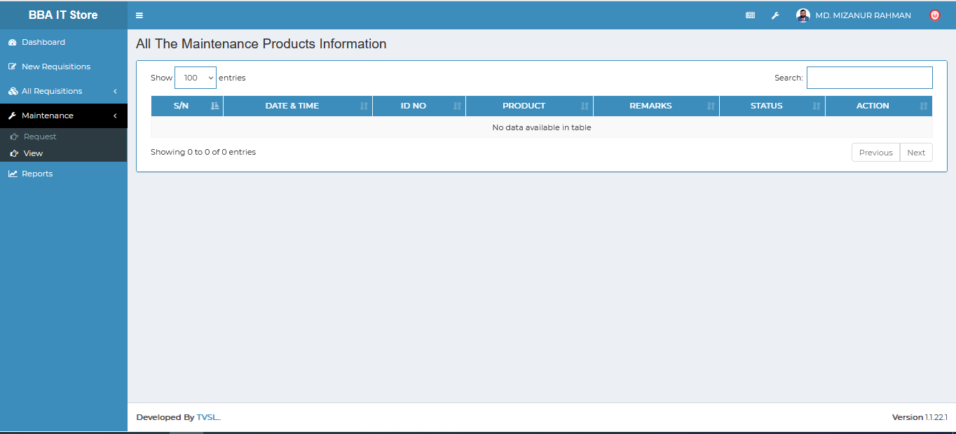

Figure 8.3.2: view( All requisition) Search

## 8.4: Reports Menu Overview

### 8.4.1:(Reports)Requisition/Maintenance Report generator

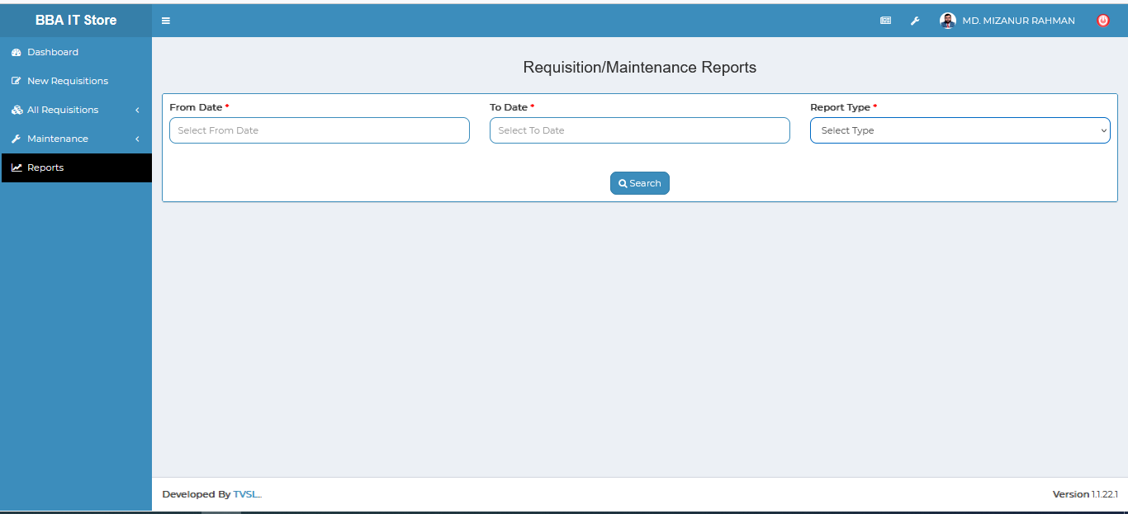

Figure 8.4.1: ( Reports) Requisition/Maintenance report generator